Sustainable Desalination System - An EPS@ISEP 2016 Project
L. Augustyns, M. Milesi, P. A. Valls, M. Kang, M. Pogoda
liesaugustyns@gmail.com , dustmejjo@gmail.com, marion.milesi17@gmail.com, pogoda.maciej@gmail.com, pol.valls.aguila@gmail.com

Abstract— If only 2.5 % of the water on earth is fresh water, it is important to think what to do with what is left. A desalination system already showed the possibility of reusing seawater, however it was at large scale and/or by using fossil fuels. The sustainable Desalination System gives the ability to desalinate water from the Ocean only by using solar energy. The paper presents the development about the production and virtually selling the product.

Keywords— Engineering education, Collaborative Learning, European Project Semester, Desalination, Seawater, Salt, drinkable, drinkable,

Introduction
Facts are straight. Only 2.5 % of the water on earth is fresh water. It leaves us with 97.5 % that currently people are not using. About 80 % of people in the world live around 156 km from the coast, so desalination is an obvious response to the lack of fresh water. Idea of water desalination is few generations ahead of us, until 2050 there will be 9.7 billion people on our planet So it is clear that the world will need more fresh water [1]. Currently, 95 % of water desalination process is made with help of fossil fuels, because it is efficient but not economical and ecological interesting [2].

Water desalination separates dissolves salts and other minerals from water. This gives the potential to provide a large population of drinkable water near the coast. The purpose of the authors is to design a sustainable desalination system that supplies those people with drinkable water out of water from the ocean by only using solar energy. Target audience are governmental institutions, refugees, people living on water, people that live close to the coast (like surfers) and eco-lovers. The government institutions provides our product to people instead of regulating them. Refugees can get high quality of water from thin and dirty water. People living on water and near coast will be able to obtain drinkable water from a large amounts of seawater in their surroundings. The purified water can also be used for different purposes like gardening or washing. Eco-lovers are interested in environmentally friendly things. So they will have interested in our product because it operates without use of any fossil fuels or non-recyclable materials.

The paper is divided in several parts. Section II presents the methodology of four desalination systems which are currently provided on the market. One of those systems is rescaled and optimized by the authors thanks to research and experiment to response to the demands of the target audience. The functionality of the system is proven on thermodynamics and functional tests explained in Section III and Section IV. These results are shown in Section IV. After the tests, Section VI explains how the whole product can be brought on the virtual market. Therefore, additional studies shows the marketing plan, sustainability and ethical part of the product. Section VII concludes the project and suggests further work based on advantages and disadvantages.

Methodology

Current market
A variety of desalination methods and processes already exists. The main goal of our team is to desalinate water for direct consumers who live in a dome near by the ocean. For these consumers, the most common techniques for desalination without chemical processes are Vapor Compression, Reverse Osmosis, Direct Contact Membrane Distillation and Water Desalination powered by renewable energy sources [1].

Vapor Compression
The process evaporates seawater by heat delivered by compressed vapour. Compression increases the pressure which gives a lower temperature for evaporation. By increasing the temperature to the evaporation temperature by the high pressure, water evaporates and the salt and other minerals stays in the container. The vapour rises and flows into the tube. In this tube, the vapour returns into drinkable water by the compressor. Fig. 1 shows the process. This type of desalination is usually performed by a mechanical driven compressor or a blower.
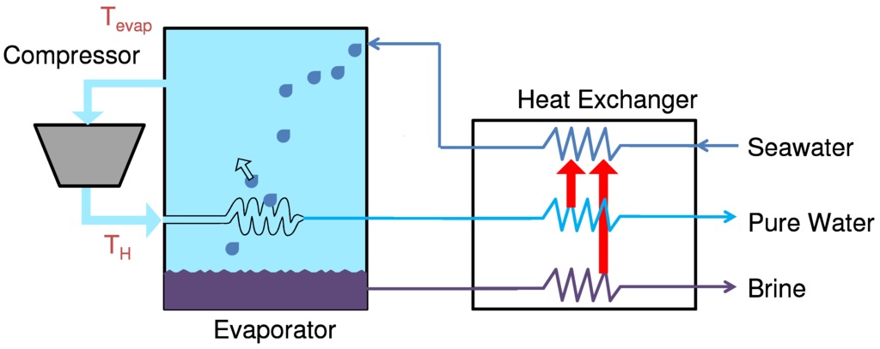
Fig. 1 Vapor compression
This system needs a small amount of energy, nevertheless this system will exceed the budget of our project. Moreover it is important to power the system by renewable energy [3].

Reverse Osmosis
The technology of reverse osmosis relies on high pressures to overcome osmotic pressure to force water through a membrane that rejects salt and other minerals, which is shown in Fig. 2. This chemical process (the membrane is used based on chemical knowledge) is highly recommended for a large scale desalination system [4].
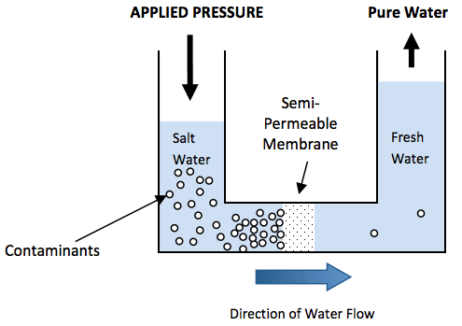
Fig. 2 Reverse Osmosis [5]
Although for the authors, not the favorable because of the membrane based on chemical knowledge, the impossibility of rescaling for a small amount of the system, the susceptible to membrane fouling and the high cost [6].

Direct Contact Membrane Distillation
The system exists of one big container with a membrane vertically in the middle which divides the container in two parts. The left part is colored black, the right part is white with a cooling system inside. By providing the left part with seawater, the solar energy heats the container and let the seawater evaporate. The membrane has a lower temperature because of the cooling system in the right container. The second law of thermodynamics proved the heat transfer from high to a lower temperature. The vapor thus flows from the black side through the membrane into the white side. The cooling system lowers the temperature to condensate the drinkable water, which can after be collected [7]. Fig. 3 shows the process.
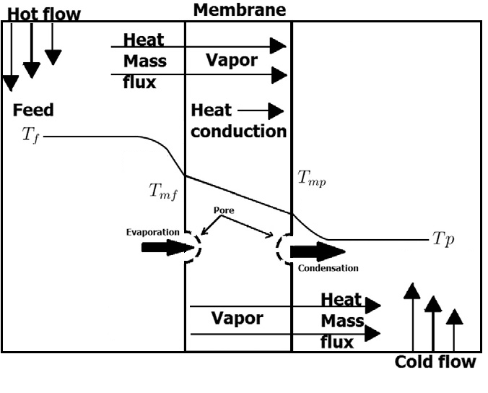
Fig. 3 Direct Contact Membrane Distillation [7]
The second system provides a small-scale system, low cost comparing with the Vapor Compression system, but has an intensive energy consumption,membrane pore wetting and the authors are not familiar with chemical engineering [6]. The second system has too many shortcoming of the desalination process to get optimized by them.

Water desalination powered by renewable energy sources
Next system all depends on solar power which is heating the water inside the pentagon-bases pyramid. The drinkable water evaporates and condensates on the transparent cover. Finally, the drinkable water can be collected. The process is shown in Fig. 4.
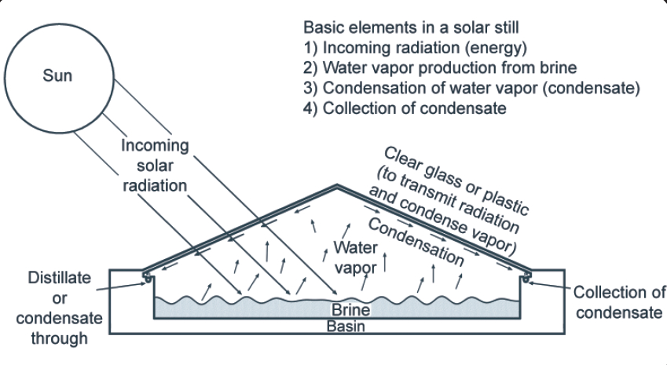
Fig. 4 Water desalination powered by renewable energy sources [8]
The second process is used to proceed the paper because of the matter of only using solar energy, scalable size and the low cost.

Project development: the system

Working principle of the system
The desalination process starts by pumping the seawater into the black container in the center of the pyramidal part. The sun will beat down on the transparent PMMA and heat the inside of the pyramid. This heat will release the evaporation of the seawater. Thanks to the difference of temperature between the inside and the outside of the pyramid, the water vapor condensates on the transparent PMMA, flows down into the big white base. Because of the hole in the white base, the drinkable water collects in a container which is attached with a valve to use the drinkable water whenever is needed.

The salt will not stay in the black container. When the container of the drinkable water is at its limit. The process stops. There are two possibilities. The most common occasion is to collect the high concentrated seawater. The valve which is connected with the black container opens and seawater pumps up into the black container to get high concentrated seawater from the container through the valve into the little container. After the pump stops. The black container is empty, the valve need to close and the little container can be disconnected and put in the air the let the water evaporate and collect the salt and other minerals. The second occasion is to clean the black container from the salt crystals and other minerals. By opening the pyramidal shaped transparent cover, the system can be cleaned.

Architecture
The white base is on an angle of 3°. Therefore, the drinkable water flows in the collecting container. The Black container is horizontal to optimize the evaporation. The transparent cover is made out of 5 triangles on an edge of approximately 30°. The pyramidal shape of the cover needs a less sophisticated making mechanism and is economical more interesting compares to a bowl shape. Fig. 5 shows the system from outside and the lateral view.
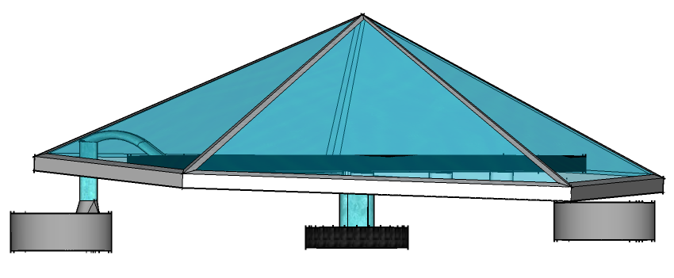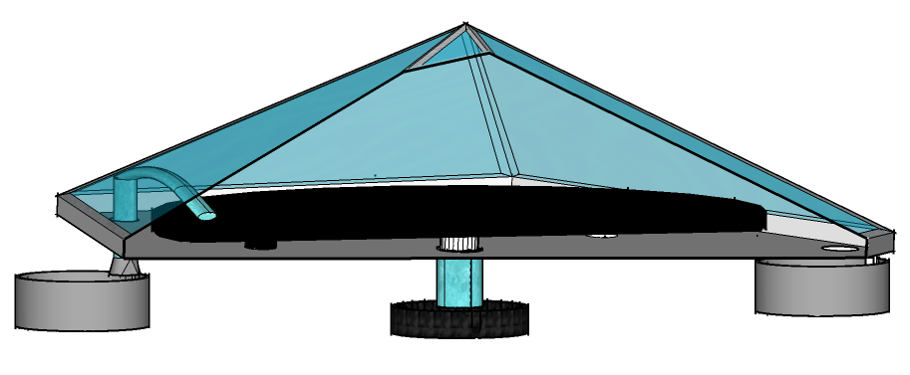
Fig. 5 (A) Total system (B) Lateral view of the system
Transparent PMMA is chosen over Glass due to:
- Light transmission: typical PMMA grades allow 92% of light to pass through it.
- PMMA let UV light through, which make the process faster. The thickness does not affect the transparency.
- Surface Hardness and lightweight
- No environmental damage or health risks by producing PMMA by containing any toxic materials or heavy metals.
The salt container is made out of a plastic black coaster for flower pot. To absorb the heat to the seawater to increase the process.

Electronical part
To make the Water Pyramid autonomous, an electronic system will be integrated. The Arduino intelligence will be used to control one pump, one valve and four ultrasonic sensors.

Two ultrasonic sensors are considered as INPUT and follow the maximal level of water possible in the container of clean water, and the one inside the pyramid which contains the salty water. Those sensors are here to avoid any overflow and all the consequences that this problem can generate after. Preventing salt deposition, the sensor will detects when there is just approximately 100 ml in the base, and refills. Two other ultrasonic sensors are considered as INPUT pull-up and follow the minimum level of water possible in the container of clean water, and the one inside the pyramid which contains the salty water. Those sensors are here to restart the process when the container is empty for the salty water container or when the container of clean water have enough place to receive more water. On this last container, the level of clean water will be always high to have a big stock and available water all the time.

Those ultrasonic sensors will detect the presence of water at the sensor level. The sonic waves emitted by the transducer are reflected by an object and received back in the transducer, so if something appears between them, the sonic waves will change and the presence of water detected.

This system needs 2 OUTPUT, one is the pump to fill and refill the container of salty water and one is the valve to release the salt at the end of the desalination process.

Thermodynamics

Theoretical concerns
Water desalination powered by renewable energy sources is purely based on Thermodynamics. Most important heat transfers are between the surrounding to cover and the inside to cover which takes place by convection, radiation, conduction and condensation. Shown in Fig. 6.
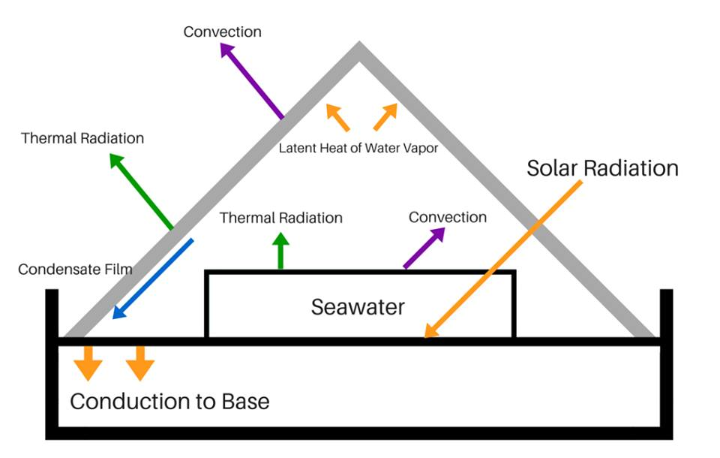
Fig. 6 Thermodynamic scheme
Solar energy transmit by radiation and convection on the cover and partially absorbs by the seawater and partially by the base. The temperature in the inside of the system rises, hereby seawater evaporates. Convection currents carry the warm vapor up to the colder cover, where vapor condensates. Due the steep cover, the drinkable water flows down the cover, over the white base and gets collected in the container. Additionally, heat transfer from the white base flows to the surrounded surfaces due conduction.

Calculations of the system is divided in heat transfers between the surrounding to cover and the inside to cover. Next equations states the rate of heat transfer from cover to surroundings by convection and radiation, which is equal to the heat transferred from the brine surface to cover by convection and radiation and by evaporation and condensations of water and the solar radiation absorbed in the cover.
The enthalpy H, emissivity e, the D and solar radiation Percentage I parameter

Energy balance around the cover of the distiller and surrounding
Q= Ho . Ac . (Tc – To) + σ . e . Ac (Tc⁴ – To⁴) (1)

Convection
Ho . Ac . (Tc – To) = (2)

Radiation
σ . e . Ac (Tc⁴ – To⁴) = (3)

Energy balance around the cover of the distiller and the inside of the system

Q= H_{o} . A_{c} . (Tb – Tc) + σ . e . Ac (Tb⁴ – Tc⁴) + D . λ + I . α_{c} (4)

Convection
Hi . Ac . (Tb – Tc) (5)

Radiation
σ . e . Ac (Tc⁴ – To⁴) (6)

Practical concerns
Referring to [10] the medium temperature between Mai and October 2015 is not beneath 291 K. The experiments took place at an outside temperature of 295 K according to [9].
However, the measurements showed a temperature of the outside of 297 K, the temperature of the inside of 325 K and the temperature of the cover was ….

Functional Tests
In this section the performance of the system are described based on practical tests. Thanks to Instituto Superior de Engenharia do Porto, the authors made test on the roof to obtain an obstacle free zone without external interruptions (people, shadow from objects and potential objects to hit the system). The tested system is a 1:5 scaled prototype of the real structure due to lower costs, transportability and achieving the approximate same values. The main goal of the functional test are to detect leaks in the system, tracking the process for determine errors and check the yield of the prototype

The process cycle is positive by obtaining evaporated water conducting on the cover, proven in Fig. 7. 200 ml of seawater in the black container which gave a film of 3 ml of water was left for 2 h on the roof at 14 h with a temperature of 297 K on the roof.
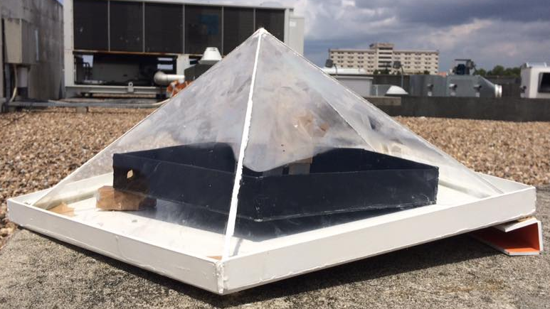
Fig. 7 Conduction on the cover
Convection between the colder outside (297 K) and the inside (325 K) make condensation occur. A thin film of drinkable water flows down through the white base, by the valve in the container, shown in Fig. 8. 35 % of the seawater evaporated.

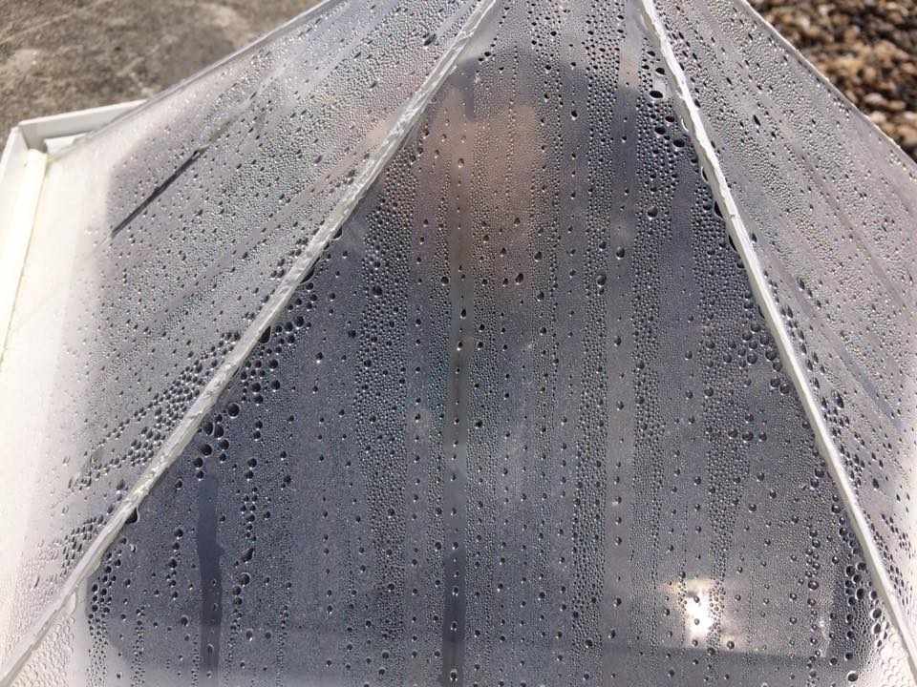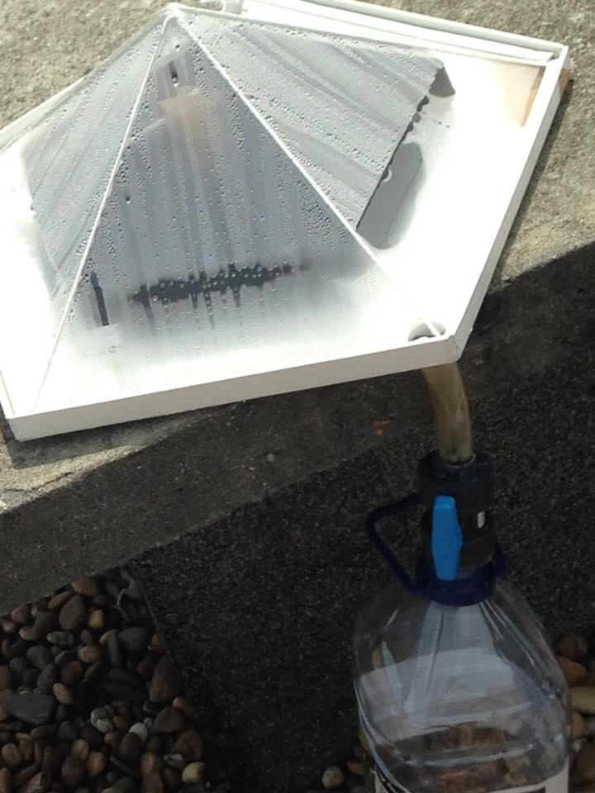

Fig. 8 (A) Condensation Process (B) Collecting the water

Results
The seawater is turned into drinkable water and is collected in a container. With a functionality of 65 ml evaporated out of 200 ml seawater in 2 h at midday. Side effects shows what do keep in mind for further research.
- Painting the bases and the saline container must be prohibited. Water gets contaminated and useless. A colored sticker is advised.
- Junctions with tubes and wires must close correctly

Results of thermodynamics.

Additional studies
The main goal of the European Project Semester for the authors is to achieve a Desalination system and to get this system on the market. Additional studies concerning Marketing, Sustainability and Ethical Studies helps to achieve this last goal.

Marketing
Countries, people, and companies try to find the ways how people can save water because of increasing of water shortage. Among them, for water desalination, California conducts 2 desalination projects [11][12] and Pakistan starts desalination project [13] which is delayed before. Also companies, for example POSCO Energy in Korea, are promoting desalination [14]. However, sometimes desalination projects are failure like New York's project [15]. That means that water desalination projects are not always viable. So each country and city has to consider about their conditions.

The authors’ target are governmental institutions, refugees, people living on water, people that live close to the coast like surfers and eco-lovers..

The authors’ idea of promoting these product by using different kind of advertising such as posting leaflets, videos, facebook page and reviews of users on social media sites. This manner of promotion is affordable compared to TV-commercials and effective to reach large amount of potential customers.

Sustainability
The sustainability of a product is based on three elements: economic, social and environment.
Because this project is relatively cheap, the society is willing to become an owner of this product. It has favorable effects on the economic for not buying more bottled drinking water.
The product must be defined as eco-friendly. It won't only give benefits in terms of knowledge and a fresh point of view for the employees. It will also provide to our employees common way of thinking and it is reflected unconsciously in the personal and professional development. By making them feeling better, they will work better. The second aspect to consider is to taking care about the suppliers. Our strong values reflect that the authors are involved in the change and this is how we can work for the progress of society. The suppliers are expected to pass a minimum of requirements to be part of our mission. A familiar relation with the users helps to ensure a strong union between them and the company. The company is not only about selling and making profit, it is about satisfying the users' needs. User service well implemented with social skills and helping with our eco-friendly product provides a better user company relation.
Our purpose is making drinkable water from seawater by using raw material and sustainable energy, sunlight and no fossil fuels. The system makes it able to get drinkable water with solar power without environmental pollution.

Ethics
For the Water pyramid, the AAWRE code is chosen (American Academy of Water Resources Engineers). This code contains the standards of good practices for an engineer but also specifications about water resources. This code is perfectly adapted to this project [16].

Objectives of the AAWRE:
- Identifying and certifying engineers with specialized knowledge in water resources for the benefit of the public.
- Recognizing the ethical practice of water resources engineering at the expert level.
- Enhancing the practice of water resources engineering.
- Supporting and promoting positions on water resources issues important to the public health, safety and welfare.
- Encouraging life-long learning and continued professional development.
- Looking at the objectives of the AAWRE code, Give me 5 make the choice to focus on « Recognizing the ethical practice of water resources engineering at the expert level » and « Enhancing the practice of water resources engineering ».
These objectives are about respecting the engineer profession in our work and behavior, but also respecting the water resources of the world.

VII Conclusion and Future Work

At this point, the Sustainable Desalination System can almost be brought on the market. The research helped to find an optimal architecture and progress of the system. The test results proved the fast process. The main goals of desalinate water is fulfilled. Some side effects must be erased, like prohibiting the using of paint and finding a more optimal system to prevent leaks.

Furthermore, our product focuses on sustainability and Eco-friendly, although the authors cannot avoid contamination because of the use of the artificial parts for the system, like the solar panel. In addition, it is sure that contamination will occur when our product is produced. Therefore, the future must consider the method of generating the least contamination for environment.

Finally, precise calculations. There was a struggle getting the optimal efficiency and minimum cost to product the product by calculating the quantity of energy that it can get, the total time required, method of system control for optimum

These future changes will take into consideration to get new ideas and an easy to use system.

VIII Acknowledgment

In this paragraph, the authors would like to thank the supervisors and teachers from the European Project Semester at Instituto Superior de Engenharia do Porto. Their patience, guidance and great help strengthened the authors’ capacity to fulfill the project. Special gratitude for our main supervisors Cristina Ribeiro and Paulo Ferreira. This European Project Semester enriched all authors by culture, teamwork and team bonding.

IX References
[1] R. Mills, “Getting A Heartbeat,” The daily journalist, 2016. [Online]. Available: http://thedailyjournalist.com/author/richardmills/.
[2] A. W. W. Association, Desalination of Sea water, 1st ed. Denver, 2011.
[3] F. Bander, “Advantages & Disadvantages of Vapor Recompression,” Design Distillation System, 2012. [Online]. Available: http://seperationtechnology.com/advantages-disadvantages-of-vapor-recompression/.
[4] H. W. C. and J. H. L. V David M. Warsinger, Karan H. Mistry, Kishor G. Nayar, “Entropy Generation of Desalination Powered by Variable Temperature Waste Heat,” Entropy, vol. 17 (11), no. 7530–7566, 2015.
[5] PureTec, “What is Reverse Osmosis?” [Online]. Available: http://puretecwater.com/what-is-reverse-osmosis.html.
[6] H. C. Duong, P. Cooper, B. Nelemans, T. Y. Cath, and L. D. Nghiem, “Optimising thermal efficiency of direct contact membrane distillation by brine recycling for small-scale seawater desalination,” Desalination, vol. 374, pp. 1–9, 2015.
[7] F. Eleiwi, N. Ghaffour, A. S. Alsaadi, L. Francis, and T. M. Laleg-Kirati, “Dynamic modeling and experimental validation for direct contact membrane distillation (DCMD) process,” Desalination, vol. 384, pp. 1–11, 2016.
[8] D. S. (seecon international gmbh Félicien Mazille (Aquasis, cewas, international centre for water management services), “Desalination,” 2010. .
[9] LLC, “Weather channel Forecast,” 2016. [Online]. Available: https://itunes.apple.com/us/app/weather-channel-app-for-ipad/id364252504?mt=8.
[10] ISEP, “Meteo Isep.” [Online]. Available: http://meteo.isep.ipp.pt/.
[11] L. Carlsbad, “Carlsbad Desalination Project,” 2016. [Online]. Available: http://carlsbaddesal.com/.
[12] correspondence of C. Hall, “Desalination project in Santa Barbara,” 2016. [Online]. Available: http://www.santabarbaraca.gov/gov/depts/pw/resources/system/sources/desalination.asp.
[13] A. Najam, “DHA Desalination and Power Plant,” 2006. [Online]. Available: http://pakistaniat.com/2008/02/20/pakistans-first-water-desalination-power-plant-is-now-operational/.
[14] POSCO ENGINEERING & CONSTRUCTION, “Seawater Desalination.” [Online]. Available: http://www.poscoenc.com/eng/business/business_career.asp?hDEPTH2=6&hDEPTH3=5.
[15] Riverkeeper, “United Water New York’s Proposed Desalination Plant,” 2015. [Online]. Available: http://www.riverkeeper.org/campaigns/river-ecology/waterfront-development-review/united-water-desal/.
[16] AAWRE, “AAWRE Code of Ethics & Release Agreement Form,” Am. Acad. fo Water Resour. Eng., p. 4, 2015.

