

Sustainable Desalination System
–
An EPS@ISEP 2016 Project
By Team 5

Performed by
Lies Augustyns
Min ji Kang
Marion Milesi
Maciej Pogoda
Pol Valls Aguila

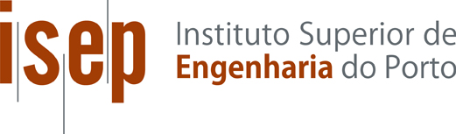

Table of Content

Acknowledgement 1
List of Figures 2
List of Tables 3
Glossary 4
1 Introduction 4
1.1 Presentation 5
1.2 Motivation 6
1.3 Problem 6
1.4 Objectives 6
1.5 Requirements 7
1.6 Functional Tests 7
1.7 Project Planning 8
1.8 Report Structure 8
2 State of the Art 9
2.1 Introduction 9
2.2 Definition and general information 9
2.3 Types of water desalination 9
2.4 Design 19
2.5 Conclusion 19
3 Project Management 20
3.1 Scope 20
3.2 Time 22
3.3 Cost 24
3.4 Quality 25
3.5 People 26
3.6 Communication 28
3.7 Risk 30
3.8 Procurement 32
3.9 Stakeholders management 33
3.10 Conclusion 35
4 Marketing Plan 36
4.1 Introduction 36
4.2 Market Analysis 37
4.3 SWOT Analysis 41
4.4 Strategic Objectives 43
4.5 Segmentation 44
4.6 Strategy/Positioning 45
4.7 Adapted Marketing-Mix 47
4.8 Budget 50
4.9 Strategy Control 51
4.10 Conclusion 51
5 Eco-efficiency Measures for Sustainability 52
5.1 Introduction 52
5.2 Sustainable development 52
5.3 Environmental 53
5.4 Economical 54
5.5 Social 55
5.6 Life Cycle Analysis 55
5.7 Conclusion 57
6 Ethical and Deontological Concerns 58
6.1 Introduction 58
6.2 Engineering Ethics 58
6.3 Sales and Marketing Ethics 59
6.4 Academic Ethics 60
6.5 Environmental Ethics 60
6.6 Liability 61
6.7 Conclusion 61
7 Project Development 62
7.1 Introduction 62
7.2 Architecture 62
7.3 Tests and Results 69
7.4 Thermodynamics 72
7.5 Electronics overview 78
7.6 To go further 84
7.7 The prototype 84
7.8 Conclusion 85
8 Conclusions 86
8.1 Discussion 86
8.2 Future Development 86
9 References 87

Acknowledgement
In this paragraph, the authors would like to thank the supervisors and teachers from the European Project Semester at Instituto Superior de Engenharia do Porto. Their patience, guidance and great help strengthened the authors’ capacity to fulfill the project. Special gratitude for our main supervisors Cristina Ribeiro and Paulo Ferreira. This European Project Semester enriched all authors by culture, teamwork and team bonding. In addition, we also would like to thank our family and home school which made it possible to study abroad.

List of Figures
Fig. 1 Team 5 and their project logo 5
Fig. 2: Multi-stage flash distillation schematic [2] 10
Fig. 3:Example of MFS Plant from United Arab Emirates. [3] 11
Fig. 4: Multiple-effect distillation schematic [4] 11
Fig. 5: Example of MED Plant: Tianjin Desalination Plant in China [5] 12
Fig. 6: Vapor compression process schematic [31] 12
Fig. 7: Reverse Osmosis desalination process schematic [8] 13
Fig. 8: Sydney desalination plant [6] 14
Fig. 9: Greenwater Kit [7] 14
Fig. 10: Direct Contact Membrane Distillation Schematic [9] 15
Fig. 11: Homemade Desalination System [10] 16
Fig. 12: Sustainable Desalination System[11] 16
Fig. 13: Prototype 19
Fig. 14: Work Breakdown Structure 21
Fig. 15: Gantt Chart 24
Fig. 16: Communication System 28
Fig. 17: Procurement 32
Fig. 18: Stakeholder Map 35
Fig. 19: Marketing Environment 37
Fig. 20: Products currently on the market 40
Fig. 21: LifeStraw 41
Fig. 22: SWOT Analysis 42
Fig. 23: Marketing Strategy Planning Process 43
Fig. 24: Choosing a positioning strategy 46
Fig. 25: Marketing Mix 47
Fig. 26: Levels of products 47
Fig. 27: Product's logo 48
Fig. 28: Communication Mix 49
Fig. 29: Marketing Control Process 51
Fig. 30: Sustainable main elements 52
Fig. 31: Life Cycle Analysis Diagram 55
Fig. 32: First idea 62
Fig. 33: Second idea 63
Fig. 34: First Case 64
Fig. 35: Second Case 65
Fig. 36: Third Case 65
Fig. 37: Fourth Case 66
Fig. 38: Third Concept 67
Fig. 39: (A) External view of the system (B) Internal view of the system 68
Fig. 40: Water Flow 68
Fig. 41: (A) External view of the system (B) Internal view of the system 69
Fig. 42: Ground Idea [5] 69
Fig. 43: First test 70
Fig. 44: (A) Setting of the experiment (B) Result ofter 24 h 71
Fig. 45: Thermodynamic scheme 72
Fig. 46: Temperature of the brine, the inside and the outside of the system 75
Fig. 47: Relative Humidity inside the system 75
Fig. 48: Temperature of the system during a 24 h test 76
Fig. 49: Relative Humidity of the system during a 24 h test 77
Fig. 50: Black Box Diagram 78
Fig. 51: Arduino Schematic 80
Fig. 52: Arduino Programming 82
Fig. 53: Arduino Code 83
Fig. 54: (A) Top view of the deformed black container and (B) Side view of the deformed black container 85

List of Tables
Table 1: Report subdivisions 8
Table 2: Comparison 17
Table 3: Deliverables 22
Table 4: Cost electronical components 24
Table 5: Cost work resources 24
Table 6: Material List 25
Table 7: Task allocation 26
Table 8: RACI matrix 27
Table 9: Communication Matrix 29
Table 10: Risk analysis 30
Table 11: Assessment 34
Table 12: Marketing Objectives 36
Table 13: Marketing Segmentation 44
Table 14: Price Factors 48
Table 15: Types for selling the product 49
Table 16: Budget Communication Actions 50
Table 17: Results 71
Table 18: Weather Conditions 71
Table 19: Results 72
Table 20: Min/Max results of the 24 h test 77

Glossary
Abbreviation | Description
AAWRE | American Academy of water resources engineers
B.C. | Before Christ
DFA | Dimensional Fund Advisors
DCMD | Direct Contact Membrane Distillation
EC | EuroCode
EU | European Union
EPS | European Project Semester
GDP | Gross Domestic Report
GPI | Genuine Progress Indicator
HDI | Human Development Index
ISEP | Instituto Superior de Engenharia do Porto
ISO | International Organization for Standardization
LCA | Life Cycle Analysis
MED | Multiple-Effect Distillation
MSF | Multi-stage Flash Distillation
NA | Not Applicable
PMMA | PolyMethylMethaAcrelate
PVC | Polyvinylchloride
RACI | Responsible Accountable Consulted Informed
RO | Reverse Osmosis distillation
ROHS | Restriction of the use of certain Hazardous Substances
SHD | Simple Homemade Desalination
SMI | Social Media sustainability Index
SWD | Simple water desalination
SWOT | Strength Weaknesses Opportunities Threats
UNICEF | United Nations Children’s Fund works for children’s rights
VC | Vapor Compression distillation
WBS | Work Breakdown Structure

Introduction
In this chapter, a brief information about the water desalination project will be provided and also how this report will look like. The report will start by presenting the team members and then you will find a few words about the team motivation, problems that the project is trying to solve, objectives, requirements and functional tests.

Presentation
Team 5 (also known as GIVE ME 5) is a group of five international students with different scientific backgrounds that have come to Instituto Superior de Engenharia do Porto for the European Project Semester. The team includes a Belgian Civil Engineer, a South Korean Mechanical Engineer, a French Packaging Engineer, a Polish expert in Logistics and a Spanish Electrical Engineer. Together, these five people took up a challenge five months ago, and in this document you will follow their work. Team 5 with their logo of the project is presented in Fig. 1.
Marion Milesi | Pol Valls Aguila | MinJi Kang | Maciej Pogoda | Lies Augustyns
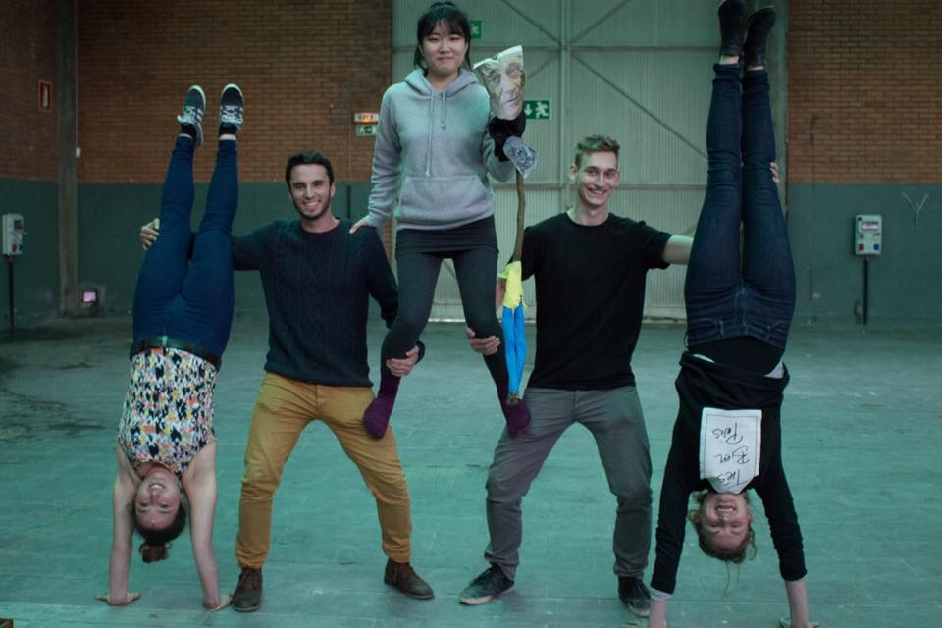
Fig. 1 Team 5 and their project logo

Motivation
Water desalination is a really important topic in the beginning of the 21st century. The oil peak is coming and we need to start thinking about our future.
Facts are straight. Only 2,5 % of the water in the world is fresh water. It leaves us with 97,5 % that currently we are not using. About 80 % of people in the world live around 97 m from the coast, so desalination is an obvious response to the lack of fresh water. The idea of water desalination is few generations ahead of us, because until 2050 there will be 9.7 billion people on our planet and most of them will born in Asia and Africa. So it is clear that the world will need more fresh water.
The process now exists in many places, but it is still not as common as it should be. On a smaller scale it is used on ships and submarines since surroundings are perfect for obtaining water that way.
Currently, 95 % of the water desalination process is made with the help of fossil fuels, because it is efficient and cheap. With a view of oil peak coming considering only the use of green energy should be a strategy that we need to develop. The process is really simple, so we want to find a way to make it better and more efficient using only sustainable energy.

Problem
As it was mentioned before, we live on a planet which will not get any bigger and still there will be 30 % people born in next 30 years. Since water is necessary for life to exist on our planet we will need a lot more than we are using right now. Desalination process will help with using the water that currently is undrinkable and our project will help make it more common and accessible for everyone in an easy way.

Objectives
The goal is to design a sustainable desalination system. The objective of the project is to construct a water desalination system in a dome structure. This system will be able to work only by using renewable energy. The sun power will be used to run and to control the process. The sea water will be heated by the sun and by the difference of temperature between the inside and outside of the system, the salty water will easily evaporate and then condensate.
There are several target audiences: governmental institutions, refugees, Eco-lovers and for private costumers (people living on water, boaters and surfers who live near by the beach). Due the dimensions of the pentagons of the dome our system cannot be bigger than 3,27 m².

Requirements
Before starting on the project, the project was shown with their requirements. The team must have these requirements at all time at their disposal. The requirements of the project are:
- Use distillation and solar radiation
- Reuse provided materials
- Use low cost hardware solutions
- Use open source software
- Not exceed 150 €
- Comply with the Machine (2006/42/CE 2006‐05‐17)
- Electromagnetic Compatibility (2004/108/EC 2004-12-15)
- Low Voltage (2014/35/EU 2016-04-20)
- Radio Equipment (2014/53/EU 2014-04-16)
- Restriction of the use of certain Hazardous Substances (ROHS) EU Directives.

Functional Tests
There are several tests that need to be done to verify and prove that the solution is working. This part of the project is very important to develop a good working water desalination system. The team needs to focus on a few aspects.
First of all, finding the materials which will be used to build the product. There are few things to be done in the project and not all of them can be built with just one material. Materials has to be chosen which will be best for brine container, the purified water container, the dome of the panel, the base of the panel etc.
Secondly the team needs to check which way of desalination would be a perfect choice for the product taking in account different weather conditions.
The evaporated and condensed water will be clean enough to be drinkable.
Finally, the electronic system is needed which would help making the process autonomous.

Project Planning
According to obtain a complete project, different tasks must be made before several deadlines. This is the deliverables. To pick up the deadlines, the team planned to make milestones for every deliverables one day or more before the deadline. Between the milestone and the deadline the team can discuss whether should be improved/changed/accepted. The deliverables of the project are:
- Black Box diagram
- System schematics
- List of materials and components
- Final report, Final presentation
- Paper
- Poster
- User manual
- Video
- Scientific paper
- Arduino Code
To have a clear view to get these deliverables, a WBS and Gantt chart are made, which are explained and seen respectively in Scope and
Time.

Report Structure
The report structure of the report is detailed on the following Table 1, displaying subdivisions of the project.
Table 1: Report subdivisions
Subdivisions | Description
1 | Introduction
2 | State of the art
3 | Project Management
4 | Marketing Plan
5 | Eco-efficiency Measures for Sustainability
6 | Ethical and Deontological concerns
7 | Project Development
8 | Conclusions
9 | Bibliography
10 | Appendices

State of the Art

Introduction
This chapter introduces technologies related to water desalination. It contains explanation of how the process works and describes existence of similar products, techniques and technologies in the market. Most of it will be based on scientific sources that were found on-line or in libraries.

Definition and general information
Desalination is a process which is about removing minerals (mostly salt) from saline water (seawater), which should result in obtaining water that could be used for washing/cleaning, agriculture purposes or even drinking. It was first used by Greek sailors in the 4th century B.C. by evaporating seawater and creating drinking water. According to research, last year there were 18 426 desalinations plants in the world which had been producing more than 86.6 x 10 6 m3 of water per day. More than 300 million people around the world rely on desalinated water for some or their daily needs of water. Most of them exist in parts of the world that are low on fresh water like Saudi Arabia or Israel.

Types of water desalination
This section describes ways to desalinate water. The most common technologies are described here with their advantages and disadvantages.[1][2]

Water desalination technologies powered by fossil fuels
Because of the cost and efficiency these are the most common types of water desalination. They divide into two main technologies[3][4]:
- Thermal desalination: multi-stage distillation, multiple-effect distillation and vapor compression)
- Membrane desalination (reverse osmosis, direct contact membrane distillation).

      - Thermal desalination

Multi-stage flash distillation (MSF)
The process here is all about seawater vaporization at low temperature in vacuum. Vapor condense to form fresh water. In a vacuum the boiling point of water is lower so it requires less energy in a whole process. The brine heater is heating sea water between 90 °C and 110 °C, but before the cold seawater reaches the heater it flows through condensing coils in vacuum flash chambers.
This process has two purposes:
It heats the cold seawater before flowing to brine heater (saves energy);
It condensate the flashed steam in containers to produce fresh water (temperature difference).
In Fig. 2 you can see how the process actually works. Figure Multi-stage flash distillation schematic.
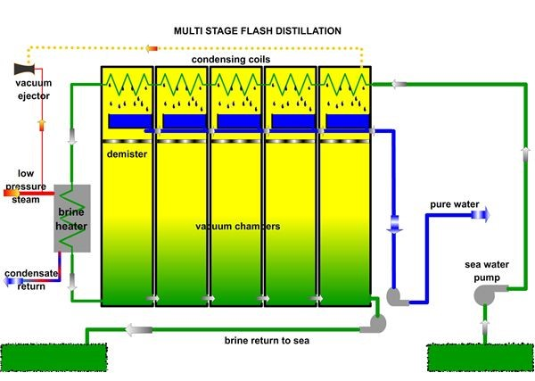
Fig. 2: Multi-stage flash distillation schematic [5]

Later hot brine enters the flash vacuum chamber. Part of the water evaporates instantly, because temperature of the water is higher than the boiling temperature at vacuum pressure. The steam rises to upper part of the container and when it contacts the condensing coils it condense to pure water. Salt and other forms of dirt remains at the bottom of the container. The steam ejectors allows to produce necessary vacuum in the containers for the process. The brine flows to the next container where process repeats. This is why the process is called multi stage flash distillation. Multiple containers makes the water a better product, since it is not possible to remove all salt in just one distillation process[6].
Energy requirement:
- Electrical energy for pumping the water.
- Steam energy for heating the brine.
Total energy requirement: 17 kWh/L In 2000 multi stage flash distillation produced about 60 % of all desalinated water in the world.
An example of MFS plant is shown in Fig 3. It displays the Jebel Ali plant in the United Arab Emirates can produce 2.13 x 109 L of water per day.
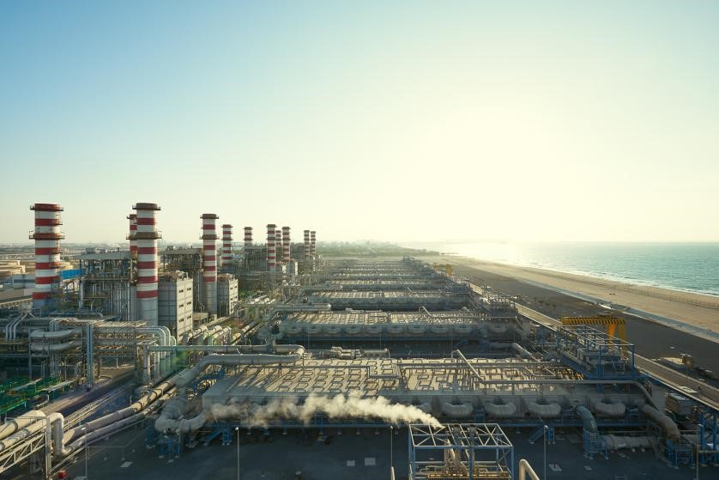
Fig. 3: Example of MFS Plant from United Arab Emirates [7]

Multiple-effect distillation (MED)
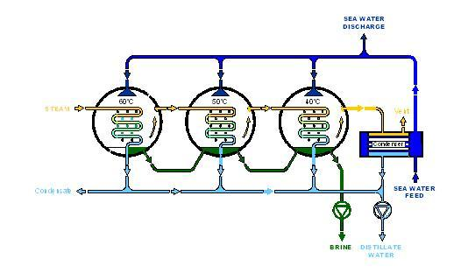
Fig. 4: Multiple-effect distillation schematic[8]

Multiple-effect distillation is a process which consists of several containers with decreasing levels of pressure and temperature. The one with higher pressure and temperature is first in the process and the one which is last, is maintained in lower pressure and temperature. In the container there is steam implemented to the system by tubes and to generate a temperature difference the sea water is falling down from the top of the container. This process allows the steam in the tube to condensate and at the same time seawater that has fallen partly evaporates and goes to the second container and process repeats with brine that has not evaporated. Since in the next container there is lower pressure and temperature it allows the water to evaporate more easily. This process is repeated in a series of “effects” as represented in Fig. 5 which displays the Multiple-effect distillation schematic

An example of MED plant is shown in Fig. 5. It displays the Tianjin Desalination Plant in China can desalinate 100 000 m3 /day.
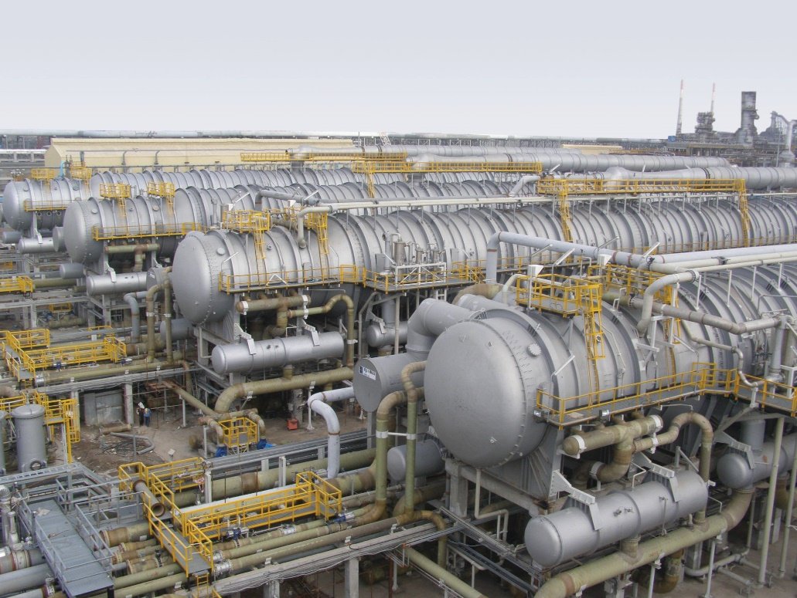
Fig. 5: Example of MED Plant: Tianjin Desalination Plant in China [9].

Vapor Compression (VC)
This kind of distillation is the third most common type of thermal desalination. In this process heat is delivered by compressed vapor. When water evaporates, heat is recycled back to the remaining feed water. This type of desalination is usually performed by a mechanical driven compressor or a blower. Fig. 6 displays the Vapor compression process schematic [10].
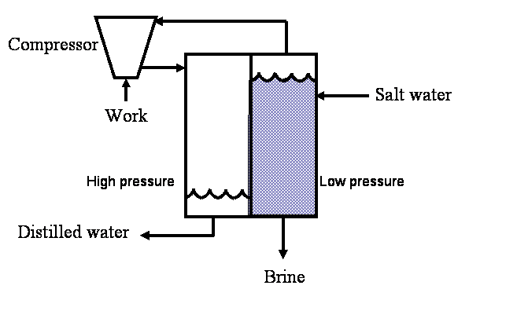
Fig. 6: Vapor compression process schematic.

      - Membrane desalination

Reverse osmosis (RO)
Reverse osmosis is different from the processes mentioned before. Reverse osmosis depends on a membrane technology. In this case a semi-permeable membrane is needed, which allows the process to remove ions, molecules and larger particles from the water. In reverse osmosis pressure is applied to the water and then through the membrane flows a 95 % to 99 % of clean water.
The kit looks easy to set up and it is powered by solar panel which allows system to work for over 10 hours while it only needs 4 hour to recharge the battery. Fig. 7 displays a reverse osmosis desalination process schematic.
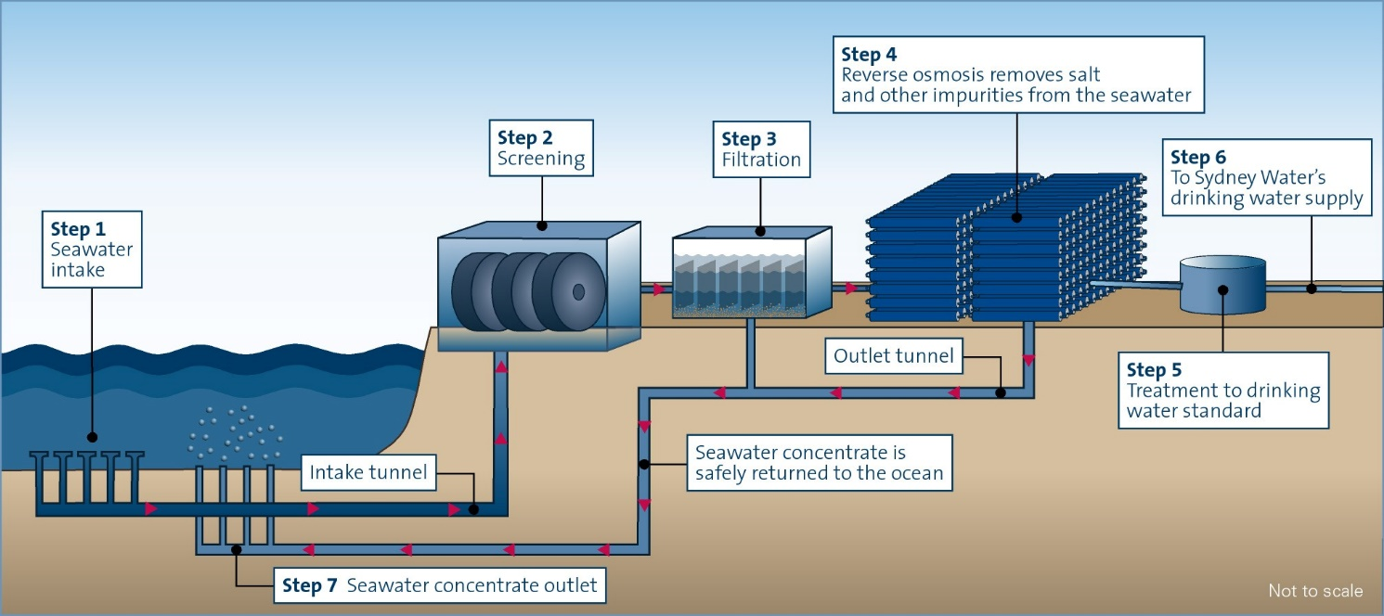
Fig. 7: Reverse Osmosis desalination process schematic [11].

Fig. 8 displays the Sydney desalination plant as an example, which can produce 500 million liters of water per day. It covers 15 % of water usage in Sydney. It won desalination plant of the year award in 2011.
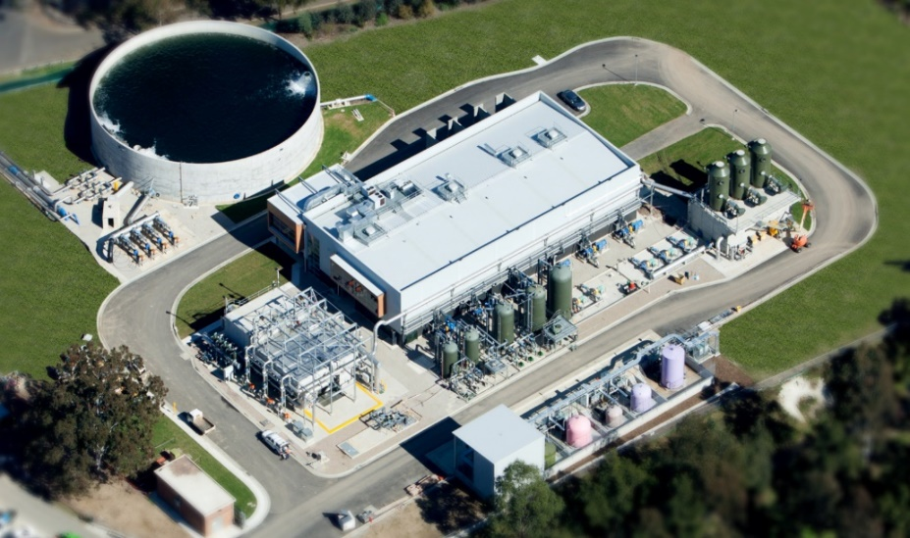
Fig. 8: Sydney desalination plant

A second example of an RO system is the Greenwater Kit. When Annika Johansson and Greger Nilsson realized that they had found their call. They started developing models and systems that could provide clean water for people in need in a safe and reliable way. Finally they invented Greenwater. Fig. 9 displays a Greenwater Kit.

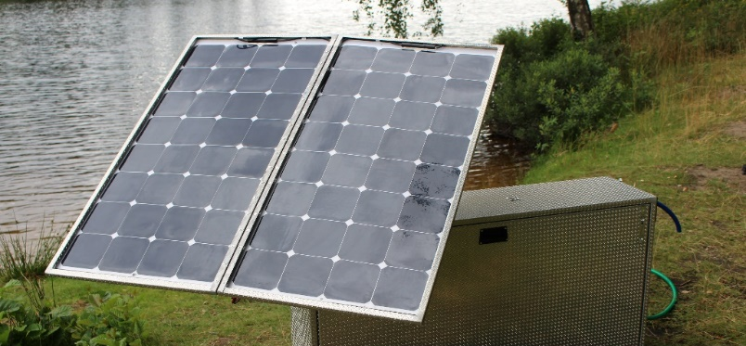
Fig. 9: Greenwater Kit [12]

Their system has incredible possibilities. They claim to deliver more than 100 - 800 (depending on the model) liters per hour of safe and good-tasting water.

Direct Contact Membrane Distillation (DCMD)
The system exists of one big container with a membrane vertically in the middle which divides the container in two parts. The left part is colored black, the right part is white with a cooling system inside. By providing the left part with saline water, the solar energy heats the container and let the saline water evaporate. The membrane has a lower temperature because of the cooling system in the right container. The second law of thermodynamics proved the heat transfer from high to a lower temperature. The vapor thus flows from the black side through the membrane into the white side. The cooling system lowers the temperature to condensate the purified water, which can after be collected. Fig. 10 shows the process.
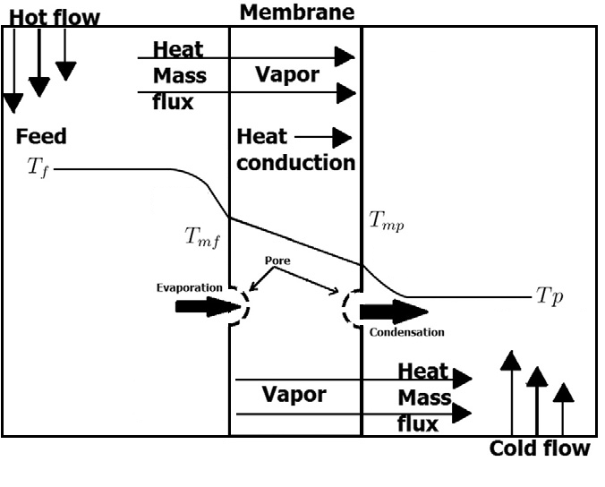
Fig. 10: Direct Contact Membrane Distillation Schematic[6].
The system provides a small-scale system and low cost comparing with the Vapor Compression system, but has an intensive energy consumption and membrane pore wetting. Hereby it is hard for the team to optimize this system without any knowledge of Chemistry. These shortcomings accordingly deselects this system for the project.

Water desalination techniques powered by renewable energy sources
Most of them are the same techniques, but the only difference is they are powered by giant solar panel plants, hydroelectric power plants or wind farms. There are also exceptions and one of them is idea of our project. In this part there will be shown some ways to desalinate water without using chemicals or chemical studies.

2.3.2.1 Simple water desalination (SWD)
The idea is simple, brine water is put in the bowl and in the middle there is a cup. Later small rocks are put on plastic foil in the middle, just a little above the cup to help the condensed drops to fall into the cup. The whole system must be in the sun to heat up the water, which will allow to evaporate and condensate. Because of the difference in temperature on different sides of the foil, it will condensate and drops into the cup. The simple water desalination system is shown in Fig. 11.
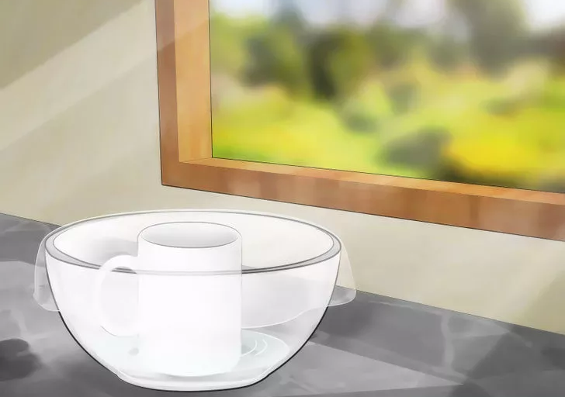
Fig. 11: Homemade Desalination System [13]

2.3.2.2 Our approach
Our approach is quite similar to the previous one. There is no membranes or compressors. It all depends on solar power which is heating the water inside the pentagon-based pyramid. Evaporation occurs by the heat transfer from solar energy to the inside of the system. Because the cover is colder than the inside of the system, the vapor condensates on the cover and flows down for finally being collected on the base of the container. Fig. 12 displays the solar desalination schematic.
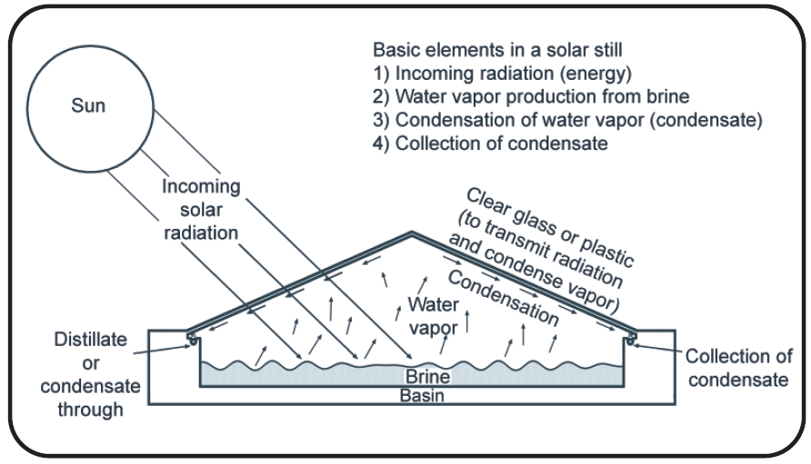
Fig. 12: Sustainable Desalination System[14].

2.3.3 Comparison
Table 2 shows the comparison between all the systems which are currently on the market [15].
Table 2: Comparison
 | Advantages | Disadvantages | Capital cost (USD/m³/d) | Operational cost (USD/m³)
MSF | 1. Low operating cost when waste heat (from power plant for example) is used for the process, 2. Quality of brine water is not as important as in the reverse osmosis technology, 3.leading technology for large-scale seawater desalination (used for 40 years, in 2000 was used in 60% cases) | 1. Requires larger space than other (RO) desalination plants, 2. Large amount of water is needed for production and cooling, 3. Requires large energy input if it is not using waste heat (from power plant for example), 4. Process is used mostly in Middle East where energy costs are not that high | 1200-3000 | 0, 7-1, 5 (with waste heat)
MED | 1. Very low electrical consumption (less than 1 kWh/m3; which is less than MSF or RO), 2. Has a low maintenance cost (only low pressure pumps to change), 3. Operates at low temperature (<70 ºC) to avoid corrosion, 4. Quality of water is not as important as in RO system | 1. High operating cost when waste heat is not available for the process | 1000-3900 | 0,4-0,8 (with waste heat)
VC | 1. Lowest cost comparing to the MSF or MED, 2. Smaller equipment needed for the process | 1. Maintenance on compressors and heat exchangers is greater than in MSF and MED, 2. High energy consumption | 1,000-1,300 | 0,5-1,2
RO | 1. Low energy requirements due to distillation without water phase change, 2. RO technology produces better water for cooking purposes, 3. RO filters are eco-friendly as they do not produce any chemicals, 4. Process removes 99% of bacteria and pyrogenic substances from the water | 1. Water is usually acidic (often below 7.0 pH), 2. Process removes most of minerals | 500-1200 (brackish water) 1000-2500 (sea water) | 0,2-1,2 (brackish water), 0,2-1,7 (sea water)
DCMD | 1. Very low operational cost, 2. good for using in laboratory | 1. High sensible heat loss, 2. not efficient as reverse osmosis | N/A | 0,01-0,04 (with waste heat)
SWD | 1. Easy to build for everyone, 2. Low operation cost, 3. Uses only solar energy, 4. Minimum space needed | 1. It is not good for larger-scale process, 2. Produces low amounts of water | N/A | N/A
Our approach | 1. Easy to implement, 2. Uses only recyclable materials, 3. Uses only power that comes directly from the Sun, 4. Does not need much space | 1. Cannot produce as much water as big desalination plants, 2. Sensitive for leakages. | N/A | N/A

Design
- The panel has a surface of 4 m² and a volume of 1.15 m³, calculated by the formula of a pentagonal (1) and (2)
$A= 5 . (z . H )/2$ (1)
$V=1/3 * surface area * height$ (2)
With z= 1,372 m and H= 0.86 m.
The shape of the design is used because this system must be applicable on the Wooden Dome from another EPS project of ISEP.
- Cardboard Model
The model is based on the experiment using a pyramid shaped glass with the salt water in the middle. The purified water will drop off the glass and will poor in the holes. This is seen on the picture Cardboard Model. This we did to catch up easy the purified water. The question is still how to get the salt out of the salt water container.
- The water that needs to go to the panel will be pumped with an aquarium pump
- To pour the purified water to the surface, a tube is needed.
Fig. 13 displays the Cardboard Model.
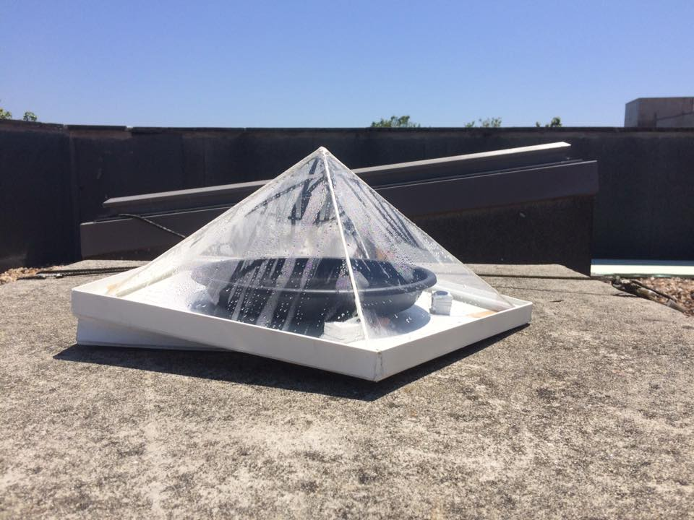
Fig. 13: Prototype

Conclusion
This chapter showed and described what desalination is and what the current desalination technologies are and how they work, what energy source they need, are they easy to implement etc. This part shows that there are many ways to desalinate water, but they are complicated and not as easy as they should be for ordinary people. In the next chapters, the methods and technology of the team will be shown and presenting the materials that will be used and explain the choices which were made.

Project Management
A management study is fundamental to obtain a successful project.
Management concerns first of all Time, Price, Quality for making a sustainable and efficient project. Next, providing an overview of the tasks division between the team members, release a better management. Moreover, it is critical to manage the risks which can occur during the project and how to keep the stakeholders satisfied.
All the running of the project is built on the project management.

Scope
Project scope is the part of project planning that involves determining the list of specific project goals, deliverables, tasks, costs and deadlines. In this section the scope of product and project are explained.
Product scope
The features and the functions that characterize our product are:
Creating drinkable water from seawater
Collecting salt from seawater
Using sustainable resources
Providing clear water to a dome structure
Project scope
To have a clear view of the different phases of the project, a progress matrix is needed. A work breakdown structure (WBS) is a technique to get a clear view of the scope. It is a diagram where the project is broken down in phases, which are broken down in deliverables. Tasks can be allocated to each deliverables if needed. The WBS of the Desalination project is shown below in WBS. During the semester, this matrix will help the team to not forget any of the following steps. Fig. 14 displays the WBS.
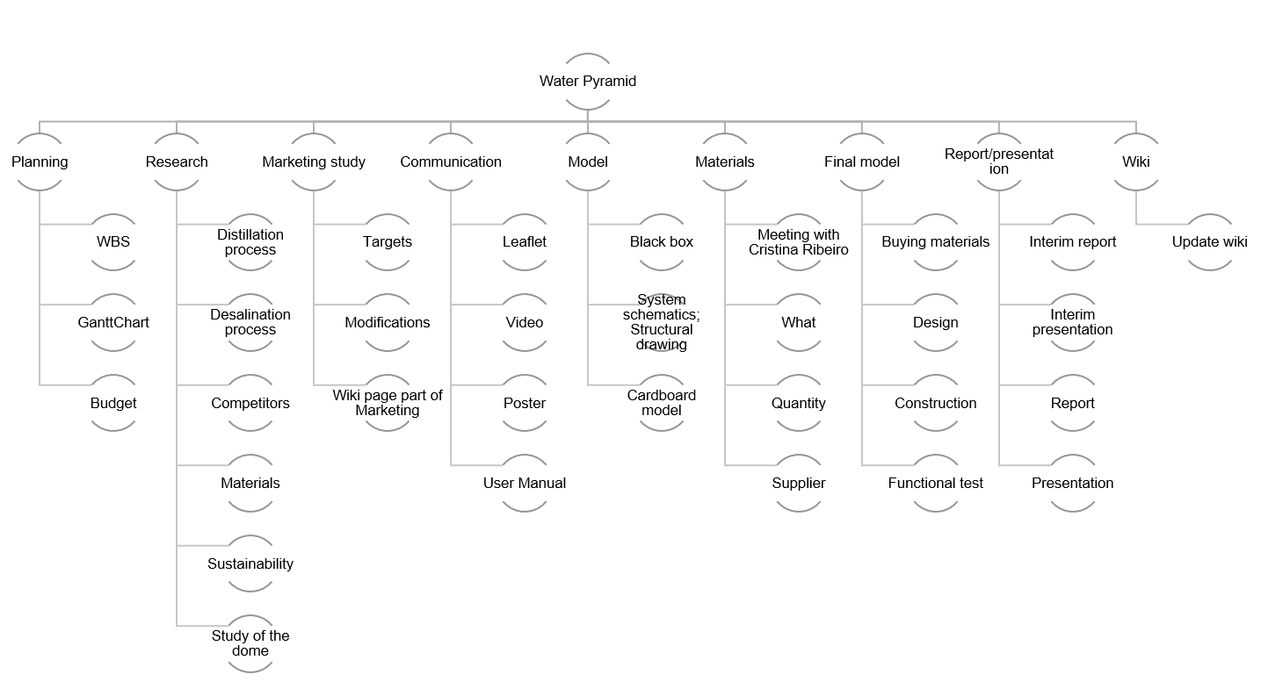
Fig. 14: Work Breakdown Structure

Time
An essential aspect of the project is Time Management.
Advantages of Time Management are:
- Stress reduction
- Sense of Accomplishment
- Pursuing other objectives
- Prioritization and efficiency
- Planning
The client needs deliverables at a certain deadline. It is very important to respect that. Here, the customers are the coordinators of the EPS program from ISEP. In the Table 3 shows the deliverables and their deadline are summarized:
Table 3: Deliverables
Deliverables | Deadline
Gantt Chart | 2016-03-08
System Diagrams and Structural Drafts | 2016-03-14
Cardboard scale model | 2016-03-29
List of Materials (what & quantity) | 2016-04-04
List of Materials (local providers & price - including VAT and transportation) | 2016-04-11
Upload the Interim Report and Presentation to the wiki | 2016-04-16
Interim Presentation, Discussion and Peer, Teacher and Supervisor Feedbacks | 2016-04-21
Upload refined Interim Report | 2016-04-29
Upload Functional Tests' Results | 2016-05-30
Upload the Final Report, Presentation, Video, Paper, Poster and Manual | 2016-06-11
Final Presentation, Individual Discussion and Assessment | 2016-06-16
Update the wiki with all correction suggestions, Hand in a CD with the corrected deliverables (source + PDF) together with all code produced to the EPS coordinator, Hand in one printed exemplar of the corrected report to the EPS coordinator | 2016-06-21
Hand in the prototype and user manual to the client, Receive the EPS@ISEP certificate | 2016-06-23
To help managing the deadlines, MS Project will be used to create the Gantt Chart. Different information is represented in the schematic: the tasks, the duration of tasks, the people attached to the task, deadlines, milestones and cost. In Fig. 15, the Gantt Chart is shown.
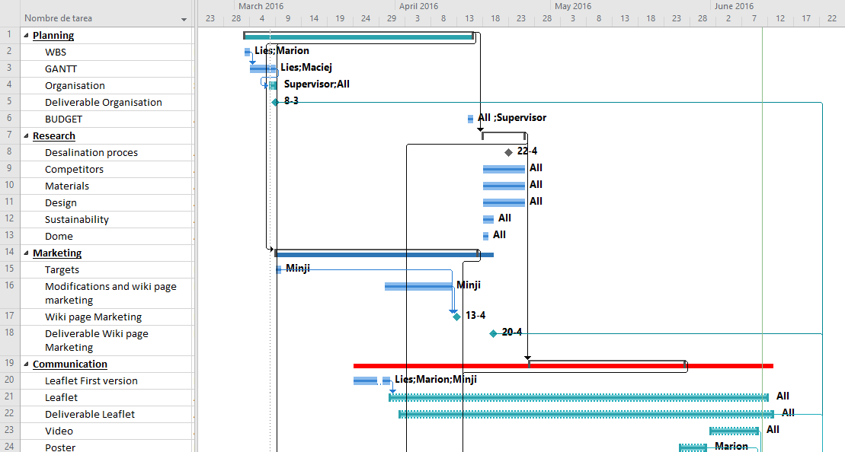
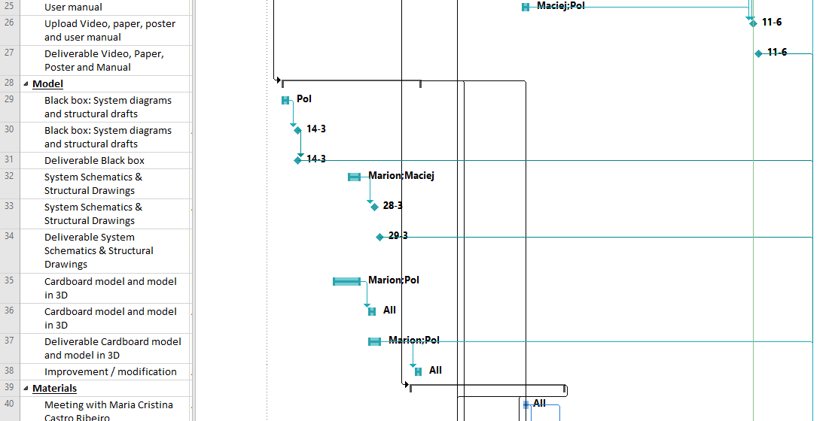
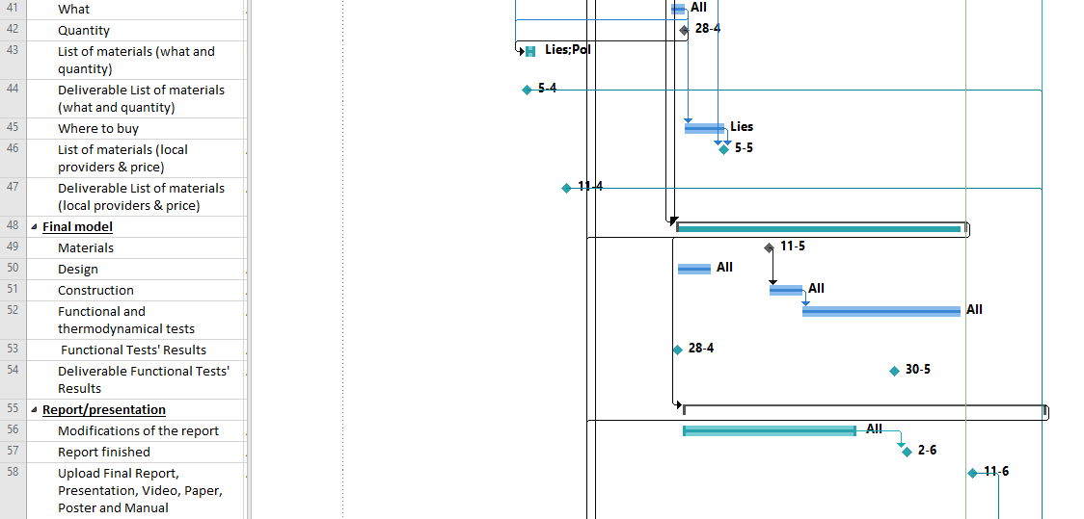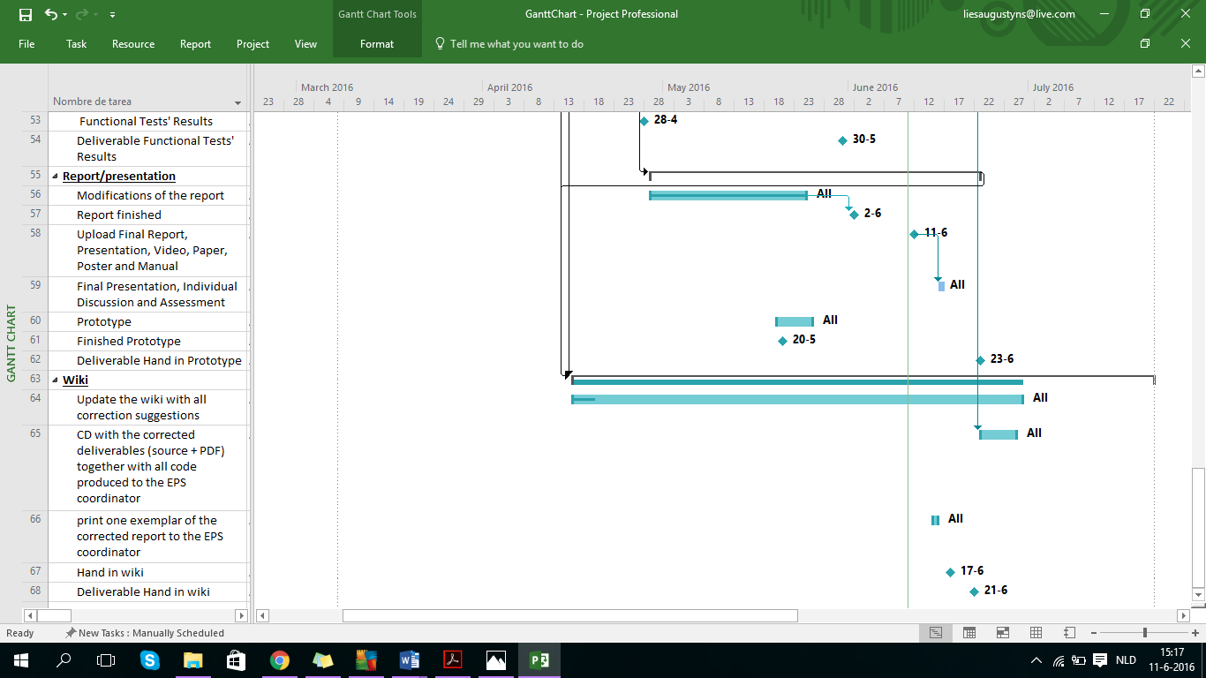
Fig. 15: Gantt Chart

Cost
The project has a budget limit of 150 €. It is necessary to implement a cost management in ability to control the budget.
Advantages of Cost Management are:
- Stress reduction
- Pursuing other objectives
- Prioritization and efficiency
- Awareness
There is a separation of costs. Work resource depends on time and Material resource has a fixed price.
To start, this is the summarized Table 4 of our electronic components, with the quantity and the price
Table 4: Cost electronical components
Component | Quantity | Cost [€]
Arduino Uno r3 | 1 | 17.39
Ultrasonic sensor | 2 | 5.51
Valve | 1 | 14
Water pump | 1 | 15
The Work resources and their prices are summarized in Table 5.
Table 5: Cost work resources
Resource name | Type | Cost [€]
Maciej | Work | 0
Marion | Work | 0
Min Ji | Work | 0
Lies | Work | 0
Pol | Work | 0

To finish, in Table 6 you will find the rest of the needed resources for the system, the materials, quantity, cost and suppliers.
Table 6: Material List
Components | Type | Material | Quantity | Cost per piece [€] | Supplier name
Pyramidal transparent covers | Material | PMMA | 2 | 30.75 | PLEXICRIL
Salt container | Material | PVC | 1 | 6 | LEROY MERLIN
Tube | Material | PVC | 1 | 2 | LEROY MERLIN
Container for purified water | Material | PVC | 1 | 2 | LEROY MERLIN
Junction cover/container | Material | Glue and molding | 1 | 6 | LEROY MERLIN
White base container | Material | Cardboard | 2 | 7.12 | LEROY MERLIN
Sticker Roll | Material | Sticker | 1 | 6 | LEROY MERLIN

Quality
For every project, quality is the proof of its success. In our time, consumers ask for quality and products working well for a long time. ISO 8402-1986 defines quality as the totality of features and characteristics of a product or service that bears its ability to satisfy stated or implied needs.
To manage good quality, you have to be aware of:
- Raw materials: it is important to check the degree of quality of our raw materials, because the final quality of our product will depend on them.
- Equipment conditions: it is essential to have a good equipment maintenance to keep a constant level of quality for our product. And do not hesitate to change some part which can generate quality troubles.
- Safety: The main dangerous aspect of our product is the glass material.
- Sense of details: obtaining a product with quality, it is important to think about every detail.
Our final deliverable is water. This water will be in contact with living beings, like humans or plants. If the quality of released water is not good enough, health issues could appear for plants or humans. Given its possibility, quality is a crucial point of this project.

People
The task allocations divides the tasks between the members of the team according to our knowledges and our desires. Even if each people is attached to one task, the team always work together to help each other at any time. Table 7 includes the different tasks and the people allocated to them.
Table 7: Task allocation
Phases | Sub phases | People
Planning | WBS | Lies; Marion
 | Gantt chart | Lies; Marion
 | Budget | Lies; Marion
Research | Distillation process | Team
 | Desalination process | Team
 | Competitors | Maciej; Min Ji
 | Materials | Team
 | Sustainability | Lies; Pol
 | Study of the dome | Lies; Marion; Pol
Marketing study | Targets | Maciej; Min Ji
 | Modifications | Maciej; Min Ji
 | Wiki page part of Marketing | Maciej; Min Ji
Communication | Leaflet | Lies; Marion; Min Ji
 | Video | Maciej
 | Poster | Lies; Marion; Min Ji
 | User Manual | Pol
Model | Black box | Pol
 | System schematics; structural drawing | Lies; Marion; Pol
 | Cardboard model | Lies; Marion; Pol
Materials | Meeting with Cristiana Ribeiro | Team
 | What | Team
 | Quantity | Team
 | Supplier | Team
Final Model | Buying Materials | Team
 | Design | Team
 | Construction | Team
 | Functional Test | Team
Report/ Presentation | Report | Team
Wiki | Update wiki | Team

By using the RACI matrix. It will be clear how the task allocation is managed. Every task can have a Responsible team member, an Accountable team member, a Consulted team member and an Informed team member. These variables means:
- Responsible: This person is responsible for this part of the project (this task). He/she will make the task with help if needed.
- Accountable: The team member is responsible of the final result of the task. If the task is not managed well at the end. The Accountable and the responsible are to blame.
- Consulted: This person can be consulted or can give advice if needed.
- Informed: The team member is informed about the task when the deadline arrives.
The RACI matrix of team 5 is made in Table 8
Table 8: RACI matrix
Phases | Sub phases | Lies | Maciej | Marion | Min Ji | Pol
Planning | WBS | A | C/I | R | C/I | C/I
 | Gantt Chart | R | C/I | A | C/I | C/I
 | Budget | A/R | C/I | A/R | C/I | C/I
Research | Distillation process | A/R/I | A/R/I | A/R/I | A/R/I | A/R/I
 | Desalination process | A/R/I | A/R | A/R/I | A/R/I | A/R/I
 | Competitors | C/I | A/R | C/I | A/R | C/I
 | Materials | A/R/I | A/R | A/R/I | A/R/I | A/R/I
 | Sustainability | A/R/I | C/I | C/I | C/I | C/I
 | Study of the dome | A/R/I | C/I | A/R/I | C/I | C/I
Marketing study | Targets | A/R | C/I | A/R | C/I | C/I
 | Modifications | A | C/I | R | C/I | C/I
 | Wiki page part of Marketing | A | C/I | R | C/I | C/I
Communication | Leaflet | A | C/I | R | R | C/I
 | Poster | R | C/I | R | R | C/I
 | User Manual | C/I | A | C/I | C/I | R
 | Video | C/I | A | C/I | C/I | R
Model | Black box | C/I | R | C/I | C/I | A
 | System schematics; structural drawing | I | C | R | C | A
 | Cardboard model | I | C | R | C | A
Materials | Meeting with Cristiana Ribeiro | C | C | C | C | C
 | What | R | C/I | C/I | C/I | A
 | Quantity | R | C/I | C/I | C/I | A
 | Supplier | R | C/I | C/I | C/I | A
Final Model | Buying Materials | A | A | A | A | A
 | Design | A | A | A | A | A
 | Construction | A | A | A | A | A
 | Functional Test | A | A | A | A | A
Report/ Presentation | Report | A | A | A | A | A
Wiki | Update wiki | A | A | A | A | A

Communication
Communication within a group is the key for an efficient work. To have a good communication, you have to pay attention to the codification of the message, to be sure that the message is understood by the two actors: sender and receiver. It's important to speak the same language, to use the same technical definition, to be aware in order to codify the message, to respect the cultural issues, etc., if you want to avoid failure inside your communication system. This Communication system can be summed up with the diagram in Fig. 16.
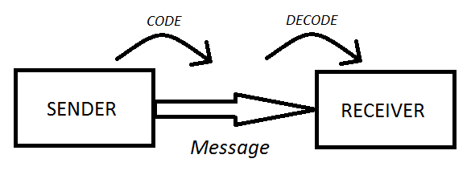
Fig. 16: Communication System

There are two main ways of communication the team adopted:
Face to face
Every week, the entire team meets to make the balance sheet of the project: Goals, decisions, evolution, solving problems, etc. Even by allocating the different tasks of the project between all the members, most of the time all the team worked together to exchange easily information, questions and always have a mental support.
Internet
At the beginning of the project the team created a Facebook group. In this group the team shares all the files and plans all the meeting. While working at home the Facebook group was an easy and fast way to communicate in case of doubts or any practical questions. To conclude one of the strengths of our group is communication. All team members are really focused on having a good and fast communication and it has absolutely been not a problem. The Communication Matrix in
Table 9 sums up our communication strategy.

Table 9: Communication Matrix
 | What | Who | How | When | Why | To whom | Code
1 | weekly team meeting | team | meeting | every Wednesday | developing project | team | English, orally, Facebook
2 | weekly supervisor meeting | team | meeting | every Thursday | confirm | supervisors | English, orally, Wiki
3 | interim Report | team | wiki page | 16/04/2016 | to get external advice, to inform | supervisors and professors | English, text, wiki
4 | interim presentation | team | Prezi, orally | 21/04/2016 | to introduce our project | supervisors, classmates, professors | English, orally
5 | final Report | team | wiki page | 11/06/2016 | to show the project | supervisors and professors | English, text, wiki
6 | final presentation | team | Prezi, orally | 16/06/2016 | to introduce our project | supervisors, classmates, professors | English, orally
7 | printed exemplar of the report + Deliverables | team | printed version | 21/06/2016 | to complete our project | supervisors | English, text, CD
8 | the EPS@ISEP certificate | EPS coordinator | paper | 23/06/2016 | to certificate our EPS | team | English, text
9 | Wiki page | team | Wikipedia | always accessible | to show the project | everybody | English, text, wiki

Risk
According to ISO 31000, risk can be defined as the effect of uncertainty on objectives. Risk management is the identification of the risk itself, its effect and searching for a solution to avoid these effects. The risks that occur during a project can be related to the product/system itself (system risk) or the making of (external and internal risks). External risks are risks that are not foreseen, the team needs to be aware of these risks. Internal risks can be avoided by the team if they are handed with accuracy and with justice. The risk management table is seen in Table 10 [16].
Table 10: Risk analysis
Risk ID | Description | Cause | Effect | Trigger | Response | Owner | Last review
Internal risk
1 | Non-functional teamwork, misunderstandings between team members | Bad communication, delays, bad or unfinished work, no progress | Scope: Fix the misunderstanding; Time: depends on the issue; Cost: a lot of working hours | team bonding | 3. Restarting communication, redistributing the task, applying team building measure learned | x | x
2 | Non-respect of the delays/deadlines | unforeseen events that occur | Scope: Not being ready for deliverables, Time: the duration of the delay, Cost: working hours + extra hours | reminding everyone of the deadlines | 2. making extra hour, asking for an extension | x | x
3 | physical wounds | scissors, knives, boxes with external pins | Scope: heal the injure ;Time: half hour until a week depends on the injure; Cost: medical treatments | working with patience and with care | 1. Go to the hospital2. Work with patience, put hands not in the line of the cutting knives. 3. Use the knives as few as possible. | x | x
External risk
4 | Customer changes his requirements: The product and its property change, modification of all the project | the purpose of the previous requirement are not satisfying enough | Scope: adjust the design, Time:2 weeks, Cost: buying new materials | carefully listening what the consumer wants | 2. adjusting at the best, being reactive/creative | x | x
5 | Material does not fulfil our satisfaction | Bad quality | Scope: Check the quality of the material we buy , Time: delivery time of new material, Cost: the cost of new material | Check quality before buying | 2. Negotiating with the supplier, having backup supplier plan | x | x
System risk
6 | Non optimal working of the system: Heat is not sufficient | Bad weather | Scope: using other systems to get heat Time: time to install the heating system, Cost: heating system and working hours | waiting, working , plugging in the heat system, optimize the system | 2.Provide heat by an another way | x | x
7 | Electronic system failure | Arduino failure | Scope: desalination will be impossible; Time: process will stop and wasting time to fix the problem; Cost: Worst case scenario is replacing the Arduino, this cost could be 20 €, Short circuit | Make test before selling/using it | 1. Mitigate – back up Arduino | team | x
8 | Leak in the pyramid:, the process will not work | not working by detail | Scope: evaporation will be hard, Time: buying and putting a new PMMA cover, Cost: buy a new triangle PMMA and working hours | leak | 2. having tight seal and resistant materials | team | x

Procurement
Procurement management is an area of logistics that is responsible for the equipment, goods and raw materials available for the team/project. It is necessary for those purchase sourcing raw materials from suppliers to provide the team to work sustainable. Providing the project with goods on time, with optimized quality for a good price as pointed out in Fig. 17.
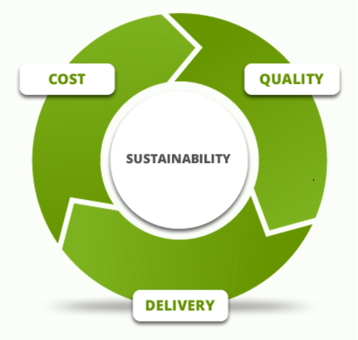
Fig. 17: Procurement
To fulfill the procurement management the team must undertake the following steps:
1. Identification of need: It is important to clearly identify the good and services needed. One mistake in this step can induce loss of money and delay on the project. The list of materials are shown in the deliverables.
2. Qualified suppliers: To make a sustainable project, finding sustainable suppliers is essential. The analysis of the sustainability of the suppliers is including in chapter 5. Eco-efficiency Measures for Sustainability
3. Delivery: Throughout the delivery process, the materials must be checked based on time, quality and cost. Our materials will be provided nearby Porto.
4. Analyzing results: Analyzing the results based on used materials and energy consumption is necessary to complete the project and to improve what is needed [17].

Stakeholders management
The project is influenced by several people, the stakeholders. These are anyone who has power and/or is interested in the project. For this project team members, supervisors, professors, the school itself, suppliers and future clients are the stakeholders. All the expectations of these stakeholders must be fulfilled. Stakeholders can be divided into four categories.
- Those with high power and interest in the project, are the people who have to be managed closely.
- Those with high power but lack of interest, are the people who has to keep satisfied.
- The ones with low power but with a high interest must be kept informed.
- Others are people with low power and interest in the project but still can influence the project. These are monitors.
All the stakeholders must be kept satisfied. They all have an impact in developing the project. Those with high power must be kept satisfied. Stakeholders from category 1 and 2 have a high influence on the project. They say if some things can be or can’t be done. Those with a high interest must be kept informed. Stakeholders from category 3 and 4 want to know all about the developing of the project. All stakeholders and their influence is seen in
Table 11 [18].

Table 11: Assessment
 | Who | role | can influence | is influenced | expectations | Power | Interest | stakeholder strategy
A | Augustyns Lies | Team member | yes | yes | High | High | High | Managed closely
B | Kang Minji | Team member | yes | yes | High | High | High | Managed closely
C | Milesi Marion | Team member | yes | yes | High | High | High | Managed closely
D | Pogoda Maciej | Team member | yes | yes | High | High | High | Managed closely
E | Valls Aguila Pol | Team member | yes | yes | High | High | High | Managed closely
F | Cristina Ribeiro | mean supervisor | yes | no | High | High | High | Managed closely
G | Benedita Malheiro | head of supervisors | yes | no | High | High | Medium | Managed closely
H | Other supervisors | supervisors | yes | no | High | Medium | Medium | Managed closely
I | Professors | teaching | yes | no | High | Medium | Medium | Keep Informed
J | ISEP | Financial and provide us everything to make the project | yes | no | Low | High | Low | Keep satisfied
K | Suppliers | Providers of the material | yes | no | Low | Low | Low | Monitor
L | Future clients | Buyers of the system | yes | yes | High | High | High | Keep satisfied
M | Home town school | scholarship, they give the ability to go on EPS | yes | no | High | High | Low | Keep satisfied

The project stakeholders can be seen with their rate of power and interest in the project. This can all be visualized in a stakeholder map.
Fig. 18 displays a stakeholder map dividing the 4 categories by a rating from low to high.
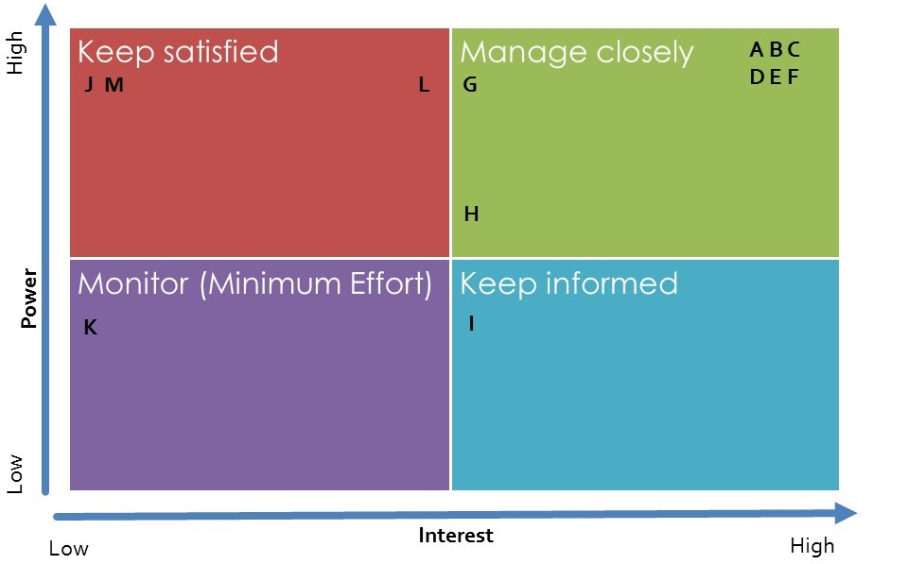
Fig. 18: Stakeholder Map

Conclusion
A project management part is essential to start a project. This management makes a clear overview of the proceeding of the project. First Time, cost and quality are outlined. Communicating and finding out how people are involved in the project are elucidate in several parts of the project management:
- People
- Communications
- Risk Management
- Procurement
- Stakeholders’ management.

Marketing Plan
In this chapter, there will be explanation about our product market analysis, micro environment and macro environment, potential customers, segmentation, strategies, marketing mix, product, price and promotion. Taking into account these things team will provide optimal marketing plan to sell a product.

Introduction
Marketing is operating activities that enterprise provides products and services to customers for profits. The goal of enterprise it to develop products or services which will satisfy the customer need through marketing activities and after that they make their profits from that. Marketing plan is important, because it includes a product, price, place and promotion. In addition it is a formal document in an organization which explains the necessary actions to achieve its marketing objectives.
In this chapter the product will be analyzed. After that, team will mention the product in terms of marketing by analyzing our potential customers, setting up marketing strategy and considering the marketing means.
Table 12 displays necessary actions to achieve marketing objectives.
Table 12: Marketing Objectives
Section | Purpose
Executive Summary | Presents a quick overview of the plan
Market audit | External and internal analysis
SWOT analysis | Strengths, weaknesses, opportunities and threats
Objectives | Define the company’s objectives
Marketing strategy | Segmentation, targeting and positioning
Marketing mix | Product, Price, Place and Communication, including digital marketing strategy and loyalty strategy
Action programs | Present information of detailed actions
Budgets | A projected financial plan
Controls | Indicates how the marketing plan is monitored

Market Analysis
Fig. 19 displays the marketing environment.
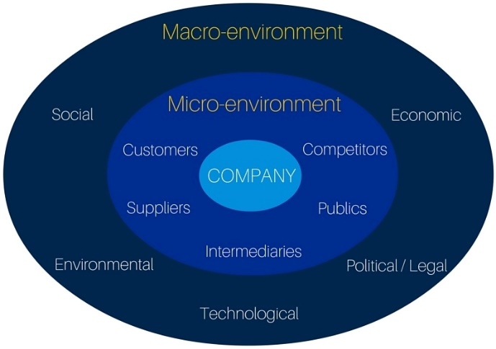
Fig. 19: Marketing Environment
Marketing environment surrounding the company can be divided into two parts: the immediate area “Micro-Environment” and the uncontrollable area “Macro-Environment”.
  - Macro-Environment
“Macro-Environment” has factors or elements in an organization's immediate area of operations that affect its performance and decision-making freedom. It includes social, environmental, technological, political/legal and economic environment.
    - Social
Countries, people and companies try to find ways how people can save water and use that efficiently, because of increasing of water shortage. Among them, for water desalination, California conducts 2 desalination projects and Pakistan starts desalination project which is delayed before. Also companies, for example POSCO Energy in Korea, are promoting desalination. However, sometimes desalination projects are failure like New York's project. That means that water desalination projects are not always viable. So each country and city has to consider about their conditions. If our products were provided, countries and companies would have interested in not only big scales of projects but also small scale of projects. In addition, they could find other solutions from our product.
    - Environmental
95% of current water desalination is being made up fossil fuels. On the other hand, our product operates with sustainable technology: solar panel. This means it doesn't use substances that generate pollution like fossil fuels. And its body is made of recyclable polymers such as PVC, so our product can be used after the end of life.
    - Technological
Features of developed product is that it utilizes simple principles.
It gathers drinkable water by using evaporation and coagulation of the liquid.
People can stop or operate the product by using the simple button operations.
We can exchange container or parts easily through upper side of product.
Additionally, the system is automatically controlled so the elderly and young children can easily use the product who have difficulty in learning new operations.

    - Political/Legal
The feature of our product is able to create drinkable water from unusable water by using sustainable energy: solar energy. It is the way that create something from nothing and also can save the energy. If countries try to encourage people to use our product, they could get more ECO- friendly advantages. When the government give the legal benefits, such as tax cuts, to people who think about environment and try to save the energy, they will choose more Eco-friendly way even they take little inconveniences.
    - Economic
When people use our product, they don't have to utilize products that use electricity like water purifier. Users don't need to pay the energy bills because our products are operated by solar power. So they can save their money and obtain economic profits from them. Also government are able to make extra energy for preventing energy shortage because the usage of energy will decrease.
  - Micro-Environment
“Micro-Environment” has major external and uncontrollable factors or trends that influence an organization’s decision making and affects it strategy and performance. It includes customers, suppliers, intermediaries, public, and competitors.
    - Customers
Before starting the paragraph of customers, it is important to mention that our product will be part of “Dome Shelter.” But the project is only for “Water Desalination”. So in this part, this product will be described separately from “Dome Shelter”.
Customers defined as groups that purchase a company's goods and services. Our targeting customers are governmental institution, refugees (like Africa or Near East) and for private customers (people living on water, boaters, eco-lovers and surfers who live near by the beach)
Governmental institution
If water shortage happened because of natural disasters like drought, the governmental institution have to conduct policy about using water (like California in 2014). If they provided our product to people, institutions don't need to suppress the water use to public property like grave and also offer new product to people for water conservation.
Refugees (like Africa or Near East)
The refugees that need real help like African countries are low on water, have no rain or have lots of useless water like muddy water. By using our product, people who live in that area don't need to go far away for getting fresh water. They just can get drinkable water easily from our product and muddy water.
People living on water, boaters, surfers who live near by the beach
There are a lot of water around people who live on water, berth their boat on the river for living and live near by the beach. But they don't get useful water easily. Our product can make drinkable water from a lot of water resources with sustainable energy and solar panel will work well, because they live relatively open space.
ECO-lovers
Eco-lovers will have interest in our product for sure, because they love “ECO” life and our product can produce drinkable water without using fossil fuel which generate pollution. They also will find out another ways to help environment by using our product. It will help the environment get better.

    - Suppliers
Suppliers defined as groups that provide resources needed to produce goods and services, important link in the “value delivery system”. In creating our product, transparent pyramid is needed for the upper side, pump for moving seawater, Arduino for controlling our desalination system automatically, polymer container for gathering purified water, etc. Materials cannot be bought just in Portugal, so team will produce the product by finding the materials that have most suitable qualities and supplier which will provide reasonable price.
Arduino and Pump used for aquarium will be provided by professors. Transparent pyramid and polymer container will be chosen from a supplier which will provide a reasonable price for those materials.
    - Intermediaries
Intermediaries defined as groups that help the company to promote, sell and distribute its good to final buyers like resellers. Personal selling for selling strategy can be also applied, but it has disadvantages that takes so much time and is the most expensive promotion tool. Therefore, our products are likely to be sold or shared through intermediaries. For example, it can be shared by agencies, such as UNICEF for helping people who need help. Additionally, our products are going to be sold camping company like Decathlon or Big market like CONTINENTE.
    - Publics
Public is defined as groups that have an interest in or impact on an organization's ability to achieve its objectives. We try to explain the purpose and environment-friendly features of our product, people will consider about our product and can catch our intention. Maybe our product could be introduced by social groups; Greenpeace, NGO for environment, WWF, and Friends of Earth because their ideas support such a sustainable project. They not only focus on protecting the earth and wild but also they are oriented sustainable society. If our product is introduced by these organizations, then our team can build good relations with people also obtain favorable publicity and build up a good corporate image.

    - Competitors
Competitors defined as groups that serve a target market with similar products and services. There are currently three similar products on the market.
First, team needs to confirm that a designer already produced a product that has similarities with our product. His name is Gabriele Diamanti and he is a freelance Industrial Designer, based in Milan. His product name is “Eliodomestico” and it is a solar household still for the developing countries. This product is only for developing countries, but there are so many characters which can be considered. Eliodomestico also uses seawater and Eco-friendly, but it doesn't need electrical control system, just only operate with solar energy. It can produce maximum 5 l per day and it makes more drinkable water than existing things that produced 3 l per day on average. Also it is easy to maintain and also good impact on the local economy.
Second, the product name is “Fontus”. This is invented by a motivated team composed of young members of different disciplines such as industrial design, electrical engineering and business. The feature of Fontus is harvesting water from the air. The earth's atmosphere contains unexploited fresh water. This product attempts to discover these resources. It is also good for who need water in the hard condition such as hikers. It has many similarities with our product, but we have to consider some things. It uses solar panel and it also is invented to bring alternative way of collecting safe drinking water or regions where drought and unclean water are a big issue, but it has specified use for bike and it is not big enough for our target customers. Our main target need huge water for their life and drinking water and it has to combine with vehicles or people. That means this product needs some movements to operate, but our product is easier, because it just can be installed where the customers want. Our customers don't need to run or ride a bike for getting drinkable water and Fontus needs specific conditions; groundwater is scarce but air humidity is high. Our project don't need that conditions to work. It just needs non-drinkable water, sun, and our product [19].
Fig. 20 displays the Eliodomestico and the Fontus
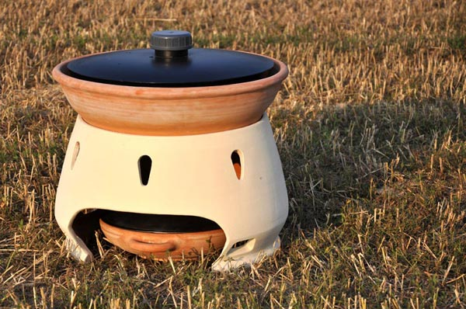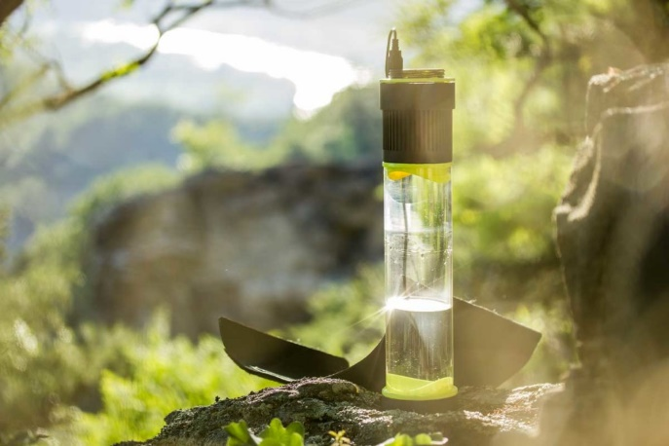
Fig. 20: Products currently on the market

Third, it is the straw make contaminated water safe to drink. The name is “Life straw”. It looks like thick cylindrical like normal straw. It uses Guinea Worm filters to produce purified water. It is quite commercialized; more than 64 countries use this product and so easy to use; just put the Life straw the surface of water and there are many types of Life straw; made of polymer, metal, combined with bottle. This product can remove almost bacteria, protozoa and viruses that can contaminate water. It doesn't need electrical power, batteries or replacement parts. But it cannot remove salt and cannot be used on seawater, ocean water, or brackish water. But our product can be utilized for everyone even who want get purified water from seawater. And it also could be frozen and lower temperature can freeze and crack the filter. It is so critical point, because for Life Straw the filter is the most important part for getting purified water and it also has specific customers for hikers, campers, travelers and other outdoor enthusiasts. But this product cannot remove chemicals of water in their natural surroundings. This project uses evaporation, so there is no threat about chemical pollution. Users also has to clean or replace the filter. It is bothersome and makes additional cost to use the product. But our product just has to remove the remained salt in the container, and that is all [20].
Fig. 21 displays the Life Straw
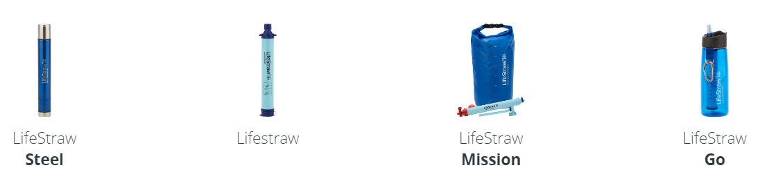
Fig. 21: LifeStraw

SWOT Analysis
A SWOT analysis is a structured planning method that evaluates four elements of a project/a business/a product. Picturing the Strengths, Weaknesses, Opportunities and Threats in a matrix gives a proper view of the four aspects. The SWOT reminds us to be careful for the Weaknesses and Threats and to use the Strengths and Opportunities to grow.
- Strengths are attributes of an organization or product that is helpful to achieve the objective.
- Weaknesses are attributes of the organization or product that is harmful to achieve the objective
- Opportunities are external conditions which are helpful to achieve the objective.
- Threats are external conditions which could do damage to the business’s performance.
The SWOT analysis of our project is given in the picture below. They are more important positive arguments then negative, what gives a higher opportunity to grow in the project.
Fig. 22 displays the SWOT analysis of our project. They are more important positive arguments then negative, what gives a higher opportunity to grow in the project.
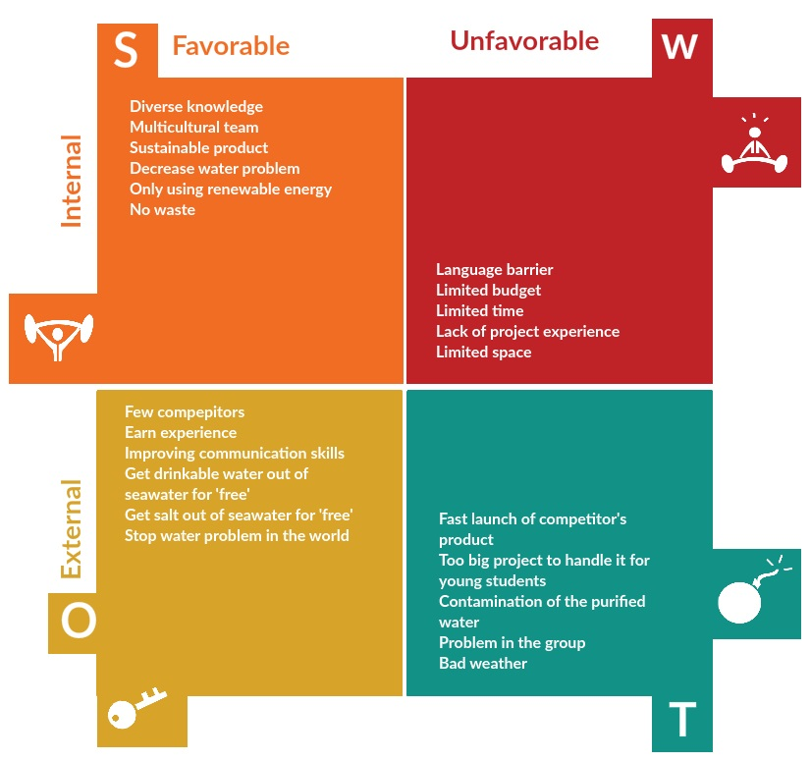
Fig. 22: SWOT Analysis

Strategic Objectives
Fig. 23 displays the Marketing strategy planning process
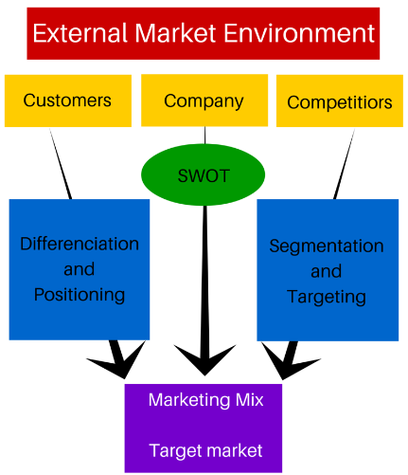
Fig. 23: Marketing Strategy Planning Process
Uncertainty and competition have increased significantly and effective marketing is essential for survival and prosperity. When producing products, companies have to think about 5 things: SMART.
S (specific): Details exactly what need to be done.
M (measurable): Achievement or progress can be measured.
A (Achievable): Objective is accepted by those responsible for achieving it.
R (realistic): Objective is possible to attain. (important for motivation effect)
T (timed): Time period for achievement is clearly started.
The most important objective for the team is that the product is made perfectly for commercialization. When the first version is developed, next step will be easier. When our product develop more and more, perfection will increase and the potential customers appear who want this product. Additionally, our team is able to sell our product based on our knowledge that we learned in the classroom. If project team could work with a team to manufacture and sell the product, higher sales could be achieved. Because our processes are accurate, so those are recorded using computer programs. When the product is produced, it is made by precise calculations. The documents are recorded and saved in the computer, therefore all the calculations can be checked in direct, fast, and convenience way. Our goal is to produce the machine that can make drinkable water from non-drinkable water. When our project semester is over, all of the results will be recorded in Wiki. Our project is in progress throughout the semester (approximately 5 months). In this period, everyone will learn about the overall technical knowledge and practical knowledge related to everything with their products.

Segmentation
    - Segmentation concept
Concept is dividing markets into smaller segments that can be reached more efficiently and effectively with products and services that watch their unique needs. Requirement for effective segmentation
Measurable: Size, purchasing power, and profiles of segments can be measured.
Accessible: Segments can be effectively reached and served.
Substantial: Segments are large or profitable enough to serve.
Differential: Segments are conceptually distinguishable and respond differently to different marketing mix elements and programs.
Actionable: Effective, programs can be designed for attracting and serving the segments.
Market segmentation
Market segmentation is for those things:
- Identify bases for segmenting the market.
- Develop segment profits.
    - Levels of market segmentation
Table 13 displays the marketing segmentation.
Table 13: Marketing Segmentation
Segmentation | Definition
Mass marketing | Same product to all consumers (no segmentation, e.g. Coca-Cola: at one time)
Segment marketing | Different products to one or more segments. (some segmentation, e.g. hotels)
Niche marketing | Different products to subgroups within segments (more segmentation, e.g. standard of luxury SUV's)
Micromarketing | Products to suit the tastes of individuals and locations (complete segmentation)
Marketing strategy | Segmentation, targeting and positioning
Marketing mix | Product, Price, Place and Communication, including digital marketing strategy and loyalty strategy
Action programs | Present information of detailed actions
Budgets | A projected financial plan
Controls | Indicates how the marketing plan is monitored
Our product is applicable to Niche marketing because our products set specific users e.g. country, company, and some people in strong need of purified water.

Geographic segmentation
Among the target Customers, there are refugees (like Africa) and people living on water, boaters, surfers who live near by the beach. They are good for explaining the geographic segmentation.
First of all, the refugees that need real help like African countries are low on water, have no rain or have lots of useless water like muddy water. By using our product, people who live in that area don't need to go far away for getting fresh water. They just can get drinkable water easily from our product and muddy water.
Secondly, there is a lot of water around people who live on water, berth their boat on the river for living and live near by the beach, but they don't get useful water easily. Our product can make drinkable water from a lot of water resources with sustainable energy and solar panel will work well, because they live relatively open space.
Demographic segmentation
Our product's operation is so easy and electrical systems are controlled automatically, everyone can utilize our product. This product is related with essential component: water. So we will develop our product can be used everywhere that water is present.
Psychographic segmentation
Users can reduce their stress from obtaining purified water in the hard condition by using our product. By obtaining a more purified water, they will be able to release their thirst and further maintain the cleanliness of their surrounding and environment. Then their surroundings will get better and they will try to find a way to improve their quality of life.
Behavioral segmentation
Users use our product are able to get purified water continuously, they will feel satisfaction and be existing customers. Also they automatically do promotion to our potential customers. That situation will help us increase sales. Or publics find that some people's hard condition get better, they will have interested in our product and it can be transferred get more profits from regional or global interest.

Strategy/Positioning
How to deploy a long term marketing strategy is innovative and its aim is continuous improvement. The width of the expansion is to be integrated and be most suitable adjustments, be sure to configure all marketing functions. Marketing strategy involves a three-dimensional deployment of analysis, the whole of the things of the most appropriate strategy, organizational strategy to find the opportunity. To develop these strategies, there have a lot of relationships with non-marketing companies, namely human resources, accounting, etc.
Product's positioning for market is the way the product is defined by consumers on important attributes. And product is compared with competing products simplifies the buying process by helping consumers organize products into categories.
Market must:
- Plan positions to give their products the greatest advantage in selected target markets.
- Design marketing mixes to create these planned positions.

Fig. 24 displays the positioning strategy of our product.
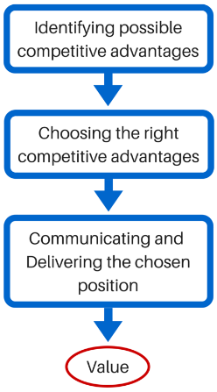
Fig. 24: Choosing a positioning strategy
Competitive advantage is extent that a company can position itself as providing superior value to selected target markets.
Referring to the competitors, there are several products that have similar objectives to us, are made utilizing the evaporation principle. But their features, designs, intentions that designer want to tell people are little bit different with our product. And this appears very big difference between their product and ours in the end. Our product includes the intention or characteristics of other products that already present on the market in general. Our product is able to drinkable water from non-drinkable water. User can be anyone who want to utilize the product. Users don't have to put the product outside because every processes are achieved in the house and the roof. There is no need to carry our product out for using that. When these features compared to other products, our possible competitive advantage is “Product differentiation”.
Our product is able to get drinkable water and household water from non-drinkable water. When our product is combined with the dome, their position is the roof, so there is no limitation of space. Once the installation is complete, users don't need to change some parts additionally, so it is economical compared to other products. People can obtain water by using natural principle even in areas which is difficult to get water in hard conditions. When other people spend the money for buying water, our customers are able to cost for that. Given these aspects, our product's right competitive advantage is “Profitable”.

Adapted Marketing-Mix
Fig. 25 displays the Marketing mix
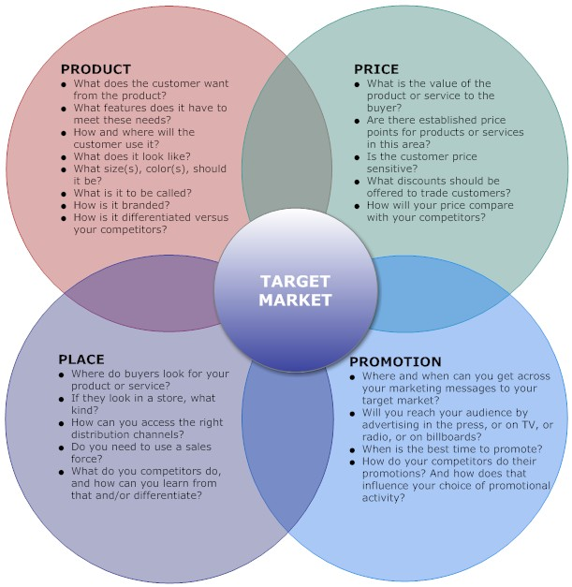
Fig. 25: Marketing Mix
Defining our marketing mix is essential to establish the company's strategic position and to being able to connect with the right audience. The marketing mix consists of 4 parts: price, place, product and promotion. They are 4 fundamental things company should define in order to reach a certain target audience.
    - Product
Fig. 26 displays the levels of products
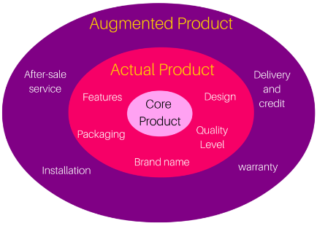
Fig. 26: Levels of products
A product is anything that can be offered to a market for attention, acquisition, use or consumption and that might satisfy a want or need.
    - Product Attributes
Our product will be produced with a high quality in order to perform fully the advertise itself. It should also be a priority to stability when it is installed in combination with the dome at the top. Appearance is to be consider a situation in which the product can be damaged by weather factors, such as wind or rain. So it has to be designed in optimal conditions. In addition, a top angle for obtaining the purified water efficiently should be set through calculation. Because even though the product is safe, if the efficiency was low, it could be useless. Inside of the product, customers are unavoidable to do manual operation because of removing salts, the product is located in ceiling, so product has to be designed in easy and safe way for eliminating salts. For example aged people or children, it is hard for them to remove salts from ceiling because the weight of salts are heavy. Then the height of salts will be higher, the system will be controlled automatically and the system doesn't work anymore. Eventually they cannot get enough purified water even they have our product. Compared with competitor's products, noticeable difference is that our product is available with automatic controls. We have to appeal this feature and encourage to potential consumers to purchase. The design of appearance is very simple. Due to the feature of the product, upper side has to be satisfied the conditions to receive the sunlight well and inside container which is for sea water, should be able to obtain and preserve the heat well. Therefore, we will use a material for upper that can receive heat but also cool the heat well, such as glass, container that holds the sea water will be painted in black to receive and preserve heat well.
    - Product Branding
Fig. 27 displays our product's logo
Fig. 27: Product's logo
By branding our product, we can tell a story, provide legal protection and help segments market. Our team has to concentrate on printed information appearing on the product: labelling. Because labelling can identify product or brand, describe several things about the product and explain how to use our product with simple graphics.
  - Price
Table 14 displays the internal and external factors that determinates the price of the product.
Table 14: Price Factors
Factor | Features
Internal factors | Marketing objectives, marketing mix strategy, cots, and organizational considerations.
External factors | Nature of the market and demand, competition, and other environmental factors. (e.g. economy, resellers, government, social concerns)
In aspects of cost, fixed costs needs to be considered that they don't vary with sales or production levels and variable costs that do vary directly with the level of production, such as raw materials. From that costs, total costs can be got. Sum of the fixed costs and variable costs for any given level of production as well.
Also team will use “Market penetration.” Market penetration is a pricing strategies that setting a low price for a new product in order to penetrate the market quickly and deeply. It can attract a large number of buyers and win a larger market share. The refugees that need real help like African countries have thin water are also our customers, so we cannot set a high price for our product. Also when the price is high, governmental institution cannot provide so many people because of their limited budget.

  - Place
Distribution channel needs to be considered. Distribution channel is set of independent organizations involved in the process of making a product or service available for use or consumption by the consumer or business user. Why marketing intermediaries used because that results from their greater efficiency in making goods available to target markets. In addition, offers the firm more than it can achieve on its own through the intermediaries; contacts, experience, specialization and scale of operation. Our product is likely to be sold or shared through intermediaries. For example, it can be shared by agencies, such as UNICEF for helping people who need help. Additionally, our product is going to be sold camping company like Decathlon or Big market like CONTINENTE.
  - Promotion
Fig. 28 displays communication mix of our product
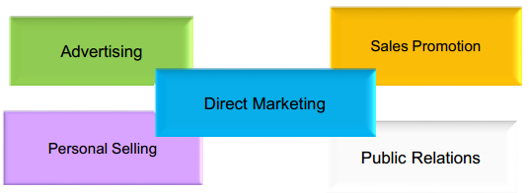
Fig. 28: Communication Mix
With integrated marketing communication, the company carefully integrates and coordinates its consistent and compelling message about the organization and its products.
    - Setting the overall communication mix
Table 15 displays our crew.
Table 15: Types for selling the product
Type | Feature
Advertising | It reaches many buyers, repeals message many times, impersonal, and expensive.
Personal selling | Personal interaction, relationship building. Most expensive promotion tool.
Sales promotion | Wide assortment of tools, rewards, quick response, effort short-lived.
Public relations | Very believable, dramatize a company or product, and underutilized.
Direct marketing | Nonpublic, immediate, customized, and interactive.
According to the customer's characteristics of our product, appropriate form of advertising will be chosen and public relations as communication mix. By advertising our team can appeal our message directly too many potential customers even is expensive. When team uses public relations, good relations with people can be build and also obtain favorable publicity, building up a good corporate image. Website, news, special events, written materials, and etc. will be used as well.
    - Digital marketing
Nowadays many people use social network system like Facebook. They can access many and varied information through that. So our using Facebook page will be good to promote our product. So our team created Facebook page “Pyramid Water” for our product. Also customers can ask something to us through this page. Our team will progress some events to attract customers. People will press 'good' button or share our product to their acquaintances. Also our team will choose some winners randomly and later gifts (such as our product) will be provided by our team. Potential customers are going to be interested in our product to get our product for free. In addition they can access the useful knowledge like discount information. Our team also will sell our product at offline stores, if our product will be sold by using digital marketing tools like that, sales rate will increase and it will produce benefits.

Budget
For creating our product, budget must be created by comparing and analysis many suppliers. Before the budget will be prepared, it is important to have an overall understanding of the expected goals and objectives that are to be accomplished with the budget. The raw materials have to be carefully considered, because our team has the limited budget: maximum 5000 euros for communication actions.
Table 16 displays the Budget for communication actions.
Table 16: Budget Communication Actions
Contents | Income | Expenditure | Balance
Retain fee | 5.000 € |  | + 5.000 €
Flyer |  | 200 € | - 4.800 €
Poster |  | 300 € | - 4.500 €
Advertising on Google |  | 1000 € | - 3.500 €
Events for Facebook page |  | 1.800 € | - 1.700 €
Advertising on Newspaper |  | 500 € | - 1.200 €
Advertising on TV |  | 1.200 € | - 0
Total |  |  | 0 €

Our team set the price of our product is 149.9 € by applying “Left-digit Effects” for our product. This strategy targets potential customers who are too sensitive to changes in the price list first digit. So if we set the price for 149.9 € instead of 150 €, sales rate will be increased, because that price makes people induce to buy more. Also our team will spend money for advertising on Google, Newspaper and TV. Prices for advertising are different each other because means are different. Also flyer and poster will be made additionally. Our team operates the Facebook page “Pyramid Water”. By using this, our team will progress some events to attract customers like providing our product for free to potential customers who like our page or product [21].

Strategy Control
Marketing control is an important function of marketing. Using suitable controls, any omission in marketing and plans could be detected and corrected to direct it towards the marketing objectives and goals. Marketing control provides the means of testing whether desired goals and results are actually being achieved or not. Control involves measurement, evaluation and monitoring. Resources are scarce and costly so it is important to control marketing plans. Control involves setting goals, measuring performance, evaluating performance, taking corrective action. If corrective action is taken, an investigation will need to be undertaken to establish precisely why the difference occurred.
Fig. 29 displays the marketing control process
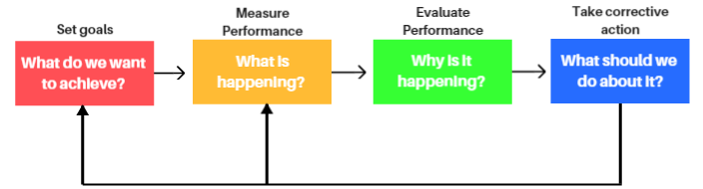
Fig. 29: Marketing Control Process
The purpose of this project is to make drinkable water from undrinkable water. Furthermore, our product would contribute for social and environmental improvement. If our team would sell the product for our profits, it might not be considered about setting target customers and environmental component, such as using sustainable technology. People will be of the intent and purpose through our products. Our team cannot do measure performance and evaluate performance about marketing parts itself, because the product is not completed and commercialized yet. Our product is manufactured and commercialized. First of all, product will go through a number of tests and trials before production is completed. For example, the angle of upper cover required to gather the purified water is very important, because product should get the sunlight and also cohere the water drops. Our team have to do many experiments for finding the optimum angle, because 100 % of efficiency is possible to achieve only through theoretical calculations. If our product is commercialized, our team have to find intermediaries and need our own marketing tools. Many different strategies for our product will be developed. After that our team can get optimum marketing plan.

Conclusion
To summarize this chapter, marketing is not just “selling a product”. It has to be considered by the external environment such as social, economic, environmental, technological, and political/legal. Additionally, internal environment such as customers, competitors which is including how to sell product. Team has to plan a marketing strategy of the product through analyzing the strengths, weaknesses, opportunities and threats. Also by establishing segmentation, clients can be found more efficiently and effectively, because product and services will comprise their unique needs. Then our team analyses the characteristics of the product and set up the place where our product will be sold, sales promotion and the product price. Our team has to decide the production and budget by considering the budget given to us. After that, the product will be introduced into the market.
Next chapter, presents the Eco-efficiency Measures for sustainability regarding the Water Pyramid.

Eco-efficiency Measures for Sustainability

5.1 Introduction
Nowadays the Sustainability is seen as a global concept. Water resources are a key element in sustainable development, the largest share is agriculture, followed by industry and households. The growing future needs will show the already serious shortfalls in investment, as well as other weaknesses such as poor sector efficiency and inadequate prices. The three main elements of sustainable development are environmental, economic and social. These three elements are explained and applied to our product, in this chapter of the report.[22]

5.2 Sustainable development
Sustainable development can be defined as a development that meets the needs of the present without compromising the ability of the future generation to meet their own. The three main elements of sustainable development are economic, environmental and social. To get sustainable development, the following three has to be combined:
- Social and environmental can be defined as Bearable
- Social and economic can be defined as Equitable
- Economic and environmental can be defined as viable
Fig. 30 displays the three main elements, and what it generates, when we mix them, as we explained before:
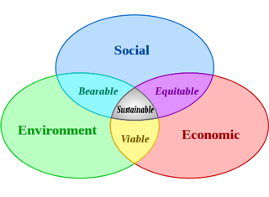
Fig. 30: Sustainable main elements
There are several indicators to measure sustainable engineering to get data from a country, product or business. Examples of this measuring area:
- SOCIAL: HDI (human development index), SMI (social progress index), Happy Index
- ECONOMIC: GDP (gross domestic report)
- ENVIRONMENTAL: Ecological footprint
All combined into one index is seen as most equivalent to measure the sustainability is the GPI (genuine progress indicator). This indicator has 26 factors: 11 for social, 9 for environmental and 6 for economic. Examples of measurements from the GPI are: Income Distribution, resource depletion, pollution, long-term environmental damage. The GPI's value is given in dollars [$]. The main challenge to obtain a high GPI is:
- Provide more value with less environmental impact.
- Disconnect the growth of the welfare of the use of material resources.
- Improve the economic and ecological efficiency.

5.3 Environmental
A sustainable product, from an environmental perspective, has to take into account these three main ideas:
- For renewable resources, the rate of harvest should not exceed the rate of regeneration (sustainable yield).
- For pollution, the rates of waste generated from projects should not exceed the assimilative capacity of the environment (sustainable waste disposal).
- For non-renewable resources, the depletion of the non-renewable resources should require comparable development of renewable substitutes for that resource.
If the product doesn't accomplish this, it won’t be environmentally sustainable.
The purpose is making drinkable water from seawater by using raw material and sustainable energy (only solar energy) without environmental pollution.

5.3.1 Process
To obtain an eco-friendly system, the Pyramid water system has to:
- Saves energy and use renewable energy for the production. The Pyramid water system uses energy from the sun to heat the water and release the evaporation of the brine.
- Integrates design, the concept, called Design for Assembly (DFA), is to minimize the product cost, by minimizing its design. If a product has fewer parts it will take less time to assemble it, thereby it will reduce the costs.
- Respects the Design for Disassembly (DFD) concept. This methodology must be implemented to speed the disposal process. Using this method of disassembly at the beginning of the design phase and promoting, it will allow for parts to be recycled easier at the end of the product life .
- Moreover, the team doesn’t have to use a lot of paper, the manuals, and other documents do not need to be printed out by sending your workplace communications to the email inbox, you can reduce your environmental impact.

5.3.2 Pollution Control
The pollution can be in a coordinated form or process of making land, water, air, dirty and not safe or suitable, using substances that help this process happen. To make the project environmentally sustainable, the team will have to follow a pollution control.
In the Pyramid water process, the team will:
- Adopt environmental responsible activities. A lower level of waste off energy and resources of the product will make it more efficient.
- Select recyclable materials for the product design. Give me 5 will choose materials that can be reused and recycled with the lowest cost, taking into account which are the best for the design. The goal is to develop a product in the most efficient way that possible, and reduce the non-environmental product quantity used.

5.4 Economical
Economic sustainability is the most elusive component of the triple bottom line approach. There is a universal consensus that businesses must be economically sustainable: economic growth, the quality of the system and the amount of selling product matters. The product will be made only with components coming from Portugal and also 100 % of the system will be manufactured in this country. This will help to reduce the cost of transportation, which is the generated pollution, and also increase the employment rate of Portuguese people.
For the water pyramid ecological footprint, it’s important to:
- Reduce water and electricity consumes during the system construction.
- Transport the system in only one box to reduce the space needed. The box will contain a manual to help the consumer using the system.
- Have components which will be as ecological, recyclable, long lasting, qualitative and efficient as possible for a reasonable price.
- Manufacture the product with production methods and technologies focusing on sustainable production.
- Collect the salt from the sea water, to re-use it for another utility, or maybe sell it.
Manufacturing practice is seen in two different stages. First of all, to manufacture the product, the team will work with the “6R” (reduce, reuse, recycle, recover, redesign, remanufacture). Afterwards, in the process, the team should have to optimize the technological improvements. The work will be focused on energy efficiency, waste reduction, practices to improve the environment and reducing contamination impacts .
The aim is to create a desalination plant for a dome, focusing on economic development and environmental protection simultaneously The team will achieve this goals by choosing the materials and methods of production that are more adequate, taking in count the relation between price and quality.
To resume, the Pyramid water is economic sustainable because there is a minimum of water and electricity consuming. The systems collects salt from the sea and the whole system is made with recyclable and long lasting materials.

5.5 Social
Social Sustainability is defined as “the ability of a community to develop processes and structures which not only meet the needs of its current members, but also support the ability of future generations to maintain a healthy community“.
The product has to be compliant with the customers’ needs. The keywords for this aspect of sustainability are social justice and human dignity.
At first, the product must be defined as eco-friendly. It won't only give benefits in terms of knowledge and a fresh point of view for the employees. It will also provide to our employees’ common way of thinking and it is reflected unconsciously in the personal and professional development. By making them feel better, they will work better.
The second aspect to consider is to take care about the suppliers. The strong values of the team reflect that Give me 5 is involved in the change and this is how they can work for the progress of society. The suppliers are expected to pass a minimum of requirements to be part of the mission. So a previous analysis and study of the suppliers can help to improve the project and adapt to new ideas or requirements, always by keeping sustainability in mind.
Finally, a familiar relation with the users helps to ensure a strong union between them and the company. The company is not only about selling and making a profit, it is about satisfying the users' needs. User service well implemented with social skills and helping with our eco-friendly product provides a better user company relation.

5.6 Life Cycle Analysis
A life Cycle Analysis is the analysis of a product system for assessing the potential environmental aspects and potential aspects associated with a product by undertaking four steps: compiling an inventory of relevant inputs and outputs, evaluating the potential environmental impacts associated with those inputs and outputs and interpreting the results of the inventory and impact phases in relation to the objectives of the study.
ISO 14040.2 Draft: Life Cycle Assessment - Principles and Guidelines
Fig. 31 displays the phases of life cycle analysis
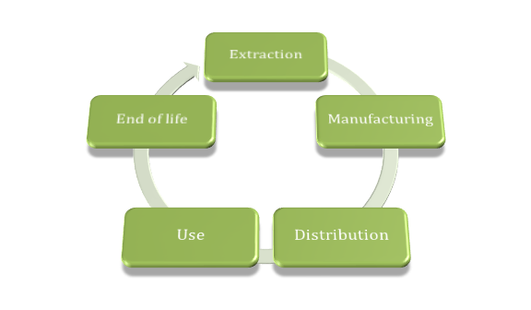
Fig. 31: Life Cycle Analysis Diagram

5.6.1 Extraction of Raw Materials
Analysis and quantification of the main components for the desalination process will be reviewed thoroughly, highlighting which raw materials, energy and resources are used throughout the production and transportation processes. All chosen Material can be seen in point 3.3 Cost. When buying all materials the sustainability of the company must be at a high level.
The LCA of the materials is:
1. PMMA is a versatile, durable, recyclable and sustainable material.
- PMMA is a light but strong material. This may have an influence on the weight the dome can bare.
- PMMA had a long lasting lifetime. Approximately 10-20 years.
- PMMA has an optimal recyclability. It can be melted and extruded into a new product of PMMA.
Furthermore, it can be easily split back into its original monomer MMA of heat transfer, and reused again for other purposes.
2. PVC is made of oil and salt. Nevertheless, oil is a non-Eco-friendly material. The magnitude of CO2 emission of the material is lower than aluminum, glass and other petrochemical products. Furthermore the PVC has a long lifetime of over 15 years and is 100 % recyclable
3. Glue and molding
By using molding, the PMMA can still buy recycled into MMA and PMMA. The water resistant glue for PVC is most of the time not eco-friendly. It can contain bad chemicals and it’s hard to recycle. But we are still going to use glue because the design needs not a lot of glue. And after using the project. It is easy to dissolve the glue and the recycle the other products
The materials used in the system are:
PMMA (polymethylmethacrylate), this product will be used instead of glass for different reasons:
- It’s lighter.
- It’s less dangerous because it breaks, without splintering, so it is especially handy for easily breakable crystals large dimensions.
- It can easily adopt any form. It can be colored easily. It’s more transparent.
- It has a high impact resistance, about ten times more than glass
- PVC, will be used instead of copper in tubes for different reasons :
- It’s less corrosive.
- It has a lower price.
- It doesn't mix any particles with the water, because there isn’t corrosion.
- It allows a uniformity in the complete system looking for materials
PVC, instead of glass, in purified water container for different reasons:
- It has excellent functions for a lower price.
- It’s lightweight
- It’s resistant to humidity.
- It’s inert and harmless, and allows the conservation of organoleptic water properties, for human consumption.
- It has a chemical stability. The material prevents decomposition.
- It’s insensitive to oxidation and corrosion

5.6.2 Design Process
After looking some different designs, we found the unique design of the desalination plant, which will be manufactured with the minimum of environmental impact. When the team will design the product, members will try to reduce the quantity of material, reduce the energy used building, and also provide the pollution production. All design process is made by computer software, this will reduce the waste of paper if some changes have to be done and also shows the model in 3D.

5.6.3 Manufacturing and Production
In this process the team will try to produce the materials to build the desalination plant, using less materials, as possible, reduce the waste and emissions on the manufacturing and use the least energy, or resources to generate the product.

5.6.4 Packaging and Distribution
The distribution plan for the product from the manufacturing warehouse to the final user is to minimize the transport and packaging emissions. Give me 5 plans to produce the materials to build the desalination plant, put it inside a box, and send it to the customer, with one employee that will build the structure. The idea is to design a transport box which will use less space to be transported in an easy way besides it will be a support for the safety of the materials. The best route has to be found in terms of time, cost, environment, and safety of distribution.

5.6.5 Customer Maintenance
The team will provide the product with a user manual to instruct the users. The user manual includes an on-line service link and a phone number to help the clients if they cannot solve on their own.

5.6.6 End of Life
The end of life includes the recycling of the product. Once the user decides that the product is it hardly damaged, the team will offer the possibility to take care of the environmentally correct recycling.
ISO 14040 Environmental management. Life cycle assessment. Principles and framework. Genève, ISO, 2006. ISO 14044 Environmental management. Life cycle assessment. Requirements and guidelines. Genève, ISO, 2006

5.7 Conclusion
As a resume, the goals are must be eco-friendly and energy independent by only using the energy of the sun, it has to provide the energy to work. The team has a strong value of environmental aspect, however, it has to work on economic and social aspects too, to allow the Water pyramid to arrive in all of the different markets we can arrange. The team gives a high value on this topic. The sea water users will use, must be turned into purified water to make sure the clients have access to use it.
Also the team can use the salt extracted from the sea water, to use it to cook, or other utilities. The salt is a common product, and it can be got while the system obtain purified water, without wasting energy, non-producing any pollution, and any additional cost to the process.

Ethical and Deontological Concerns

6.1 Introduction
In this part, the Ethical and Deontological Concerns of our project are exposed [38].
In one hand the Ethical concerns are the doubts or problems that can appear in every project. The responsible has to determine, in the way that affects to the people, if it’s a wrong or a good thing. On the other hand, the Deontological concerns are the Part of ethics which deals with the duties, especially those which govern the professional activity, like the duty to the community, to the employer, to the client, to the profession and to the colleagues.
In the Kant’s categorical imperative about deontology, we can find this: “Act only on that maxim through which you can at the same time will that it become a universal law.” Ethics and deontological issues concern everyone and have their place in each society, exactly as it should be in the middle of each project.:
The five ethic and deontological concerns which will be developed for the Pyramid Water are:
- Engineering Ethics
- Sale and Marketing Ethics
- Academic Ethics
- Environmental Ethics
- Liability / Responsibilities

6.2 Engineering Ethics
Engineering ethics is about the rules of engineering ethics that you always have to apply in a project. Being an engineer means to have responsibilities. Their decisions impact the environment, the society and the company. Therefore, this field is governed by some practices of engineering according to a code of ethics.
The engineering ethics study is focus on choose a code of ethics, describe the guidelines considered and make a critical review.
For the Water pyramid, the AAWRE code is chosen (American Academy of Water Resources Engineers). This code contains the standards of good practices for an engineer but also specifications about water resources. This code is perfectly adapted to this project [23].
These are the objectives of the AAWRE:
- Identifying and certifying engineers with specialized knowledge in water resources for the benefit of the public.
- Recognizing the ethical practice of water resources engineering at the expert level.
- Enhancing the practice of water resources engineering.
- Supporting and promoting positions on water resources issues important to the public health, safety and welfare.
- Encouraging life-long learning and continued professional development.
Looking at the objectives of the AAWRE code, Give me 5 make the choice to focus on « Recognizing the ethical practice of water resources engineering at the expert level » and « Enhancing the practice of water resources engineering ». These objectives are about respecting the engineer profession in our work and behavior, but also respecting the water resources of this word.
These are the fundamental principles of the AAWRE code of Ethics:
- Using their knowledge and skill for the enhancement of human welfare and the environment.
- Being honest and impartial and serving with fidelity the public, their employers and clients.
- Striving to increase the competence and prestige of the engineering profession.
- Supporting the professional and technical societies of their disciplines.
All the fundamental principles of the AAWRE code are important and the team chose to respect and apply them all. Their represent the prestige of this profession and all the concepts that the team chose to respect the day when all of us chose to become engineers.
These are the fundamental canons of the AAWRE code of Ethics:
- Engineers shall hold paramount the safety, health and welfare of the public and shall strive to comply with the principles of sustainable development in the performance of their professional duties.
- Engineers shall perform services only in areas of their competence.
- Engineers shall issue public statements only in an objective and truthful manner.
- Engineers shall act in professional matters for each employer or client as faithful agents or trustees, and shall avoid conflicts of interest.
- Engineers shall build their professional reputation on the merit of their services and shall not compete unfairly with others.
- Engineers shall act in such a manner as to uphold and enhance the honor, integrity, and dignity of the engineering profession.
- Engineers shall continue their professional development throughout their careers, and shall provide opportunities for the professional development of those engineers under their supervision.
Among all this canons, « hold paramount the safety, health and welfare of the public and shall strive to comply with the principles of sustainable development in the performance of their professional duties » and « act in professional matters for each employer or client as faithful agents or trustees, and shall avoid conflicts of interest » are the most relevant points for this project and the most important concept for the group.
During all the different steps of the project, all the team will respect this engineering code of ethics, but some points are more important than others for this project.

6.3 Sales and Marketing Ethics
Sales and Marketing ethics is about the relationship between the company and the clients. Nowadays, a lot of company are so interesting by making profit and winning money that they stop respecting their clients. In other words, they used the trust of their clients and advertising to dupe them and their rights. This selfish principle maybe increase at the beginning the sales but at the end that enroll the loss of credibility of the company and the dissatisfaction of the client. Moreover false advertising or disclosure of risks can be dangerous.
The sales and marketing ethics analysis is focus on trust and credibility and consumer rights.
In our project the choice to be completely transparent and honest with our clients was taken to create a sustainable relationship based on trust. The objective is to make true and efficient advertising and to propose a quality product. If this two actions are well done, all our customers will buy the expected product and be impressed by its utilization, so become faithful clients of the company.
Moreover, « Give me 5 » took the decision of establishing the price according to ethical considerations. The prices are not fixed yet, but the profit of the company will be chosen according to the work provided for the project, the price of the raw materials, and the clients. To resume, the company will make profit of the system, but not an unreasonable profit. The goal of the group is not to make profits of others but help the people to access to clean water. The price will be fair, rewarding the work supplied and allowing people to buy it.

6.4 Academic Ethics
Academic ethics is about respect and honesty in your work. It worries that people steal the ideas or sentences of other and used them as its own. This practices are unfair, not respectable and should be banned. At the opposite, if you respect your sources always declaring them, you can enrich your work and putting forward the work of other people through your project.
The academic ethics analysis is focus on inaccurate information or forging documents, plagiarism and cheating.
For this project, all the team was inspired by different sources and information to make the project realistic and efficient, but always in the respect of academic ethics. Sources could be books, articles, internet website, thesis and etc., but all sources used are summarized in the bibliography at the end of the report.
According to this principle, the conclusion is that the project doesn't represent any Academic Ethics issues.

6.5 Environmental Ethics
Environmental ethics is about the relationship between humans and environment. It worries that men do not conflict with the development and evolution of natural beings. Indeed, all the product has a certain impact on the environment and it’s essential to manage and decrease this impact for the well-being of the next generations and the planet. Human projects have to be always in accordance with the nature instead of damage it.
The environmental ethics study is focus on the project’s impact on the environment, the environmental risks and the sustainability of the project.
The water pyramid needs energy to evaporate the water and the only energy used to heat the water is the solar energy. This energy is unlimited and sustainable, without any impact on the environment. For the materials, two different plastics are used, Perspex and PVC. The both are easily recyclable so without any impact on the environment as well. The system contains also some rocks from Portugal.
According to the different below information, we can conclude that the project doesn't represent Environmental Ethics issues.

6.6 Liability
There exist four kind of liability: Legal, Crime law, labor and professional liabilities.
For the pyramid water, we can have potential Legal, Crime law, and professional liabilities.
Criminal Liability
The criminal liability can be resumed by different steps:
- Typification: Is the crime a law? The crime must be written on the law
- Illicit: is it an illicit action or not? Self-defense should be analyzed
- Imputation: did the person really committed the crime?
- Intent: Is was done on purpose? With the intention to do it?
- Punish ability
When you reach to the last step, you could be punished for the crime. Sanctions and punishments are applied
We must be careful to avoid accidents that could expose consumer to risk. Indeed, our final product is water, and the consumer will ingest the clean water inside his body so the risks in case of failure is huge. In the process we have to have a verification system in the clean water container before the consumption to avoid damages.
Legal Liability
The legal liability concerns the collateral damages, material as moral caused by the crime. The accused should repair if possible, or restore, or at worst reimburse the victim.
The potential legal liability of our project will be in case of the hospitalization of a consumer because of the ingestion of bad things contained in the water.
Professional Liability
The professional liability concerns the current rules in your work, the relationship with your colleagues, and everything affecting the company.
All the group will follow the engineering code of ethics during all the project to avoid all professional potential liabilities.

6.7 Conclusion
In the nutshell, ethical and deontological concerns affect many areas that have to take into consideration during all our project. Our engineering code of conduct lead us to have good practices in our work, and bring also some fundamentals rules about the various associates and the environment. Then, in the sales and marketing paragraph, the decision of presenting our company and our product with honesty was took to promote the authenticity and the quality of the work done. The academic ethics chapter shows the importance of respecting stranger's work by not using plagiarism and always specified the sources used in our bibliography. Next point was the environmental ethics that develop the sustainable aspect of our project, always respecting the environmental and being in accordance with it. The last chapter apply about liability, taking in consideration all the liabilities that can be applied to the project in case of failure and founding some preventive solutions to decrease the risks.
Finally, this part summarized all the ethical and deontological concerns what the team studied during the project and show how solutions to avoid them has been found. A lot of respect results from this part, a characteristic which also represents “Give me 5” team.
The next chapter will relate the development of our project, step by step, until our final system.

Project Development

7.1 Introduction
In this part the progress of the project is unrolled all along the development of our water pyramid. The water pyramid is required to transform salty water from the sea to drinkable water in a sustainable way. The final system should be able to supply a wooden dome with purified water. In this part, all ideas are summed up. Including their problems, tests and solutions. The importance of this part is to inform supervisors and interested people, so they are able to see and to contribute in the project.

7.2 Architecture

7.2.1 First concept
Our first idea was focused on the chemical extraction way, this is shown in Fig. 32 [24].
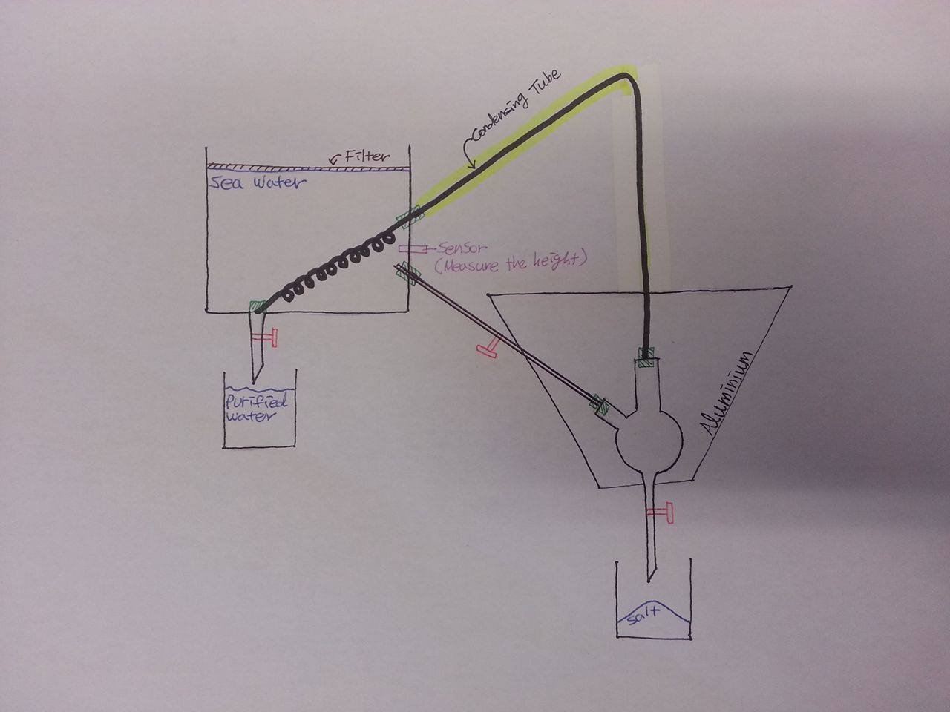
Fig. 32: First idea
Elements:
- Big container for the seawater: The idea is to let the users pour the sea water in the container. There will be a filter above the container, to avoid the entrance of undesirable dirt. The difference of temperature between the inside and the outside of the container must be as high as possible. The Pump must have a working level which is high enough to pump up the water
- One sensor will be used just above the tube to alarm when the container must be filled with sea water.
- Inside the container three holes must be made. One on the bottom and one on the side, to let the condensing tube cross the container. The third hole will be used to lead the water in the balloon.
- Reaction Balloon:
- A 3-neck round bottom flask with outlet for making the reaction: buying a new one will be too expensive so it is necessary to find a used one. If it's not possible, there is a need of creating a balloon with a cap at the bottom.
- Solar Oven: Cone shape, cover with aluminum, with the balloon in the center.
- Two collectors, one for the clean water and one for the salt.
- A tube, composed by two parts; one should keep the heat and one should help to cool and condense the steam.

Operations
- The user put seawater in the big container.
- The water flows through the tube to the balloon.
- Solar energy gathered in the solar oven heats the balloon and water inside. Rock or biomass presence can increase this effect.
- Distillation process starts, the steam rises through the condensing tube.
- The condensing tube cross the big container of sea water and condense the steam into liquid.
- The purified water is collected in a container.
- When the amount of salt is big enough, it is possible to collect the salt using the outlet in the bottom of the balloon, into a container.
Problems
This solution was a scholar one, easy to apply in a lab for a little quantity but not available outside and too difficult for our project. Next step is finding a smarter solution, more exotic. It's how the second concept appeared.

7.2.2 Second concept
To find a solution more appropriate, the focus in our research is on a system adapted to an exterior environment. Going backwards to determine the concept of the condensation process. The main goal was to make a huge difference of temperature to create first the evaporation (vapor phase) and next the condensation (liquid phase). Thanks to our reflection, advices and some researches, a second idea can be shown in Fig. 33.
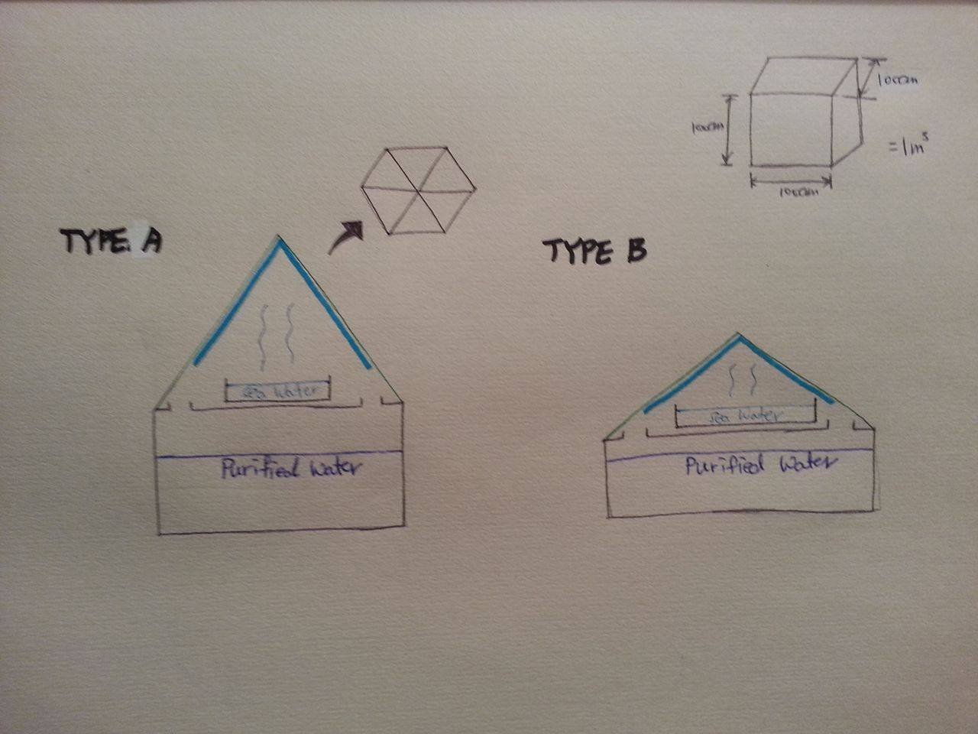
Fig. 33: Second idea
Elements:
- Container for the seawater :
- The container should be dark to absorb the heat of the sun
- The container should be small to increase the evaporation process
- Container for the clean water: This container should collect the clean water after the evaporation and condensation phases.
- Pyramid: made out of glass to allow the sun to cross and heat the inside and heat the salty water

Operations:
- The user put seawater in the dark and small container.
- Solar energy heats the inside of the pyramid and the seawater.
- The evaporation of the water start.
- The water condenses while in contact with the transparent walls.
- The water flows along the inside walls of the pyramid, to the clean water container.
- When the seawater container is empty. Someone has to poor more water. This process can be continued until there is too much salt inside. In that case, the salt must be removed.
Problems
This idea is very good, but everything should be done manually and this is not possible if the pyramid is on the top of a 2.5 m of high dome. This must be made automatically.
Questions appeared as well at this step of the development:
- Is the pyramidal shape the most adapted? What about a round shape?
- Where is the best place to put the seawater container?
To change conditions, there were 4 cases for the water desalination system:
First Case
The plate with seawater is in the center of black-colored container. Cover is round-shaped. Purified water can be collected at edge of plate. Shown in Fig. 34
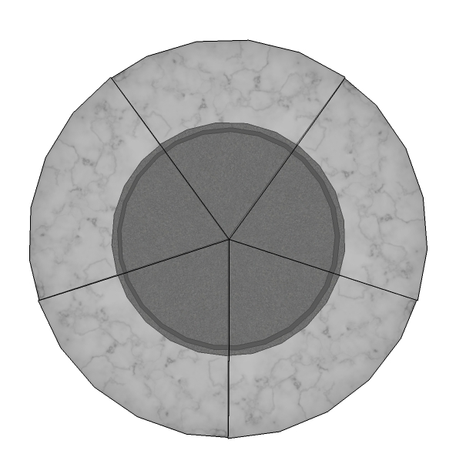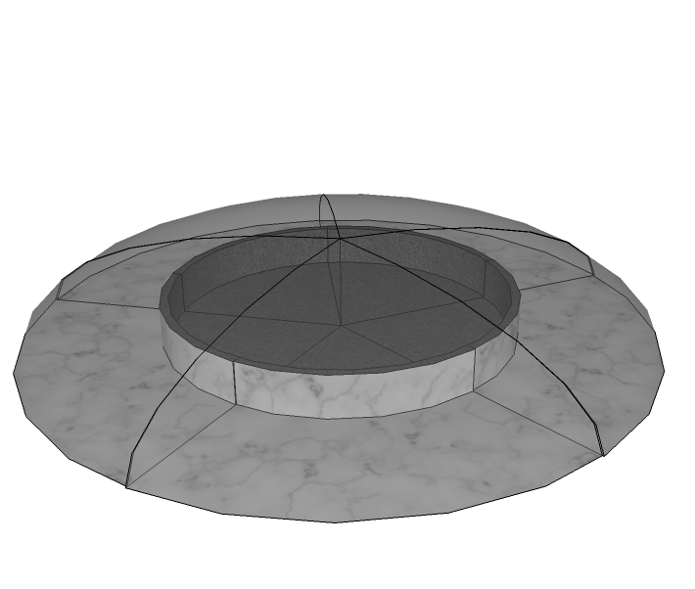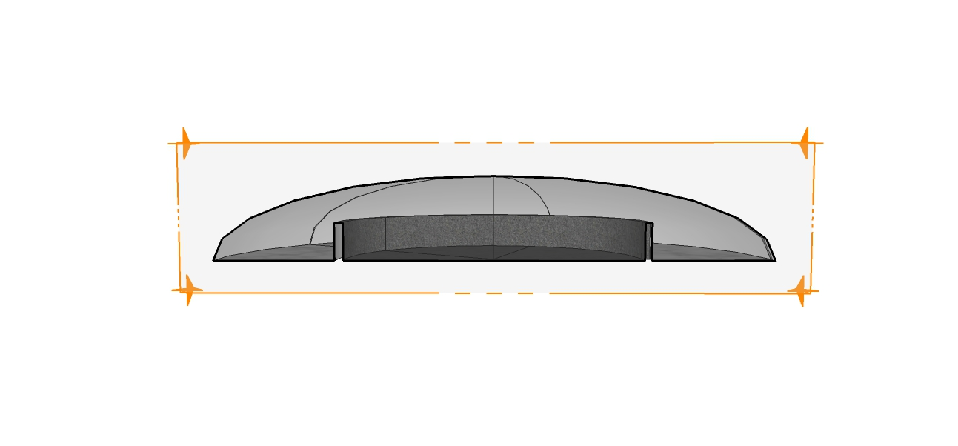
Fig. 34: First Case

Second Case
The plate with seawater is in the center of black-colored container. Cover is pyramid-shaped. Purified water can be collected at edge of plate. Shown in Fig. 35
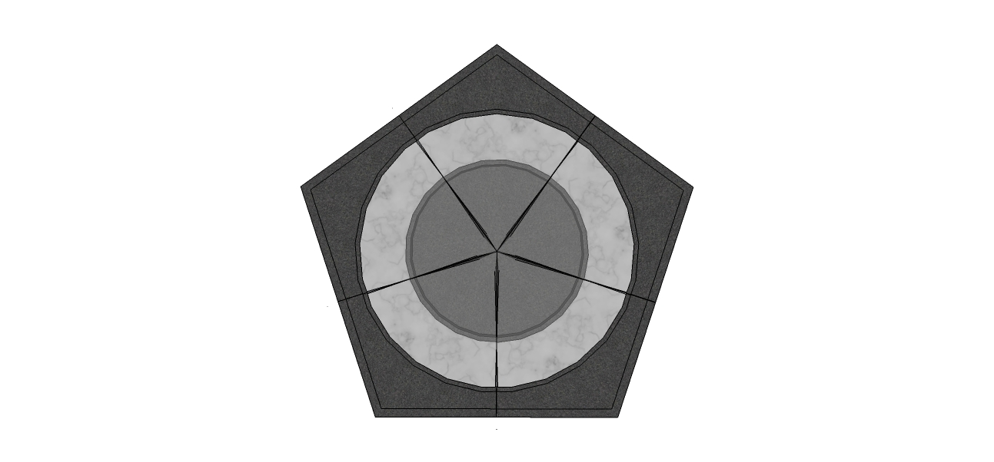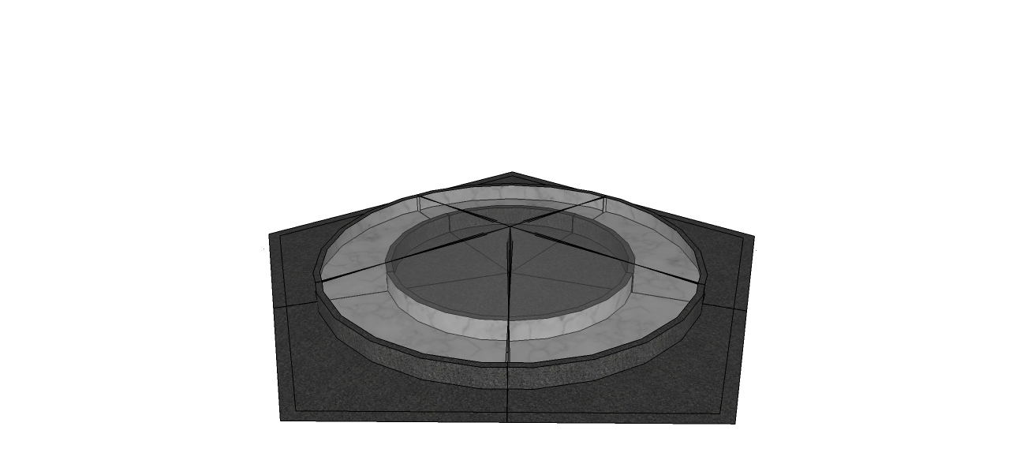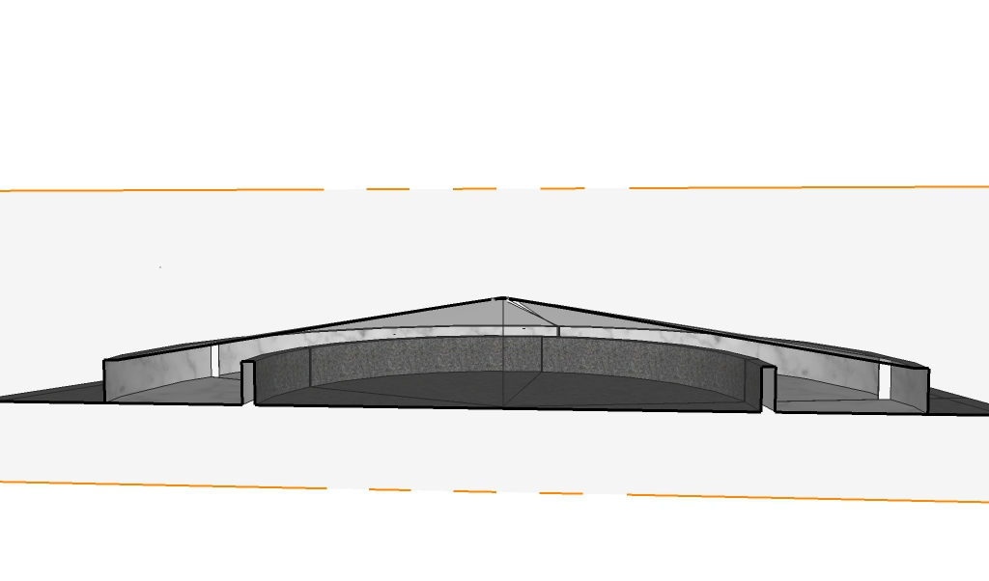
Fig. 35: Second Case

Third case
The plates with salted water are in the edge of black-colored container. Cover is round-shaped. Purified water can be collected at the center of the plate. Fig. 36 shows the panel with a bowl shaped glass with 5 containers of sea water and 1 round container of purified water in the middle.
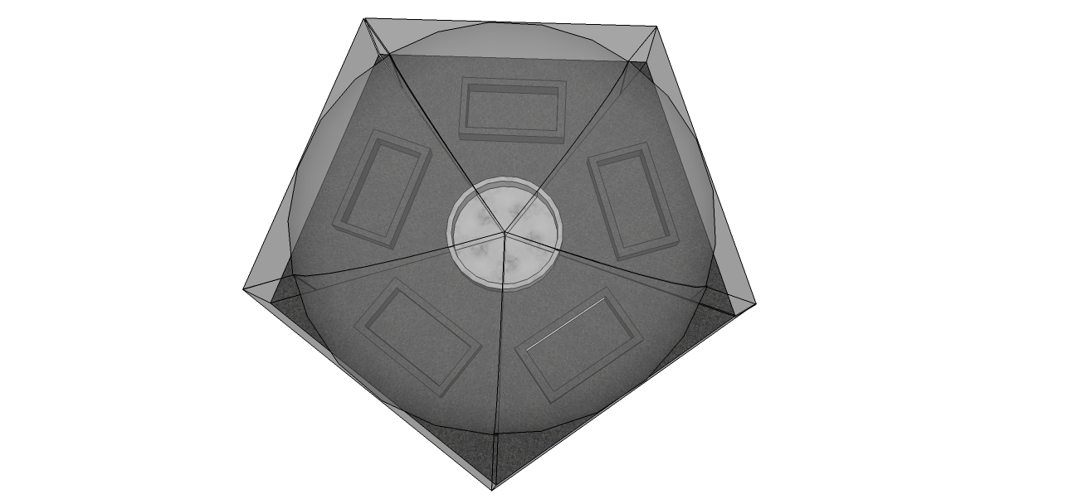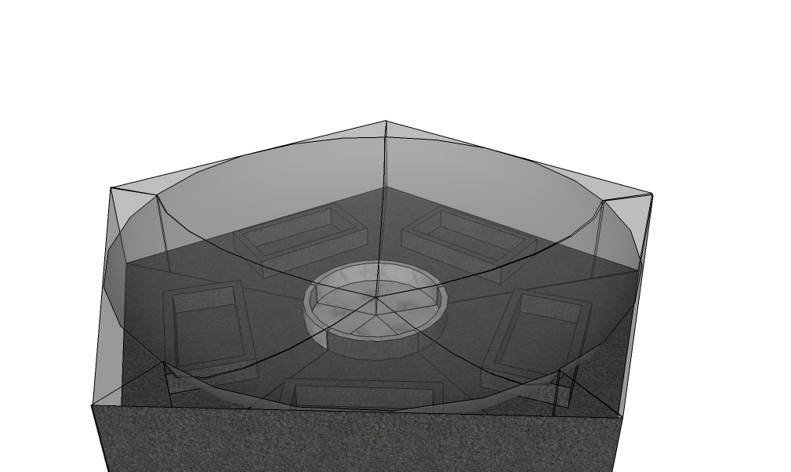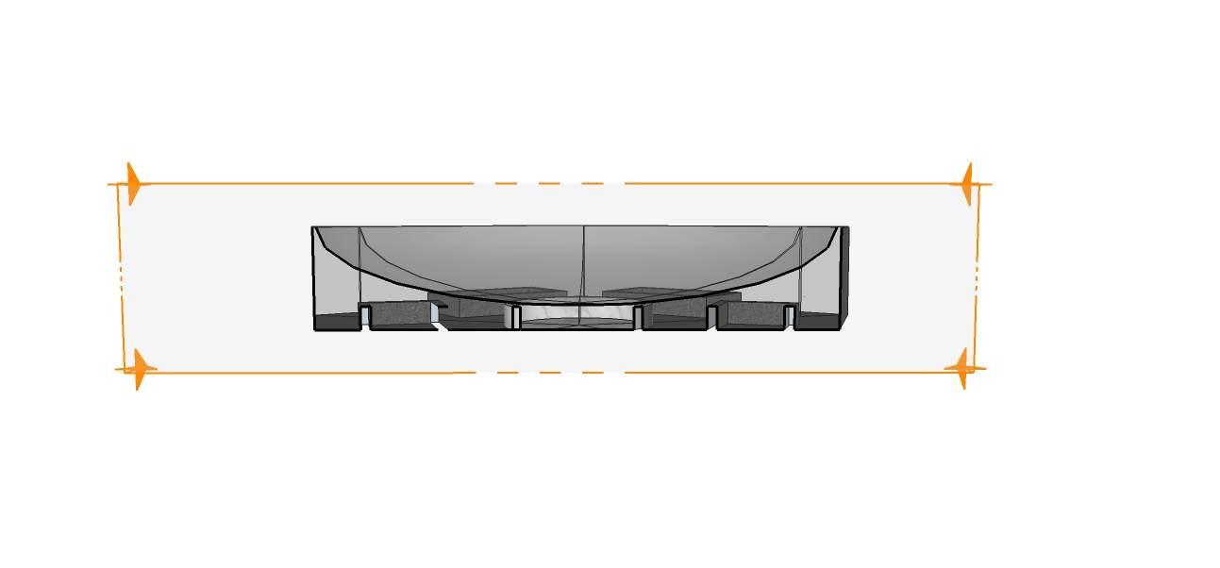
Fig. 36: Third Case

Fourth Case
The plates with seawater are in the edge of black-colored container. The cover is pyramid-shaped. Purified water can be collected at center of plate. Fig. 37 pictures the panel with a triangle shaped glass with 5 containers of sea water and 1 round container of purified water in the middle.
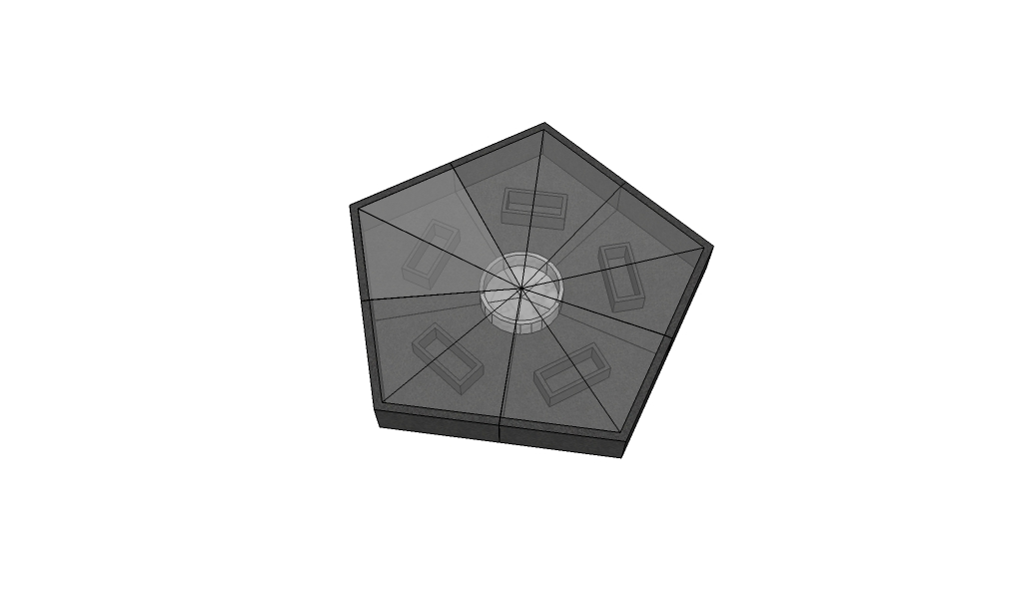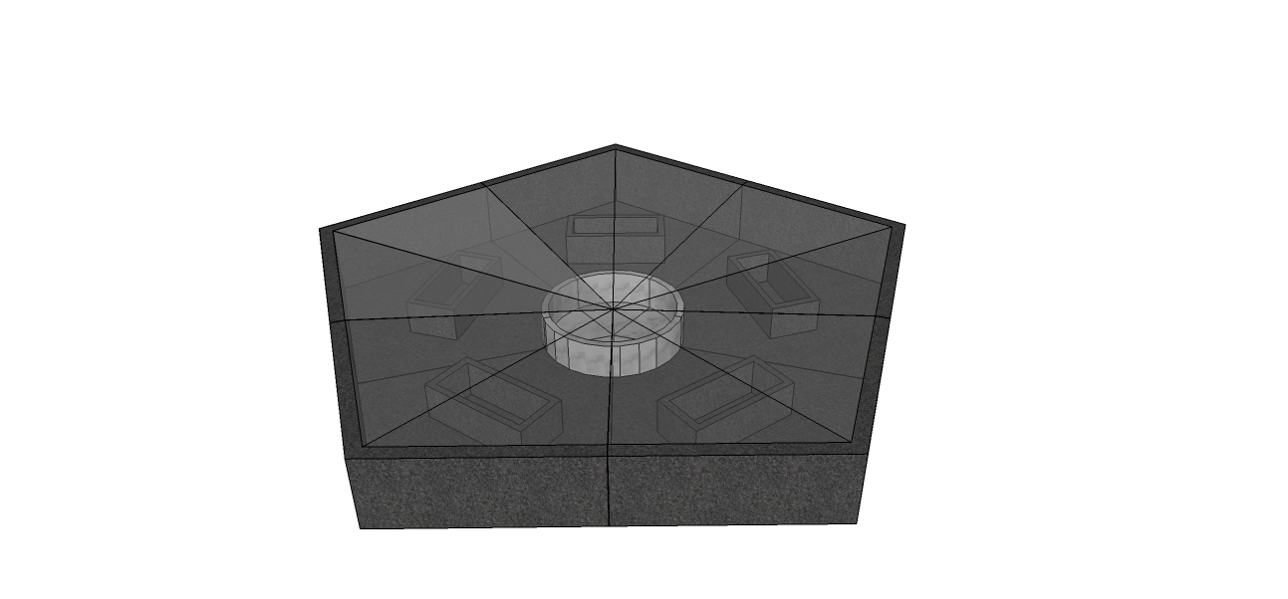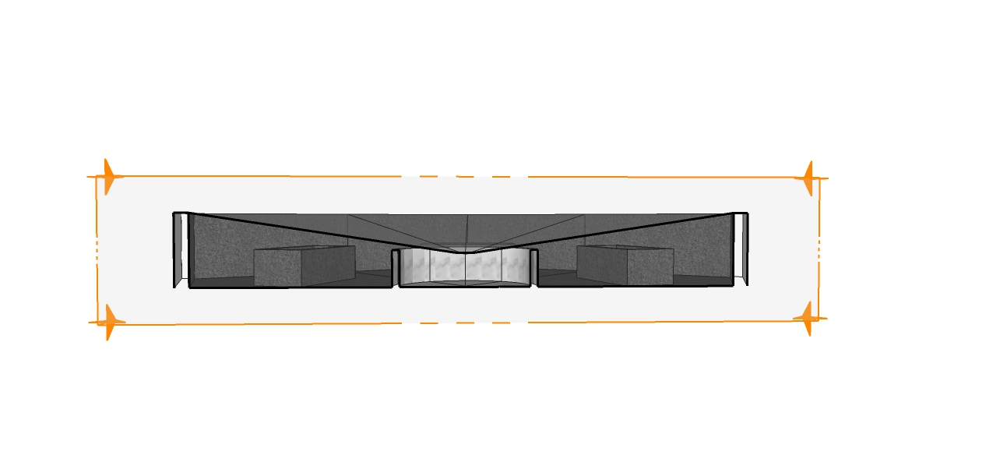
Fig. 37: Fourth Case

These 4 proposals are discussed and finally a final shape was chosen.
The system will be made with the seawater container in the middle and with the pyramidal shape made out of PMMA (Polymethylmethacrylate).
Statements for choosing the shape:
- It is easier to have one container of salt (water) to refresh.
- The pyramidal shape will be easier to build. The 5 glass triangle pieces will be attached with each other by glue
- It will be safer to use the pyramidal shape of Perspex.
- Is PMMA really better than glass?
- Which container for the salt?
- How to automate the process? How to bring the seawater inside the container and how to drain the water?
- Which test has to be done next?
By more research, a third concept is appeared. This concept was the last explained, before deliver the interim report.

7.2.3 Third concept
In Figure shows the scheme of the third schematic with the improvements of the second version.
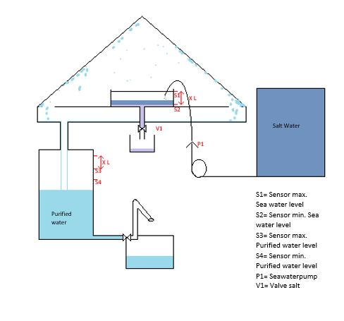
Fig. 38: Third Concept
The central area is the pyramidal part where the desalination process will happen. To separate the water from the salt, the brine will be placed in that dark and thick container in the center of the pyramid. The sun will beat down on the walls and heat the inside of the pyramid. This heat will release the evaporation of the water. Thanks to the difference of temperature between the inside and the outside of the pyramid, the water vapor will condensate on the walls. The water will be collected by the bottom and the salt will stay in the container[25].
Around this system, components are needed to make this continuous:
- 2 big containers, one for the seawater and one for the purified water,
- 1 pump to bring the seawater from the container into the pyramid,
- 4 humidity sensors which can handle the pump to manage the level of water in all the system,
- 1 valve to release the salt extraction at the end of the process. A little bit of salty water will help it to go down.
The components, the functionalities, the tests and results of our final concept will be explained further in this Project Development part.

7.2.4 Final adjustment

First step
The shape of the structure is based on previous research. The system contains out of 4 containers, which can be seen in Fig. 39
A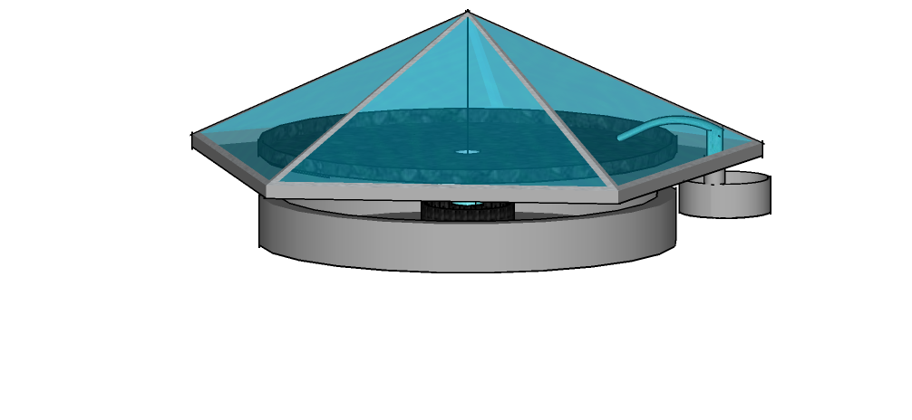B 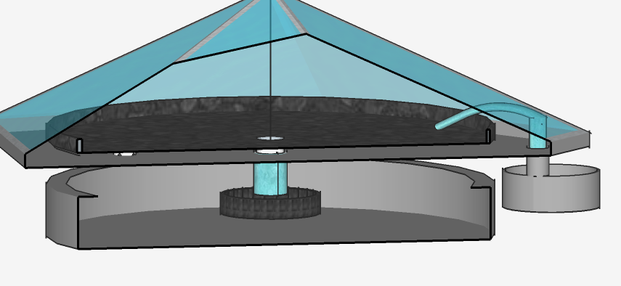
Fig. 39: (A) External view of the system (B) Internal view of the system

First of all, the container, connected with the pump must be filled manually with seawater. After this, the seawater will be pumped up to the big plate. To let the evaporation start. The evaporated water will condense against the pyramid and will flow to the base container. The little white supports of the salt container, has little wholes at the bottom to help the water flow into the next container. This can be seen in Fig. 40.
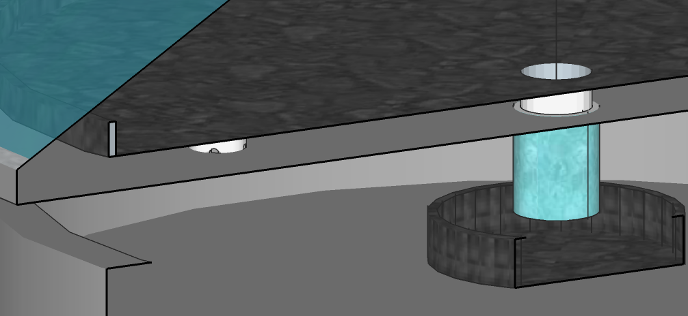
Fig. 40: Water Flow
This container contains purified water which can be attached to a tap and a sink for using this water. This part must be made in further work. After using this flow track several times, the seawater on the big plate will have a high concentration of salt. For this, more seawater will be poured in the seawater container by the pump. This water collect the high concentrated seawater and make everything flow into the little black container under the big black container in the middle. This can be taken of and placed in the sun or just an open area to evaporate the water and collect the salt.
Comments
By making tests and making the prototype, errors occurred and needed to be fixed. For this, structure details changed. *The base need to be steep to collect the purified water in one point. *The seawater container cannot be steep to optimize the evaporation of seawater. *The base and the pyramid are not attached. Rubber between the both elements will keep it close from water and air.

Last step
By building the prototype, the team realized that the collecting water part was very difficult to create. So some changes appeared, on the last schematic you can see that the big white container is bend in one side, leading directly the water through a hole to collect it. The little dark container is also bend, but. In the inside, no big visible changes, as you can see in Fig. 41(A) in the exact opposite direction of the other one, to obtain a flat surface and increase the evaporation action. All those changes are seen in Fig. 41(B).
A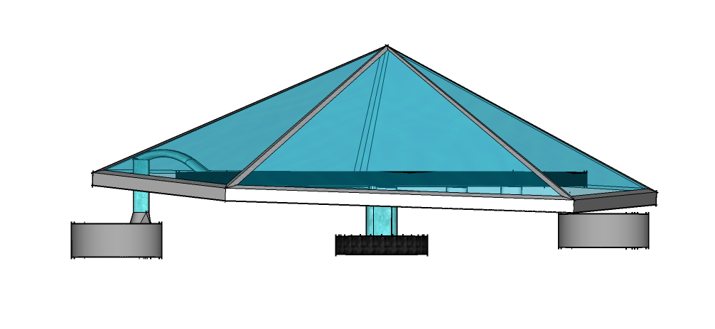B 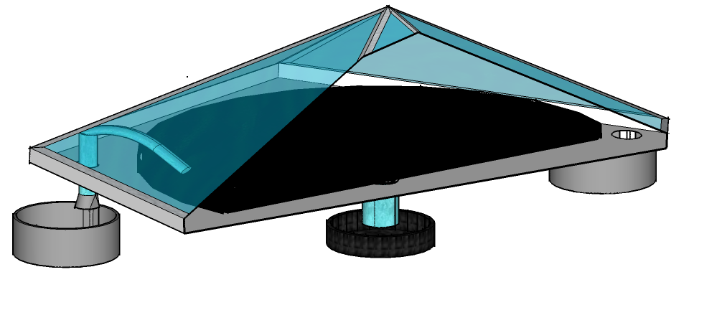
Fig. 41: (A) External view of the system (B) Internal view of the system

7.3 Tests and Results

7.3.1 Evaporation
First of all it is important to know if evaporation of sea water can really happen by heating the seawater as shown in Fig. 42. For this uncertainty, seawater can be heated in a cooking pot to see what will happen. If after the end of the test, only salt crystals remain at the bottom of the pot, it is sure that evaporation happened. For this experiment it is possible to use the wisdom of the group to know the evaporation will happen. For example, during the summer at the beach. People who come out from the sea, dry without using a towel, only using the solar energy and body warmth to evaporate the salty water of the body.
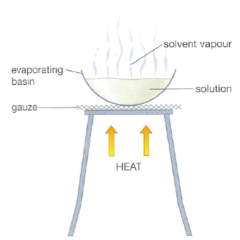
Fig. 42: Ground Idea [13]

7.3.2 Testing the ground idea of the system
The next step is to discover if a box out of PMMA is able to create a big difference in temperature between the inside of the box and outside the box to make evaporation and condensation happen. For this experiment the team went to the roof of the F-building of ISEP with a pyramidal Perspex, thermometer, sea water and a small container for the seawater to see if the process works. More details of this experiment is seen in Fig. 43.
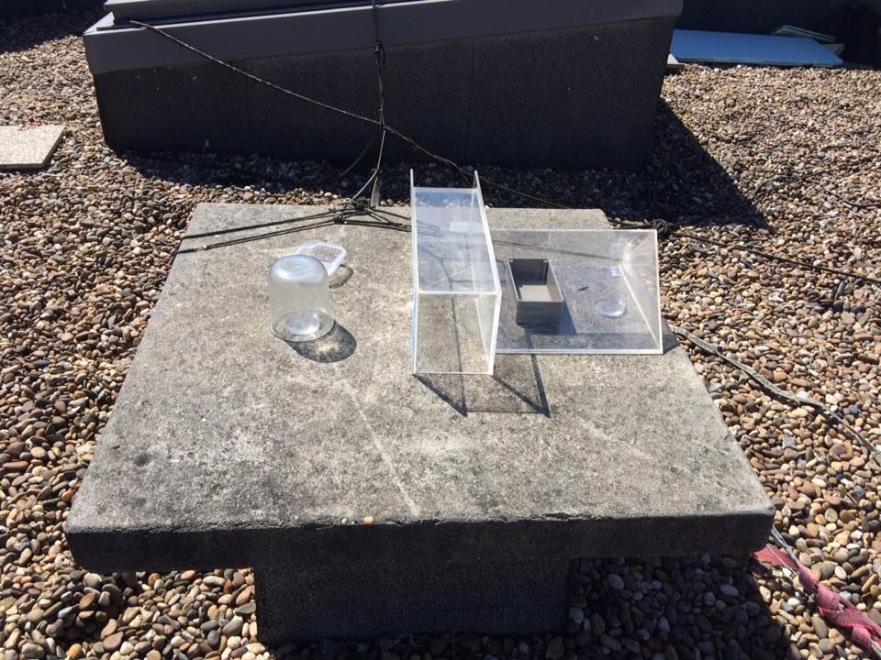
Fig. 43: First test

7.3.3 Experimenting
In this experiment, the team wants to test if PMMA is really a better material than glass. Research already showed advantages of PMMA, but experiments will still be the big proof. Advantage Transparent PMMA
- Light transmission: typical PMMA grades allow 92% of light to pass through it.
- Passes UV light. This light is more energetic and might kill some waste products in the seawater
- Good heat insulation enables saving the heat inside. The PMMA let UV light through, which make the process faster.
- Surface Hardness
- Does not shatter
- Lightweight
- Insoluble in water, resistant to salty water.
- No environmental damage or health risks by producing PMMA by containing any toxic materials or heavy metals
- Sustainable (see chapter Eco-efficiency Measures for Sustainability)
- Thickness of PMMA does not affect the transparency.
By the help of Cristina Ribeiro and her colleague the test between a pyramidal shaped Perspex and a small bottle of glass could be made on the roof of the F building from ISEP by good conditions (approximately 21 °C and no rain).
In the picture the samples, results and weather conditions are shown in Fig. 44, Table 17 and Table 18. In the pyramidal volume (Perspex) are two containers placed, to check the difference between a large container and a small container. In the jar is one small container (the same as in the pyramidal volume) to check the difference between the shapes of the transparent material.
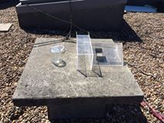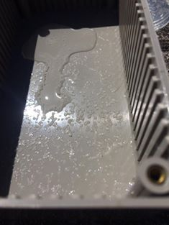
Fig. 44: (A) Setting of the experiment (B) Result after 24 h

Table 17: Results
 | Glass: small container | Perspex: small container | Perspex: big container
Water level start [ml] | 10 | 10 | 50
Water level after 24 h [ml] | 4 | 2.4 | 2.5
Evaporated [%] | 60 | 76 | 95
Table 18: Weather Conditions
Weather conditions | Start | average night | stop (24 h later)
Apple forecast [°C] | 17 | 10 | 14
Temperature measured [°C] | 24.0 |  | 14.0
Temperature measured in pyramidal volume [°C] |  |  | 30.4

Conclusion about the test
The pyramidal and Perspex (PMMA) wins from glass and a jar as we expected. Following tests will continue with the winning shape and material. For further tests, the team must take the following notes in consideration:
- The pyramidal volume was not closed. There was another Perspex box putted next to the volume to close. This was not sufficient next time the open side will be covered with a transparent film.
- The difference between the temperature inside and outside the volume must be measured again. This is a very important parameter
- Will the temperature be a big factor? What will the difference be by a temperature of 20 °C or 10 °C?
- It was putted on the roof (more than 50 m high) and the roof has some walls to hold up the wind. Will this be a big influence when the system will be put on a dome of a height of approximately 2,5 m without any walls to block the wind. The seawater container needs the have a big surface. Will the color/materials also influence the evaporating process? Which material will be best?

7.3.4 Functional tests
After the prototype was built, the team went to the roof to place the prototype outside with seawater in the black container to check if the system works. The results of this test is shown in Table 19.
Table 19: Results
Water level start [ml] | 200
Water level after 2 h [ml] | 132
Evaporated [%] | 34

7.4 Thermodynamics

7.4.1 Theoretical concerns
Water desalination powered by renewable energy sources is purely based on Thermodynamics. Most important heat transfers are between the surrounding to cover and the inside to cover which takes place by convection, radiation, conduction and condensation. Shown in Fig. 45.
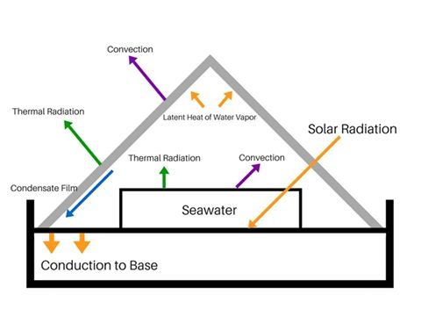
Fig. 45: Thermodynamic scheme
Solar energy transmit by radiation and convection on the cover and partially absorbs by the saline water and partially by the base. The temperature in the inside of the system rises, hereby seawater evaporates. Convection currents carry the warm vapor up to the colder cover, where vapor condensates. Due the steep cover, the purified water flows down the cover, over the white base and gets collected in the container. Additionally, heat transfer from the white base flows to the surrounded surfaces due conduction.
Next equations states the rate of heat transfer from cover to surroundings by convection and radiation, which is equal to the heat transferred from the seawater container to the cover by convection and radiation and by evaporation and condensations of water and the solar radiation absorbed in the cover. Parameters for the calculations:
- H₀ : Convection of heat transfer coefficient from cover surface to atmosphere
  - T_{c} : Temperature of transparent cover
  - T_{a} : Temperature of atmosphere
- σ : Constant of Stefan-Boltzmann
- E_{c}: emissivity factor for radiation from cover to atmosphere. For this the PMMA emissivity is 0.84
- H_{i} : Convection of heat transfer coefficient from seawater container to cover surface
- T_{b} : Temperature of seawater in basin
- E_{b,c} : Emissivity factor for radiation from seawater to cover
- D : Distillate outflow rate (kg/m/m²) from base
- λ : Enthalpy of condensation of water vapor is 2264 KJ/Kg

Energy balance around the cover of the distiller and surrounding
$Q= Ho . Ac . (Tc – To) + σ . e . Ac (Tc4 – To4)$ (1)
Convection
$Ho . Ac . (Tc – To)$ (2)
Radiation
$σ . e . Ac (Tc4 – To4)$ (3)

Energy balance around the cover of the distiller and the inside of the system

$Q= Ho . Ac . (Tb – Tc) + σ . e . Ac (Tb^{4} – Tc^{4}) + D . λ + I . αc$ (4)
Convection
$Hi . Ac . (Tb – Tc)$ (5)
Radiation
$σ . e . Ac (Tc^{4} – To^{4})$ (6)
Assumptions are taken for the calculations. The area of the seawater container, white base and cover stays equal. The cover and condensate film are at a temperature of Tc, the temperature Tb is uniform throughout the basin, liquid and vapor leakage is negligible and the cover condensate are opaque to thermal radiation from the seawater container. Over-all energy balance around 1m² of distiller is:
$I\left(1-εr\right)= H0 \left(Tc – Ta \right)+ σ . ec. Ac \left(Tc^{4} – Tr^{4}\right)+D \left(Tc – Ts\right)+ B \left(Tb – Ts \right)+ Σ$ L (7)
I : Solar radiation rate on horizontal surface [W/m2 ]
R: Loss of solar energy by reflection
B: water outflow rate
L: Miscellaneous heat loss form distiller
In this equation the solar radiation absorbed in the seawater container and on the distiller bottom per hour is equated to the sum of the heat transferred from the cover to the atmosphere by convection and radiation, the sensible heat carried out in the hot seawater and the warm condensate and heat losses, including the heat transferred through the bottom of the basin. The energy balance is written with the incoming saline water at the reference temperature and there is a further assumption that the condensate leaves the distiller substantially at the cover temperature.

7.4.2 Practical concerns
The efficiency of the process relies on the mass of condensated water [kg/m³]. This can be calculated by
$∆m= - ∆es/(Rv . Tlowest)$ (8)
With
- es: the difference of water vapor pressure of the highest and the lowest temperature [bar]:
e_{s} = 6.1078 . ${10}^{7.5 . Ti/ (237.9+Ti) }$with T [°C]
- R_{v}: the gas constant of water vapor [461.5 J (K Kg)-1]
- T_{lowest}: the temperature at the lowest value [K]
The difference of water vapor pressure also can be calculated by the difference of Relative Humidity inside the system by:
$RH = (e/es) . 100$ (9)
With e: Real vapor pressure inside the system

7.4.3 Water Pyramid Test Result
Once the prototype was ready the team made some tests during 2h on the roof of ISEP:
- Temperature on the Arduino Board: [45,89 ; 53,11] °C
- Pressure on the Arduino Board: [1004,79 ; 1006,11] hPa
- Temperature inside the brine, on the inside wall and outside wall of the pyramid, Figure
- Humidity inside the pyramid
This test was made to ensure the big difference between the temperature of the inside of the pyramid, the outside of the pyramid and the brine itself. In Fig. 46 a graph is shown which make clear that the Temperature from the inside of the pyramid is approximately 10 °C higher than the Brine temperature and approximately 18 °C higher is than the outside temperature. By this, the team can conclude that the process can work. Namely, the evaporation of the Brine will occur and the vapor can condense at the PMMA because the outside of the pyramid is colder than the inside of the pyramid.
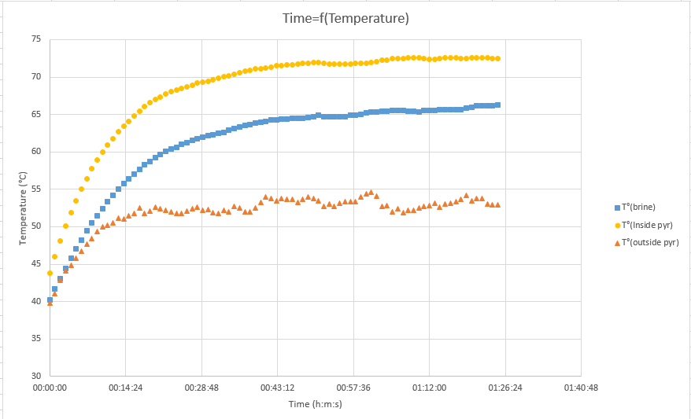
Fig. 46: Temperature of the brine, the inside and the outside of the system
The Relative Humidity stays constant at approximately 60% in the inside of the pyramid, as seen in Fig. 47. The higher the Relative Humidity, the more brine evaporated.

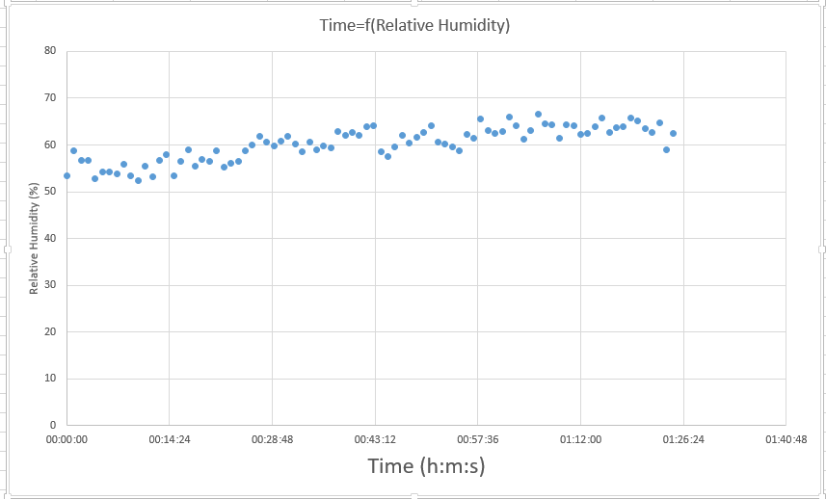
Fig. 47: Relative Humidity inside the system

After this test, another test of 24 h was made. This for two reasons: to make calculations and to compare the results with the experiment itself, and to get the difference between the minimum and maximum temperature of the inside-, outside of the system and the brine.

The results of the graph in Fig. 48 shows the big difference during day and night. This difference is important for the evaporation and condensation process. By day, the brine evaporates. By night, the vapor condenses. This can also be proven by the Relative Humidity graph in Fig. 49. During the evening/night the Relative Humidity increase up to almost 95 % and after this, after condensing, the Relative Humidity decreases.

Fig. 48: Temperature of the system during a 24 h test

Fig. 49: Relative Humidity of the system during a 24 h test

Table 20: Min/Max results of the 24 h test
On the Arduino |  |  |  |  | White sensor |  | Temperature sensors
 | Temperature | Humidity | Temperature | Pressure | Temperature | Humidity | T° (brine) | T (°C) Inside pyr | T (°C) outside pyr
min | 18.51 | 15 | 18.34 | 1000 | 17.3 | 31.4 | 17.87 | 16.56 | 15.94
max | 47.56 | 83.7 | 45.34 | 1004 | 52.9 | 95.7 | 49.94 | 61.19 | 43.63

With the results of Table 20 it is possible to calculate the percentage evaporated water.
- E_{s1} = $122,21 . 6,1078 . 10 ^(7,5 . Tmaxbrine/ (237,9+Tmaxbrine))$
- E_{s2} = $20.41 = 6,1078 * 10 ^(7,5 * Tminbrine/ (237,9+Tminbrine))$
- ∆E_{s} = $101.80 = Es1-Es2$
- ∆m = $0.012 kg = Tmin inside/(461,5 . ∆Es)$
- Water evaporated = $12.75 ml = ∆m . 1000 ml/kg$
- % evaporated = 6.37 %
In this experiment only 6.37 % evaporated. To increase the percentage evaporated, it is important to make the higher difference between the temperatures. In future development it is necessary to take this in consideration.

7.5 Electronics overview
To make the Water Pyramid autonomous, an electronic system must be integrated. The Arduino intelligence will be used to control 1 pump and 4 sensors like you can see in the following Black Box Diagram in Fig. 50.
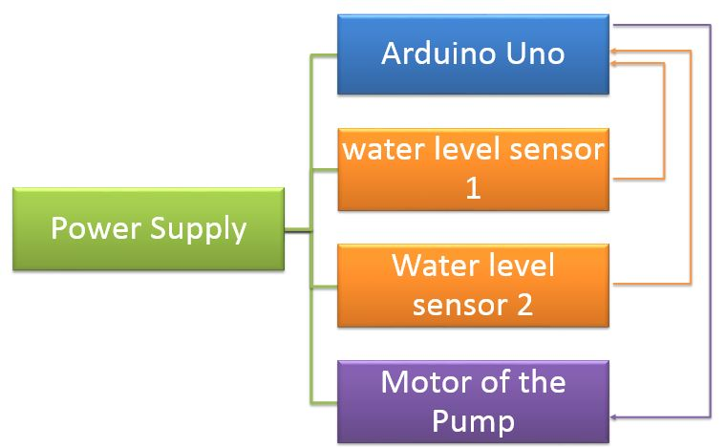
Fig. 50: Black Box Diagram

7.5.1 Grafcet Analyses
Before the Arduino programming, the team established a Grafcet scheme:
- Find the actuators : The pump
- Find the detectors : the 2 electronic sensors
- Link them together
According that the little black container for the brine is called C1 and the container which collect the clean water under the pyramid is called C2, here you will find the development of our electronical system:
- The pump must not work if C1 is full, if C2 is full, so also if one of the both is full.
- The pump must start if C1 and C2 are empty.
- The pump have to start during 5sec if C1 is empty and C2 is full
The Grafcet scheme is on the figure
This system needs 2 ultrasonic sensors [30].
Those ultrasonic sensors are considered as INPUT and follow the level of water possible in the container of clean water, and the one inside the pyramid which contains the salty water. Those sensors are here to avoid any overflow and all the consequences that this problem can generate after. They are here to restart the process when the container is empty for the salty water container or when the container of clean water have enough place to receive more water. On this last container, the level of clean water will be always high to have a big stock and available water all the time.
Those ultrasonic sensors will detect the presence of water at the sensor level. The sonic waves emitted by the transducer are reflected by an object and received back in the transducer, so if something appears between them, the sonic waves will change and the presence of water detected.

7.5.2 Arduino
This system needs 1 OUTPUT, one pump to fill and refill the container of salty water.
The Arduino programming appears in Fig. 51, Fig. 52 and Fig. 53[26].
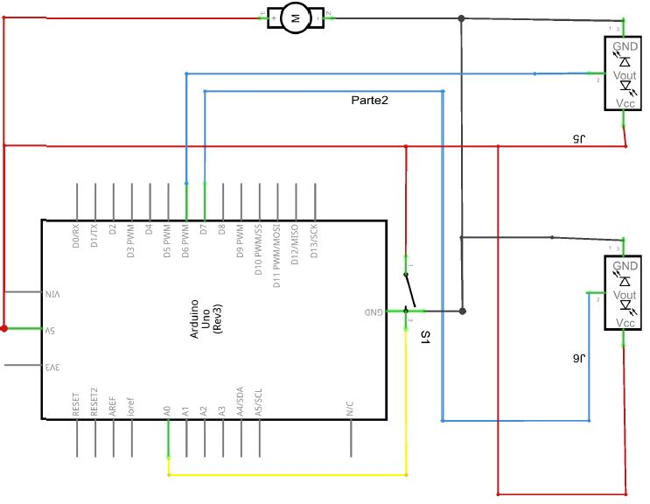
Fig. 51: Arduino Schematic

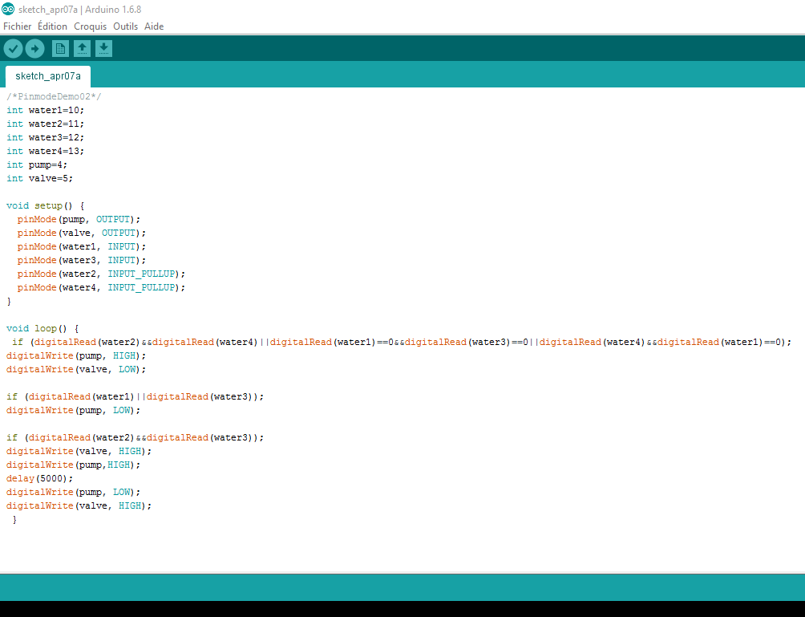
Fig. 52: Arduino Programming
PING_TRIG1=10;
int PING_ECO1=9;
int PING_TRIG2=12;
int PING_ECO2=8;
int pump=13;
long duration1, duration2, distance1, distance2;
void setup() {
pinMode(PING_ECO1, INPUT);
pinMode(PING_TRIG1, OUTPUT);
pinMode(PING_ECO2, INPUT);
pinMode(PING_TRIG2, OUTPUT);
pinMode(pump, OUTPUT);
Serial.begin(9600);
}
void loop() {
digitalWrite(PING_TRIG1, HIGH);
delayMicroseconds(10);
digitalWrite(PING_TRIG1, LOW);
duration1 = pulseIn(PING_ECO1, HIGH);
distance1 = (duration1/2)/2.9;
Serial.println(distance1);
delay(50);
digitalWrite(PING_TRIG2, HIGH);
delayMicroseconds(10);
digitalWrite(PING_TRIG2, LOW);
duration2 = pulseIn(PING_ECO2, HIGH);
distance2 = (duration2/2)/2.9;
Serial.println(distance2);
if(distance1 > 20 && distance2 > 50);
digitalWrite(pump, HIGH);
if((distance1 <= 20) ||(distance2 <= 50) || (distance1 <= 20 && distance2 >= 50))
+3 || (distance1>=20&&distance2<=50);
digitalWrite(pump, LOW);
delay(1000);
} int

Fig. 53: Arduino Code

7.6 To go further
This report is made in the middle of the project. Next step will be:
- choosing the material of the container
- Making calculation of thermodynamics to ensure the measurements of the components
- Finding the optimal solution to desalinate water by thermodynamics
- Testing if the purified water is drinkable
- Building the scale model: buying materials, assembling the different components and make test to see the efficiency of the project
- Finish the report by improving the State of the art, Project Management, Marketing Plan, Eco-efficiency Measures for Sustainability, Ethical and Deontological concerns and Project Development.
- Preparing the Final Presentation with the Final Deliverables
In the following two months the team will carry out a good project by accomplishing the previous tasks.

The prototype
    - Building the prototype
To build the prototype, the team was waiting the materials. Once the different materials arrived, the prototype was built following those different steps:
- Cut the five PMMA triangles
- Glued to each other the five triangles using glue. Clean the pyramid by cutting the excess of glue and using dissolvent
- Cut the two pentagonal bases in a plastic board
- Glued the bottom to increase the resistance and the different edges
- Painted the bases, the small one for the brine in dark, and the big one for the clean water in white using spray
- Perforated the bases for the tubes
- Glued silicone to the pyramid to hermetically seal the pyramid
- Created a plastic system to bend the bases to collect the clean water
- Assembled all the elements

    - Problem experienced
Dark Container
Some test are quickly done after that to check everything is going well. But during these tests, the dark container for the brain began to deform itself like shown in Fig. 54. So a new material had to be found for the salt container, and test did again.
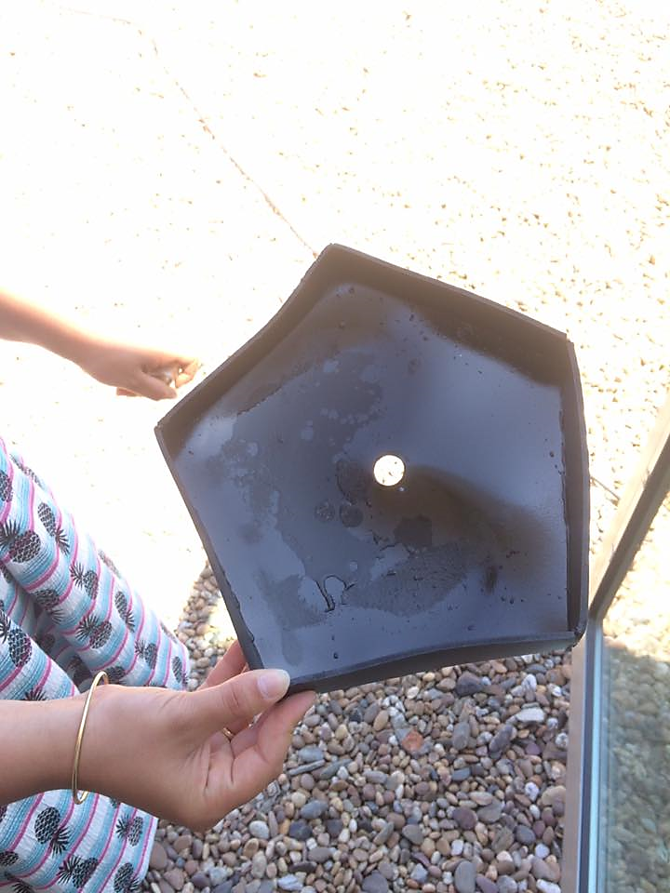

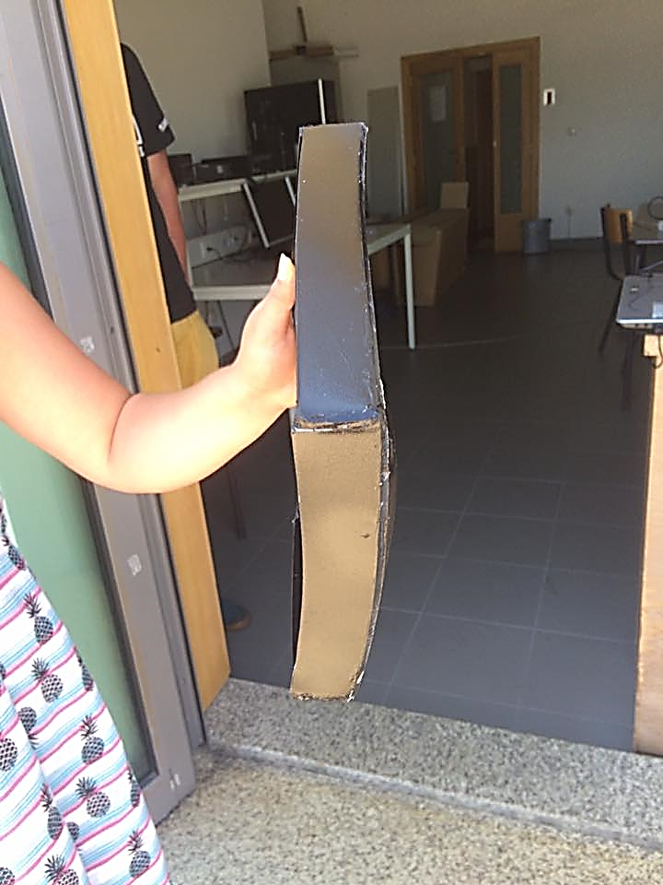
Fig. 54: (A) Top view of the deformed black container and (B) Side view of the deformed black container

Painting
The two containers were painted with spray painting. Stickers will be used the next time to avoid the contamination of the water by the paint. Indeed, during the first test, a paint-like odor released from the pyramid because of the heat.

8 Conclusion
In this chapter the team has written about the ways of how the team managed to develop the ideas of this project. The changes of the product and the system were explained, tested and discussed over the time. Based on test results, material is chosen and making the electrical schematic for our project makes the whole process easier and more user-friendly.

Conclusions
This chapter comprises a summary of the whole work developed during the European Project Semester as well as suggestions for future development.

8.1 Discussion

At first, the target and objectives were established to get to know in which direction the project should be going. After this research was done to choose right methods for developing the project. Next step is to identify the most appropriate methods to achieve the main goals on theoretical perspective. Later the set up objectives had to meet the practical way of developing the product, which took a lot of effort. The practical way includes a lot of experiments in appropriate conditions. Thus, the prototype has changed including shapes, materials and design.

The prototype has to satisfy the users’ needs in terms of sustainability and marketing, with the help of management and ethics.

When everything was designed in the right way, the scientific part had to be checked. This means studying the thermodynamic reactions through the system. These test proved the prototype is working but needs improvements, which will be defined in next part of the conclusion.

As a team, we are proud of what we achieved and what we worked on. The problem behind our project is very important. This optimized project could be very promising for the future.

8.2 Future Development

Regarding the future, several factors of the product can be improved.
First of all, more test about materials can be done do guaranty a sustainable, low cost and efficient system.
Next the electronical part can make the product autonomous.
And last but not least, more thermodynamic experiments should be done to ensure at which conditions the system works best.

References

[1] D. S. (seecon international gmbh Félicien Mazille (Aquasis, cewas, international centre for water management services), “Desalination,” 2010. .
[2] Riverkeeper, “United Water New York’s Proposed Desalination Plant,” 2015. [Online]. Available: http://www.riverkeeper.org/campaigns/river-ecology/waterfront-development-review/united-water-desal/.
[3] A. Pugsley, A. Zacharopoulos, J. D. Mondol, and M. Smyth, “Global applicability of solar desalination,” Renew. Energy, vol. 88, pp. 200–219, 2016.
[4] S. to the O. of G. S. of T. A. University and in partial fulfillment of the requirements for the degree of D. O. PHILOSOPH, “Different Desalination system,” no. December, 2005.
[5] L. Stonecypher, “How Desalination by Multi-stage Flash Distillation Works.” [Online]. Available: http://www.brighthubengineering.com/power-plants/29623-how-desalination-by-multi-stage-flash-distillation-works/.
[6] F. Eleiwi, N. Ghaffour, A. S. Alsaadi, L. Francis, and T. M. Laleg-Kirati, “Dynamic modeling and experimental validation for direct contact membrane distillation (DCMD) process,” Desalination, vol. 384, pp. 1–11, 2016.
[7] S. Lowell, “This Plant in Dubai Makes Half a Billion Gallons of Fresh Water a Day,” TIME, 2015. [Online]. Available: http://time.com/3625511/this-plant-in-dubai-makes-half-a-billion-gallons-of-fresh-water-a-day/.
[8] VEOLIA, “Multiple Effect Distillation (MED),” 2012. [Online]. Available: http://www.entropie.com/en/services/desalination/MED/.
[9] waste and waste water International, “Cambodian water authority wins Stockholm Industry Water Award,” ASIA/PACIFIC. [Online]. Available: http://www.waterworld.com/articles/wwi/print/volume-25/issue-3/regulars/worldwide-news/asia-pacific.html.
[10] F. Bander, “Advantages & Disadvantages of Vapor Recompression,” Design Distillation System, 2012. [Online]. Available: http://seperationtechnology.com/advantages-disadvantages-of-vapor-recompression/.
[11] PureTec, “What is Reverse Osmosis?” [Online]. Available: http://puretecwater.com/what-is-reverse-osmosis.html.
[12] “Greenwater Kit.” [Online]. Available: http://www.greenwater.se/.
[13] Wikibooks, “Desalinate water,” 2015. [Online]. Available: http://www.wikihow.com/Desalinate-Water.
[14] MECHELL & LESIKAR, “Desalination,” sswm, 2010. [Online]. Available: http://www.sswm.info/content/desalination.
[15] E. El-Bialy, S. M. Shalaby, A. E. Kabeel, and A. M. Fathy, “Cost analysis for several solar desalination systems,” Desalination, vol. 384, pp. 12–30, 2016.
[16] B. Dictionary, “risk management.” [Online]. Available: http://www.businessdictionary.com/definition/risk-management.html.
[17] D. Inc., “procurement-management,” 2016. [Online]. Available: https://www.deltabid.com/procurement-management/.
[18] Expertprogrammanagement, “Stakeholders Analysis.” [Online]. Available: http://www.expertprogrammanagement.com/2010/06/stakeholder-analysis-template/.
[19] Jawahir-Manuf, “Sustainable Manufacturing,” 2008.
[20] B. Dictionary, “Social Sustainability,” 2015. [Online]. Available: http://www.businessdictionary.com/definition/social-sustainability.html.
[21] A. Sevenster, Evaluation of PVC using the “natural step” framework. 2012.
[22] R. Brandao, “Lecture Sustainability.”
[23] AAWRE, “AAWRE Code of Ethics & Release Agreement Form,” Am. Acad. fo Water Resour. Eng., p. 4, 2015.
[24] V. Velmurugan, M. Gopalakrishnan, R. Raghu, and K. Srithar, “Single basin solar still with fin for enhancing productivity,” Energy Convers. Manag., vol. 49, no. 10, pp. 2602–2608, 2008.
[25] L. Malaeb, K. Aboughali, and G. M. Ayoub, “ScienceDirect Modeling of a modified solar still system with enhanced productivity,” Sol. Energy, vol. 125, pp. 360–372, 2016.
[26] P. Ferreira, “Arduino,” 2016.

